YAGEL
EDUCATION
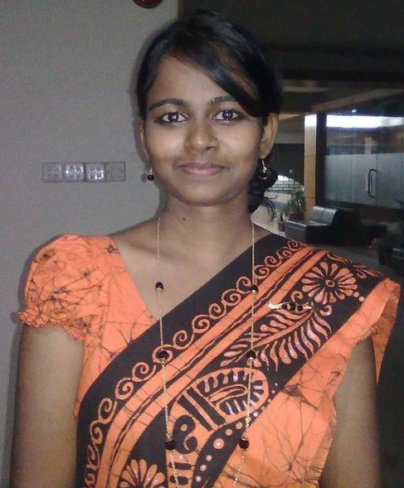
E-mail:
yagel.369633@2freemail.com
Date of Birth:
September 26, 1990
Nationality:
Sri Lankan
UAE visa Status:
Visit Visa
Interests:
Handwork
Reading books
Degree:
BSc in Public Health

2011-2015 Asian University for Women Chittagong, Bangladesh
Bachelors degree in Public Health
- Grade: 3.26 CGPA
2010-2011 Asian University for Women Chittagong, Bangladesh
Diploma in English (Access Academy)
2007-2009 Methodist College Colombo, Sri Lanka
General Certificate of Education (GCE) Advanced Level
Dec 2006 Methodist College Colombo, Sri Lanka
GCE Ordinary Level
PROFESSIONAL EXPERIENCE
2016-2017 World Vision Lanka Colombo, Sri Lanka
Management Trainee- Health and Nutrition
World Vision is a Christian relief, development and advocacy
organization dedicated to working with children, families and
communities to overcome poverty and injustice
- Supervise and provide technical support to the five area
development programs’ (ADPs) health and nutrition project in Uva
province
2014-2015 Asian University for Women
Peer Health Educator
Asian University for Women is an independent, international
university in Chittagong, Bangladesh seeking to educate a new
generation of leaders in Asia
-Work as a team to plan and organize events and campaigns to
to ensure a healthy student life at the university
2011-2015 Asian University for Women Chittagong, Bangladesh
Student Supervisor- Information Technology (IT)
Asian University for Women is an independent, international
university in Chittagong, Bangladesh seeking to educate a new
generation of leaders in Asia
- Supervise the IT assistants working in the IT labs and provide
support to the students who use the IT labs with their issues

Aug 2013 Navajeevana Healthcare Centre
Medical Assistant
Navajevana Healthcare Centre is a Christian, Sri Lankan, non-
government organization established to meet the need of
affordable quality healthcare
- Support and work closely with the Doctor by checking the
vitals of in-patients
Key Skills:
- Communication
- Team work
- Punctuality
- Active
- Time management
- Writing
- Adaptable
- Flexible
- Friendly
- Helpful
- Quick learner
Computer Skills:
- Internet browsing
- Microsoft office (Word, PowerPoint, Excel)
- Adobe Photoshop
- Adobe Movie maker
- Paint
- SPSS
- STATA
Language skills:
- Fluent in speaking, reading, and writing in Tamil, English, and Sinhala languages

RESEARCH EXPERIENCE
2014-2015 Asian University for Women
Researcher and Analyzer
Feeding Practices and Growth Status of Infants in Chittagong Slums
- As a part of the senior seminar, research was conducted and the
results were presented to the university after analyzing
Jun 2013 Good Shepherd Girl’s Home and Boy’s Home
Project member
We Overcome Our Weakness - WOW
-Designed, organized and conducted leadership workshops to build
up team work and self esteem in two different Children’s Home
Jul 2012 Bostami Turtle Shrine
Research Assistant
Population Status of Bostami Turtle
- Measured and analyzed the population status of the Turtle in the
Bostami Shrine with the environmental status

