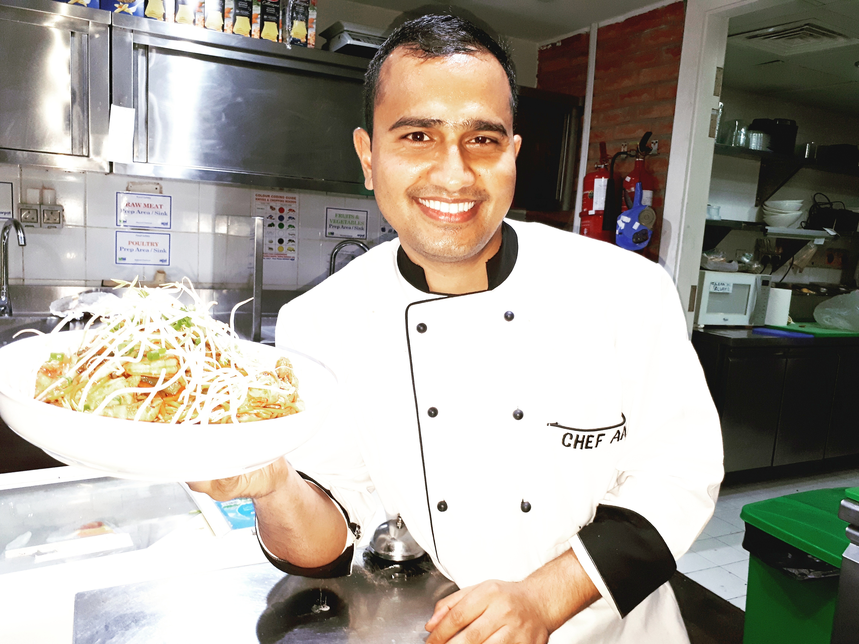

**Sous Chef**

**ANIL**

[Anil.369651@2freemail.com](mailto:Anil.369651@2freemail.com)



To join a hospitality company that gives me an opportunity to showcase my skills and also helps me gain practical exposure in business sector.

**CAREER GOAL**



**Sous Chef / International Cuisines | November 2016- present**

**The Kitchen Cafe, Marina – Dubai – U.A.E**

* Help in the preparation and design of all food and drinks menus
* Produce high quality plates both designs and taste wise
* Ensure that the kitchen operates in a timely way that meets the quality standards
* Manage and train kitchen staff, establish working schedule and assess staff’s performance
* Resourcefully solve any issues that arise and seize control of any problematic situation
* Fill in for executive Chef in planning and directing food preparation when necessary
* Comply with and enforce sanitation regulations and safety standards
* Maintain a positive and professional approach with co-workers and customers
* Order supplies to stock inventory appropriately

**Kitchen Supervisor (Indian Cuisines) | June 2014 – September 2016**

**Hotel Royal Residency – Sheikh Al Faisal Group, Umm-Ul-Quwain – U.A.E**

* Managing the kitchen porters
* Making sure the kitchen is a safe and hygienic place to work
* Organising the inventory, storage, and distribution of foodstuffs and supplies
* Helping to plan menus, apportion ingredients and use food surpluses
* Control portion costs by working out the number of portions per food batch
* In some jobs you will be required to cook

**Options by Sanjeev Kapoor| March 2013 to May 2014**

**Chef Indian Cuisines, Dubai – U.A.E**

* Preparation, cooking and presenting Indian Tandoori/Curry dishes
* Maintain high standards of food hygiene and health & safety at all times
* Participate fully in all meetings, training and forums
* Monitor food consumption to ensure 100% customer satisfaction and minimum waste
* Support the Head Chef in the introduction of new seasonal dishes
* Cascade your knowledge and expert cooking to all kitchen staff
* Suggested innovation and commercially viable ideas to improve food quality
* Perform any reasonable duties as required from time to time in order to contribute to the achievement of business aims and objectives

**WORK EXPERIENCE**

**Commis 1| September 2011 to March 2013**

**Hari Niwas Hotel, J&K – India**

* Maintaining high standards of hygiene
* Preparing the ingredients for a more senior chef
* Measuring dish ingredients and portion sizes accurately
* Dealing with deliveries and stock rotation

**Commis 2| May 2006 to June 2008**

**Hotel Ashok, Delhi – India**

* Performance all required task in accordance to Hotel policies and procedures.
* Responsible for consistently implementing the Policies and Procedures in operating
* Responsible for establishing and maintaining high sanitation standards in the work station
* To ensure that personal hygiene is always up to the highest standard.
* I have the knowledge of handling cattering section also even can handle 800 persons foods.
* I have the knowledge of Indian dishes and Tandoor also with Kitchen Pantry and Continental Cusine
* With also I am much aware of the knowledge of Chinese and Arabic Cusine.

Picture12

**CORE SKILLS**

Picture9

* 3 years Diploma from I.T.D.C. in Food Production (Indian Tourism Development Corporation) – **September 2008 to September 2011**.
* Senior Secondary from J&K Board of School Education
* Secondary from J&K Board of School Education

**ACADEMIC**

**QUALIFICATIONS**

● A high standard of professionalism in my work

● The ability to remain calm and objective in all situations

● The ability to quickly identify and resolve issues

● Able to work autonomously and in a team environment

● A good sense of humour and the willingness to be part of a team

**PROFESSIONAL ATTRIBUTES**

● Date of birth: 7th Octobar 1989

● Nationality: Indian

● Marital Status : Single

● Visa Status: Employment

● License: No

● Notice period:1 month

**PERSONAL DETAILS**

Available upon request

**REFERENCES**