JISSA
JISSA.369670@2freemail.com
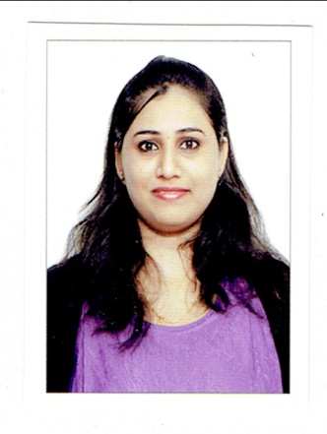
OBJECTIVE

Desiring a post of medical coder with an aspiration to work in an international healthcare industry from the expertise knowledge of basic anatomy and physiology gained during my academics.
Seeking a job in your hospital/company to exhibit my skills of quick learning and to be a loyal worker by which i can symbiotically help the reimbursement of the claim and gain knowledge in the fundamentals of health care industry in UAE.

PERSONAL PROFILE
Date of Birth : 21/01/1991
Nationality : Indian
Gender : Female
Marital Status : Married
Languages Known : English, Hindi, Malayalam, Telugu, Tamil.
Interests :Teaching, Singing, Traveling

ACADEMIC QUALIFICATION

Year | Level | University/Board | Grade/Class/Percentage
2006 | SSLC | Kerala State Board | First Class
2008 | HSC | Kerala State Board | First Class
2012 | Bsc Nursing | DR.NTR University,Vijayawada | First Class
TECHNICAL SKILLS
- MS Office 07 and 10, Kingsoft Office;
- Browsers - Internet Explorer, Mozilla, Chrome etc.
- Ms word
PERSONAL SKILLS
1) Time Management
2) Good Communication
3) Quick Learning
WORK EXPERIENCE
Saifee Hospital
Location : Charni Road, Mumbai
Position : Staff Nurse
Duration : 06 Jan 2014 to 08 Mar 2016

GEBBS Health Care Solutions
Location : Airoli, Mumbai
Position : Medical Coder
Duration : 14 Sep 2016 to 22 Mar 2017
JOB PROFILE :
* Analysing the report.
* Doing detailed case study if needed.
* Checking etiology and manifestation.
* Checking CCI and LCD.
* Searching Highest specific ICD codes and coding.

CERTIFICATION : CPC { May 2017} Issued by AAPC

KNOWLEDGE : Knowledge of CPT, ICD-10, Modifiers and HCPCS.
SOFTWARES OPERATED :
I code, 3M Coderyte system and Optum system also have a knowledge of operating Encoder Pro and ICD-10data.com.

