RESUME
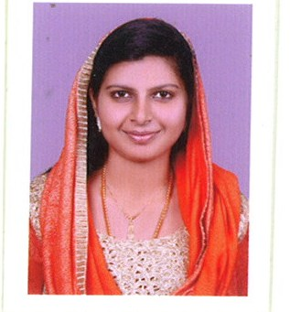
SHABINA
Visa Status - Visit Visa
Email: shabina.369715@2freemail.com
CAREER OBJECTIVE
To engage in a career that will allow for progress in terms of skills, socio- economic development, and innovation through exposure to new ideas for personal and professional growth, as well as growth of the company. Seeking a suitable position of civil engineer in the respective Organization and to take challenges there by enhancing knowledge and skills to contribute to the growth of Organization

WORK EXPERIENCE:

- Worked as a Quantity Surveyor in Deva Matha Construction Company Kollam
Kerala, India – Period from June 2016 to February 2017.

WORK RESPONSIBILITY
- Quantity takes off for Residential Building.
- Preparation of bill of quantities.
- Assisting the senior quantity surveyor for the preparation of rate analysis.
- Assisting the senior quantity surveyor for preparing work order & variation orders.
- Preparation of QS report.
- Preparation of final job close out report and analyzing with theoretical quantities verses actual quantities and preparation of as built drawing.
ACADEMIC PROJECTS UNDERTAKEN
Major project
Project description: Structural analysis and design of a multistoried building by using STAAD PRO V8I.
Analysis of multi storied building by using the software Staad Pro. Building consists of G+5 stories. Beams, columns, and pile foundation are designed. Loads consider for analysis are Dead Load, Live Load, Wind Load, Seismic Load and their combinations.
Areas of Interests:
- Quantity Survey
- Estimation
- Cost and Time management using primavera
EDUCATIONAL QUALIFICATION:
- Bachelor of Engineering in Civil Engineering, from Kerala University, 2016 with 78 %
- Diploma in Quantity Survey
- Diploma in QA/QC
- Successfully completed training course in NDT
- Plus Two ( Science ) with 90% - Kerala Board of Examination
- SSLC (General) with 92 %
Civil Software
- Auto CAD 2D
- STAAD PRO V8i
- Primavera
PERSONAL SKILLS
- Disciplined
- Self motivated
- Leadership Skill
- Hard working and ambitious

PASSPORT DETAILS
Date of Issue : 10/06/2015
Date of Expiry : 10/06/2025
Place of Issue : Trivandrum

PERSONAL INFORMATION
Date of Birth : 10/08/1994
Sex : Female
Status : Married
Nationality : Indian
Driving License : Indian License
DECLARATION
I do hereby affirm that the above information given is true to my best of my knowledge and belief.
Place:
Date:
SHABINA

