Azel Bhelly  Filipino, 26 Years Old  Email Ad: azel.369723@2freemail.com | 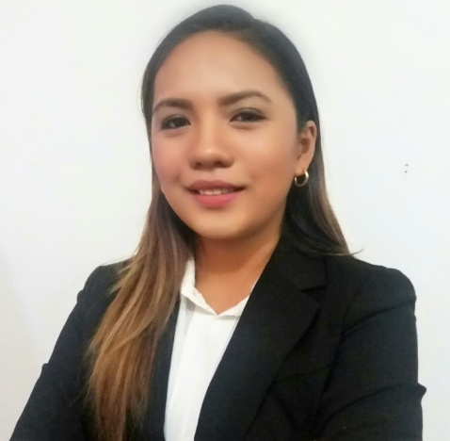
A self-motivated and hard-working individual who is able to cope well under pressure. Proven ability to use initiative and problem-solving skills to successful deal with challenges and effectively handle difficult situations. Detailed-oriented, resourceful and highly organized. Exceptional interpersonal skills, strong leadership abilities and team work skills. An energetic and fast learner who is committed to caters to total business and customers satisfaction.

WORKING EXPERIENCE

Teradyne Philippines Ltd. Basak, Lapu-lapu City
Business Intelligence and Database Developer (May 2013 – December 2016)

Duties:
    - Lead daily meetings for project updates and issues.
    - Collaborate with business owners and create business requirements documents.
    - Practiced company’s core value: Honesty and Integrity, Open Door policy and Customers count on us.
    - Responding quickly to client requirements and prioritizing task in accordance with corporate goals.
    - Communicate effectively to counterparts based in the US and Costa Rica.

Trainings:
PMO Classes
(Project Management Basics, Understanding and Managing Project, Project Risk Management) Feb. 02, 2016 - Feb. 16, 2016
Bookkeeping and Basic Accounting for Non-Accountants
Mar. 11, 2016 – Mar. 16, 2016

Globe Telecommunication Pala-o Branch, Iligan City
Database Designer (September 2012 – March 2013)

Duties:
- Analyzed customers and clients need and created business intelligence reports in Microsoft access and Microsoft Excel.
- Converted business requirements into specification documents.
- Simplify and Automate for data entry and insure data quality.
- Developed and implemented best practices in creating Business Intelligence solutions.

Pilmico Food Corporation Dalipuga Cove, Iligan City
Report Developer (Intern) (April 2012 – June 2012)

Duties:
- Designed and developed Warehouse Management Business Intelligence Reports in Microsoft Access.
- Converted Business Requirements into specification documents.
- Developed interactive data entry forms and Dashboard using macros.
- Created a Technical Documentation for the Business Intelligence Tool and dashboard, this includes test cases, ERD and Flow Diagram.

SKILLS

- Proficient in written and verbal English communication skills
- Excellent problem solving and analytic skills
- Eager to learn new technologies and ideas
- Customer Oriented Professional
- Creative, hard working and Organized Individual
- Reliable and flexible individual
- Savvy with computers and technology
TECHNICAL:
- Office Tools: Microsoft Word, Microsoft Excel, Microsoft PowerPoint, Microsoft Visio, Microsoft Access
- ERP Software: SAP ERP, Sterling ERP
- Others: Photoshop, Notepad++, Sharepoint

EDUCATION BACKGROUND

MINDANAO STATE UNIVERSITY – ILIGAN INSTITUTE OF TECHNOLOGY (MSU-IIT)
Bachelor of Science in Computer Science, Batch 2013
Andres Bonifacio Avenue, Tibanga Iligan City, Lanao Del Norte

