Last updated on 25th Feb, 2017

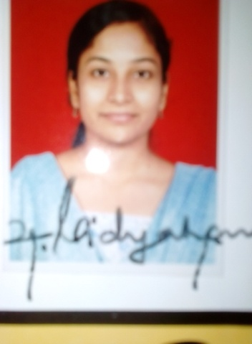  Dr.Sandhya=  My Career Objective  To utilize my professional capabilities to the fullest, to deliver excellent results by meeting the organizational goals and thus contributing to the organization’s growth and development as well as developing self.  Email:  Sandhya.369734@2freemail.com  passport no#  In process  Personal Profile  DOB: 15th june 1986  Sex: Female  Marital Status: Single  Interests  Traveling  Playing games  Music | Work Experience  - Well trained in managing patients in labour.  - 5 years of experiance as a general practioner.  - Keen sense for details and can work under pressure.  - Excellent oral and written communication skills in English.  Role Responsibilities ;  - Diagnosis and Management of Out-Patients.  - Management of Patients in labour.  - Managing other gynecological disorders.  - Screening of patients for ca cervix and councelling for infertility.  SCHOLASTIC RECORDS (in Chronological order)  2005-2010 M.B.B.S. Yenepoya Medical College, Mangalore, karnataka, India The course comprises of two years and six months of Basic Sciences and three years of clinical sciences.  2010-2011 INTERNSHIP This comprises of one year of roatory training in all the departments.  ATTENDED CME :  Surgery  Ophthalmology  Community medicine  Dermatology  I solemnly declare that all the above details are true as per my knowledge and belief.  Yours faithfully  Dr.Sandhya

