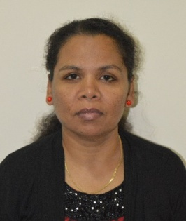
Eliza
Email: eliza.369737@2freemail.com

Objective:

To work with as a Assistant Teacher in your school, that provides a professional working environment favorable for personal and professional development, gives value to its resources and rewards performance.

Summary:

Dedicated educator committed to create a classroom atmosphere that is stimulating, encouraging and supportive for all students.

Experience:
- Little Feet Nursery November 2015 – February 2016
I was working as a Teacher
- South India Baptist Academy June 2013 – August 2015

I was working as an Economics teacher for Higher Classes
I was also teaching Social Science for the Primary Classes

- Bishop Francis Matriculation School January 2006 to May 2010

I was working as a Primary Teacher (KG, I std – V std)

Developed and implemented daily and unit lesson plans for primary classes, administered testing, tracked analyzed class performance. Conducted group and one – on – one math, reading and writing activities.
Fostered a classroom environment conductive to learning and promoting excellent student engagement.
Conducted parent conference.
Created and implemented interdisciplinary literature study based on international theme.
Taught general education students as well as individuals with learning challenges and special needs within a mainstreamed inclusive classroom.
Established positive relationships with students, parents, fellow teachers and school management.
Engage with children on an individual basis to build positive relationship with them.
Closely monitor children’s play activities to verify safety.
Supported after-school activities and homework.
Organize activities that enhance children’s physical, emotional and social well-being.
Academic Profile:

- High School, St. Joseph Higher Secondary School- Tamil Nadu, India.
- Bachelor of Arts, Economics, Holy Cross College of Arts and Science-Nagercoil KK Dist, Tamil Nadu, India.
- Diploma inPre Primary Teachers Training, Tamil Nadu Open University- Coimbatore, Tamil Nadu, India.

Highlights:

      - Flexible and Adaptive
      - Kindergarten Psychology
      - Calm Under Pressure
      - Computer Proficient
      - MS Office and Internet Knowledge

Declaration:

I am confident to be a part of your school which uses my skills and experience in its process of growth and prosperity while giving me opportunities to learn and enrich my competencies. I hereby declare that all the above furnished details are correct, true and complete, best of my knowledge. I now look forward to hearing from you on the affirmative.

Thanking you with anticipation

With Warm Regards

Eliza

