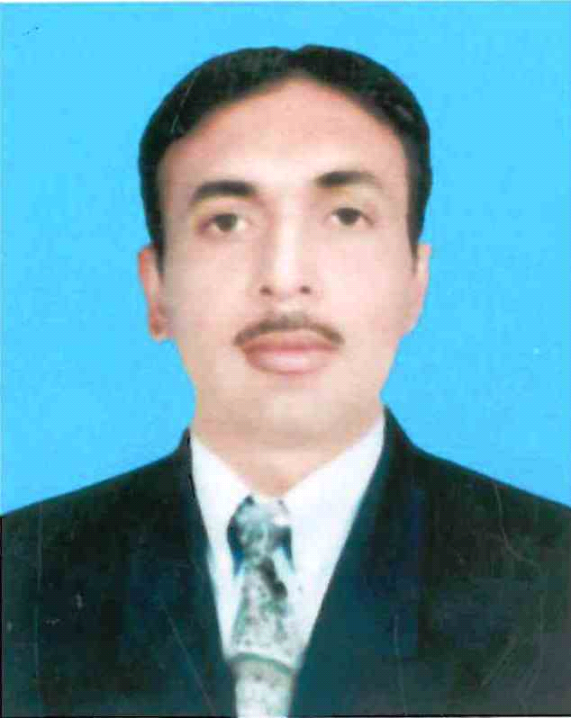 Muhammad

E-MAIL : Muhammad.369750@2freemail.com Proposed Position: Civil

Foreman

CAREER OJECTIVE:
The core objective of my life is to play a vital role as an Asset in your organization, I believe in challenging myselves every day. I am passionate about stretching my limits, for that alone creates more value for you. I believe my best is yet to come.

ACADEMIC QUALIFICATION:

- D. A.E(Diploma of Associate Engineer) in CIVIL Technology from Punjab Board of Technical Education Lahore, Pakistan
- Matric from Board of intermediate and Secondary Education Faisalabad, Punjab, Pakistan

PROFESSIONAL SKILL:
- All Type of Block Work Drawing
- Supervision of Block and Brick Works
- Supervision of RC Work
- Material Arrangement and Management on Site
- Supervision of Masonry Works
- Plaster Work
- Supervision of Brick Works
- Supervision of Fire Sealant Work
- Supervision of Water Proofing Work

PERSONAL INFORMATION:

- Date of Birth : 01-01-1980
- Nationality : Pakistan
- Religion : Islam
- Marital Status : Married

EXPERIENCE:

- TAV Constructions ,TCA JV (UAE)

Position: Civil Foreman
Duration: 3 Years (03 Sep 2013 to 31 oct 2016)
Project: Abu Dhabi International Air Port Mid Field Terminal Building
Basic Responsibilities:
- Supervision of Block Work
- All Type of Block Drawing
- Supervision of Concrete Work
- Supervision of Masonry Work
- Supervision of Masonry Repairing Work
- Supervision of Fire Sealant Work
- Supervision of Water Proofing Work

- Unique Builders Govt. Contractor (Pakistan)
Position: Civil Foreman (4 years) July 2008 to August 2012.
Labour Charge Hand (3 years) May 2005 to June 2008.
Duration: 7 Years
Project: Sultan Foundation School Project. (T.T.Singh, Punjab, Pakistan)
Project: The National College Project. (T.T.Singh, Punjab, Pakistan)
Project: DHQ Hospital Gojra Punjab, Pakistan.
Project: Water Supply Station of Shalimar Town Toba Tek Singh.
Basic Responsibilities:
- Supervision of Block Work
- Block Drawing
- Supervision of Concrete Work
- Supervision of Masonry Work
- Supervision of Masonry Repairing Work
- Plaster Work
- Supervision of Brick Work

LANGUAGE:

English Average
Arabic Average
Urdu Excellent
Punjabi Excellent
Hindi Speaking only
Reference:

- Furnished on demand.

