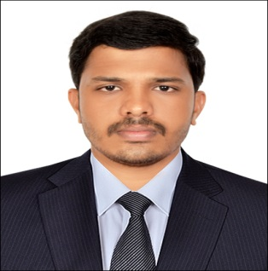
SUJITH
E-Mail: sujith.369761@2freemail.com

Carrier Objective
I intend to build a challenging and rewarding career with ample opportunities for growth in a competitive environment, which will help me to explore myself and inspire me to improve my potential.

Academic Profile
- Master of Business Administration (Finance & Marketing) from Rai Business School, Chennai, affiliated by EIILM University (2011 – 2013).
- Bachelor of Commerce from BAM College, Mallappally, affiliated by Mahatma Gandhi University, Kottayam, Kerala, India (2008 - 2011).
- H S C from N S S H School, Kunnamthanam, State Board of Kerala (2008).

Experience Chronology

Data Tracks Services Limited –Chennai (India)(Since April 2013)
Designated as Senior Financial Executive with the following responsibilities:
- Responsible for the interpretation and application of all relevant accounting guidance such as SEC regulations.
- Prepared and reviewed quarterly and annual financial statements including review of footnotes in accordance with SEC regulations and U.S. GAAP.
- Ability to maintain a high level of accuracy of preparing and entering financial information.
- Handling client queries through mail and phone.
- Coordination with various departments like: Business Development Department, Finance department.

Computer proficiency
- SAP FICO
- Package: M S Office/Excel
- Tally

Industry exposure
- ORGANISATION: Universal Sompo General Insurance Company, Chennai, India
- DEPARTMENT: Finance and Marketing
- DUTIES AND RESPONSIBILITIES: Maintaining the details of 3 tie up banks of the company, policy collection campaign.(As a part of academic project works).

Competencies
- Quick Observer
- Self-Confident and flexibility.
- Ability to work with in a team or as an individual.
- Confidence and willingness to learn new things

Personal details
Name : Sujith
Date of Birth & Age : 13.06.1991, Age :25 years
Nationality : Indian
Languages Known : English, Hindi, Malayalam & Tamil
Salary Expectation : Best in the industry.
Visa Status : Visit visa
Availability to join : Immediately
Driving License : India

Declaration
I hereby declare that the above mentioned details are correct to the best of my knowledge.

Date:
Place: Dubai (Sujith S)

