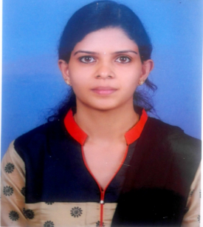
UMA
E-mail Id : uma.369813@2freemail.com

CARRIER OBJECTIVE
“Seeking a responsible and challenging position with a dynamic organization which offers opportunities for personal and professional development and where I can best utilize me knowledge and skills.”
Education
- Passed high school from St.paul’s school,Davangere.
- Diploma in Engineering (computer science) in Bapuji polytechnic,Davangere.
- Web and Graphic Design, Adoro institute of multimedia, Bengaluru.
TECHNICAL & PERSONAL SKILLS
- Skilled with Adobe Creative Suit ( Photoshop, Illustrator, Indesign,Corel Draw).
- Microsoft Office Word.
- Responsible, Creative & ability to learn quickly & adoptability.
- A Good team Player.
EXPERIENCE – 2 YEARS
- Completed 1 year course in Animation Web & Graphic Design.
- Worked as Back office assistant & co-teacher in a nursery school.(2 Years).
My SKILLS
- Designing photos,Masking,Editing photos using photoshop software.
- Designing and Creating a Logos,Pamplets , Brochures,Newspaper,Cards.
- Develop graphics for product illustrator and Logs.
- Creating 2D animation using resource like Photoshop, illustration and InDesign.
- Writing Skills(Good in cursive writings).

PERSONAL INFORMATION
- Date of birth : 29-09-1988
- Gender : Female
- Marital Status : Married
- Languages known : English,Kannada
- Hobbies : Drawing, Listening Music etc.
- Nationality : Indian
- Visa : Husband Visa

Declaration
I hereby declare that the above information furnished is true to the best of my knowledge and belief.
Place : Abu Dhabi
Date : (Uma ) SIGNATURE

