RESUME
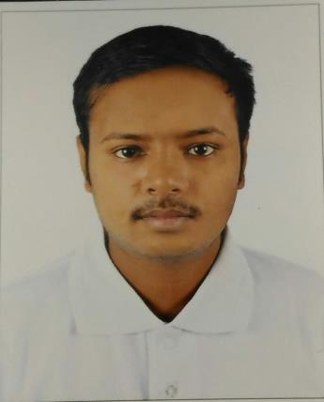

RAHUL

Email : Rahul.369833@2freemail.com

OBJECTIVE

To work with leading company and to use my analytical thinking to the best of my ability combined with perseverance, so as to contribute to organization’s growth and goal, as well as to attain my professional goal.

PROFESSIONAL QUALIFICATION:

- Completed Diploma In Electronics & Communication Engineering From TNDTE, CHENNAI,2016.

ACADEMIC QUALIFICATIONS:

Secondary from Central Model School, Barrackpore (C.B.S.E Board), KOLKATA- 2013

COMPUTER PROFICIENCY:

- Working knowledge of Windows and Internet. And familiar with MS-Word/MS-Excel

- C PROGRAMMING

- VLSI DESIGN

- EMBEDDED DESIGN OVER TINA SOFTWARE

- NETWORKING

QUALIFICATION DETAILS:

BOARD/ | INSTITUTION | COURSE | PASSING | PERCENTAGE
UNIVERSITY | NAME |  | YEAR | (%)
C.B.S.E.Delhi | C.M.S.Barrackpore | MATRIC | 2013 | 74.10%
Directorate Of | BHARATH | DIPLOMA | 2016 | 92%
Technical Education, | POLYTECHNIC | (ECE)
Tamilnadu
 | COLLEGE

PROFESSIONAL EXPERIENCE:

- One year training experience in Allied Electronics Co. ,Chennai,india

SKILLS:

- Good Communication Skills.

- Easily negotiate with other people.

- Have high level of persuasiveness.

- Can work effectively in team, as well as individually.

- Have good inter-personal skills.

Extra-Curricular Activities:

- Played football at school level

- Participate in science excibition at school level

- Participate in project work in college level

PERSONAL INFORMATION:

Marital Status: Sex:

Unmarried

Male

Date of Birth:

Language Known:

Nationality:

Strength:

07th MAY, 1996

English & Hindi

Indian

Confident, Positive attitude, Hardworking, Punctuality, Good listener and Quick learner

Hobbies:

Internet Surfing, Reading Newspaper, Playing Cricket, Football etc.

DECLARATION:

I Hereby inform you that all the statement made above are true the best of my knowledge and belief.

(RAHUL)

