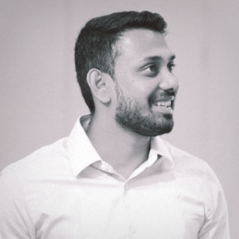
Name: Fazil
D.O.B: 22nd Nov 1986
Relationship: Married
Nationality: Indian
Email: fazil.369851@2freemail.com

Profile
Mid-level Architect with comprehensive experience in preparing Architectural Designs for full completion of Commercial, Public, Educational, Mixed Development and Residential Projects. More than 5years of experience in the field of Architecture led me to a wide variety of challenges, which helped me develop an ability to critically analyze situations and adapt to the demand. I aspire to play a challenging position in architectural management/planning which is growth oriented and also further enhances my knowledge and creative skills.

Work Experience
Al Bayaty Architects, Abu Dhabi (November2014- Present)
Mid-Level Architect

ABRD Architects, New Delhi, India. (Sept2009-March2012)
Architect

Education
DIA BAUHAUS, Germany. (October2012-August2014)
Master in Architecture MA-Arch
MEASI Academy of Architecture, Chennai, India. (June2004-July2009)
Bachelor in Architecture B.Arch

Software Skills

AutoCAD, 3dsmax, Rhino5, Revit Certified, Photoshop CS6, Indesign, Illustrator, Sketchup Pro, Grasshopper, MS Word, Excel, Powerpoint

Technical Skills

Architectural drafting, Detailing, 3d modeling, Presentation, Documentation, UPC Project Reports, Service Co-ordination, Laser cutting

Languages

Tamil, English, Limited working proficiency Hindi & malayalam, Elementary Proficiency German & French.

Certification

SOE Mem no: 39384
COA Reg no: CA/2010/48045
Revit Certified

