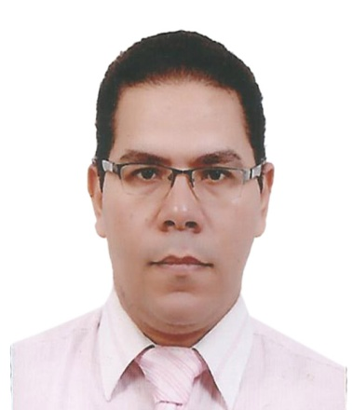
Melad
Melad.369853@2freemail.com
Chartered Accountant – Financial - Acc Manager

Personal Data:
Date of Birth : 22/02/1978
Marital Status : Married
Gender : Male
Nationality : Egypt
Military service : Exempted
Certificates:

- Graduated from the Faculty of Commerce Ain Shams University 1999.
- Holds the membership of the Register of Accountants and Auditors of the Ministry of Finance in December 2004.

Experience:
- Financial Manager in Microfilm Egypt for Import
(From 5 / 2015 Jan 2017 )
- Accounting manager in Amigo Group for Tourism and Contracting
(From Jan 2012 to 4/2015 ).

- Accounting manager in Egyptian Company for Investment (EGYSWIS).
(From December 2009 to dec2011 ).

- Accounting manager in Sutter Group Import and export. (From May 2006 - November 2009).

- Chief accountant in Elsalam& El Molak For Poultry.
(From September 2004 to May 2006).
- Accountant and Auditorin Mr. Rizk Shendi accounting office.
(From October 1999 - December 2004).

Years of Experience : 17 years
Expected Salary :
Description of job skills:

- Performing accounting, auditing, value added tax and general taxes for several companies over the years of experience
- VAT registration / VAT planning / Quarterly filing of VAT return and coordinate with Govt. Dept. / VAT Audit
- Control the execution of the monthly plan.
- Preparation of budgets.
- Receipt the budgets of all departments reviewed.
- Approved and make a general budget of the company.
- Review the monthly tax declaration.
- Full review sections, and units of accounts (suppliers - customers - banks - Treasury - Taxes - stores ).
- Issue the monthly balance and financial position.
- Making monthly review of the balances of banks and suppliers.
- Customers and outlets and stores.
- Review the policy of credit limit and opinion.
- Review inventory of stores and outlets.
- Preparations for the general tax and sales.
- Processing tax examination (general and sales and gain work).
- Supervising the work of opening, closing restrictions / adjustments / depreciation, Issuing year's budget with Explanatory attachments.

Qualifications:

Languages:
- Arabic : Mother Tongue
- English : Knowledge to work

Computer Skills
- Good Experience on Excel.word
- Word Processing and typing skills (Arabic & English).
- Good Experience on internet connectivity.
- Good experience on accounting programs and able to learn more.

