PERSONAL DETAIL
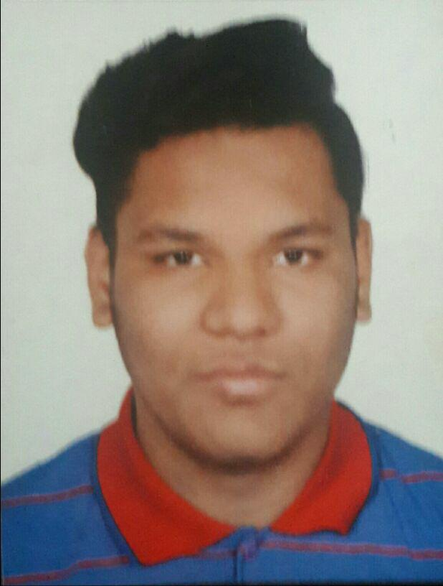

Name | Rohan
Email Id | Rohan.369860@2freemail.com
Date of Birth | 16 March 1998
Gender | Male
Marital Status | Single
Languages Known | English, Hindi, Gujarati

BRIEF SUMMARY

I have completed my Diploma automobile engineering in first devision of 2016 from L.J polytechnic with 8.13 CGPA.

I also worked in Emrald Honda as a trainee but it's covered in my 5th semester study because it's part of study.

CAREER OBJECTIVE

To Work with a Rapidly Growing Organization with a dynamic and challenging environment to achieve goal of organization with my best efforts.

EDUCATION DETAILS

 | Year of Passing | Degree/Course | Percentage/CGPA
 | 2016 | Automobile Engineering | 8.13
 |  | L.J polytechnic ,

ACHIEVEMENT

Diploma in AUTOCAD

certificate

Yellow belt in karate

SKILLS

Drawing, Teaching work as a part time Drawing tutor in School

AREAS OF INTEREST

Service Advisor Position

HOBBY

Drawing, Swimming, Karate

Rohan

