CURRICULUM VITAE 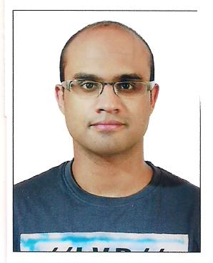
______________________________________________________________________________
Name : NIKHIL
Date of birth : 28/03/1995
E- Mail : nikhil.369862@2freemail.com

CAREER OBJECTIVE :
I am looking for an opportunity in a reputed organization which will help me deliver my best and upgrade my skills in engineering and meet the demands of the organization.

EDUCATIONAL QUALIFICATION :
- Completed ‘BE in Mechanical Engineering’ from K J Somaiya College of Engineering, Vidyavihar, Mumbai affiliated to Mumbai University, CGPA: 7.8/10.
- Passed Std. XII (CBSE) in May 2013 from ‘The Indian High School’, Dubai with 90.8% marks.
- Passed Std. X (CBSE) in May 2011 from ‘The Indian High School’ Dubai with CGPA of 8.8
PROJECTS AND PARTICIPATION :
- Final Year Project: Design and fabrication of a vegetable oil burner.
- Presentation: Presented a technical paper on Compressed Air Energy Storage (CAES) for renewable energy power plants.
- Participation in Automotive IC Engine Design Workshop

WORK EXPERIENCE :
AGS Engineering Workshop LLC, Dubai (Summer Internship 2016)
- Understood the operation of equipment and machines including CNC machines, cutting machines and hydraulic presses for the fabrication of mechanical components.
- Developed fabrication and machine shop skills.
- Became adept at reading blueprints/drawings and fulfilling work orders.
- Became acquainted with logistics and supply chain management.

PERSONAL SKILLS AND HOBBIES :
- Proficient in Solidworks, Autocad, MS Office, with basic knowledge in C++, ANSYS and Matlab.
- Knowledgeable in Mechanical Engineering Sciences.
- Fast learner and independent with strong leadership and critical thinking skills.
- Enjoys reading, writing, travelling.

---- End ----

