Curriculum Vitae
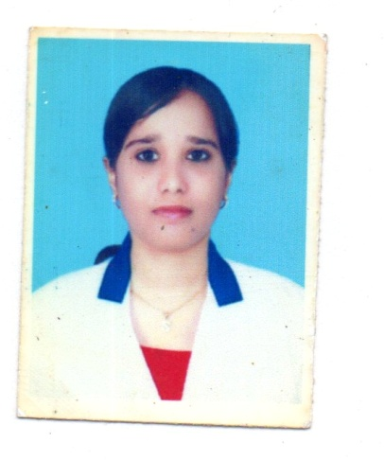

Saiyada
E-mail Id: saiyada.369864@2freemail.com

Career Objective

To Work In a Organization Where I Can Extend My Service, My Capabilities. To hold a position of Lab Technician to serve at my best skills and knowledge.

Education

- DIPLOMA IN MEDICAL LABORATORY TECHNICIAN (k.L.E para medical college)

- P.U.C II (GOODWILLS College)

- S. S. L. C (GEMS English School)

- Passed Saudi Licensing Prometric Examination at US TEST CENTER Security Procedure At Bangalore

Computer Skills

- Basics of Computer
- Operating Systems: MS Windows 95, 98, XP, Vista, and Win 7 MS Office , and MS Internet Explorer.

PROFESSIONAL SKILLS
JOB PROFILE
- Responsible for sampling, testing, and analyzing results in biological, and life sciences.
- Carry out fundamental tests as part of a scientific team.
- Tests on bacteria, and other microorganisms.
- Create report for different tests.
- Able to keep record of all patients with their tests.
- Huge experience as lab technician.

Past Employer

Worked for MEDISCOPE HOSPTIAL (2006-2009) in a pathology department

Past Employer

Worked for Dr.Ambedkar medical college & hospital (2009-2012) As a microbiology technician.

Job Profile
- Carried out various tests and procedures in the lab.
- Created urine, blood, and tissue specimens for analysis.
- Provided report to patients on drug levels in the blood.
- Analyzed the chemical content of fluids for testing purpose.
- Provided all the necessary technical support to enable the laboratory to operation effectively.

Present Employee

Presently working in Vital Malaya hospital (2013- present) As a microbiology senior lab technician.

Job Profile
- Gram staining techniques
- Isolation techniques
- Bio chemical test
- Processed urine and other culture for susceptibility of pathogen
- Performed antibiotic susceptibility test of pathogen
- Generated reports on computer
- Carried out various tests and procedures in the lab.
- Created urine, blood, and tissue specimens for analysis.
- Provided report to patients on drug levels in the blood.
- Analyzed the chemical content of fluids for testing purpose.
- Provided all the necessary technical support to enable the laboratory to operation effectively.
- Participated in Hospital infection control

Personal Details

Date of Birth : 07TH MAR 1987
Sex : Female
Marital Status : married
Nationality : Indian
Languages Known : English, Hindi, Kannada, & Urdu ,Arabic read only.

Passport Details
Issue Date : 13 – 04 - 2015

Expiry Date : 14 – 04 - 2025
Place of Issue : Bangalore

Personal Skill

- Good Communication Skill
- Zeal To Learn Advanced Technologies
- Ability To Work In A Team

Hobbies

Cooking, Listening to khuran recitation, Gardening.

Declaration

I Here By Declare That The Above Statements Are True And Complete To The Best Of My Knowledge And Belief.

Thanking you,

Yours Faithfully,

Date: (SAIYADA)
Place: BANGALORE

