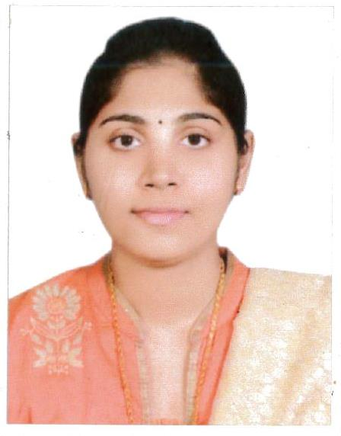  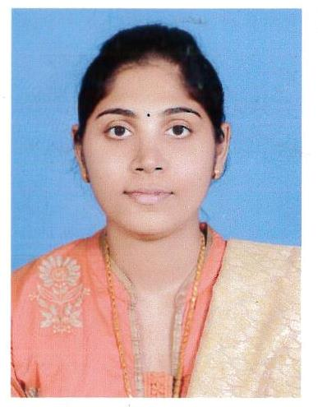  NAME – TISNA  MOH LICENSE NO:  RN012496  LOCAL RECRUITMENT (RL) NO :  RL110317016796  CONTACT DETAILS:  E-Mail: tisna.369873@2freemail.com  VISA STATUS  Husband’s Visa  Valid till : 17/10/2018  PERSONAL DATA  Date of Birth : 21-11-1987  Gender : Female  Marital Status : Married  Nationality : Indian  Languages Known: English, Hindi, Malayalam and Basic Arabic.  PASSPORT DETAILS  Date of Issue : 21-04-2016  Date of expiry : 20-04-2026  Place of Issue : Kozhikode  NURSING REGISTRATION:  - Madhya Pradesh Nursing Council Registration No:  I – 17487, II – 16836  Date: 01.10.2011  Valid till – 06.10.2021.  STRENGTHS/SKILLS  - Dedicated and patient focused with proven strengths in acute patient care, staff development and family advocacy.  - Exceptional capacity to multitask  - Outstanding interpersonal and communication skills, superior accuracy in patient history, charting and other documentation.  - High adaptability  - Perseverance and integrity to work  - Objectivity  - Leadership ability & positive thinking.  COMPUTER LITERACY  Well versed with M.S. Office (Word, Excel & PowerPoint), Internet Applications and E-Mail. | CV – STAFF NURSE  MOH Registered Nurse (RN) License holding nursing professional with 5 years of experience in Medical and Surgical ward, Gastroenterology HDU and Pediatric Ward.  ACADEMIC QUALIFICATIONS  Qualification University Year Of Passing  B.Sc. Nursing Rani Durgavati Vishwa Vidyalaya, Jabalpur, MP 2010  Plus Two Board Of Higher Secondary Examination from Kerala 2006  S.S.L.C. Board of the public Examination, from Kerala 2003  TRAINING ATTENDED  - BLS – Basic Life Support  (AHA Guidelines)  Issued on : 23.05.2016  Valid till : 22 May 2018  - ACLS – Advanced Cardiovascular Life Support  (AHA Guidelines).  Issued on : 26.05.2016  Valid Till: 25 May 2018  CAREER GRAPH  NURSING EMPLOYMENT HISTORY  - Hospital : Vims Specialty Hospitals, Karnataka, India  Position : Staff Nurse  Department: Medical and Surgical ward and Pediatric ward.  Period : 10.05.2014 to 30.06.2016 and 01.12.016 to 30.04.2017  - Hospital : Medanta the Medicity Hospitals, New Delhi, India  Position : Staff Nurse  Department : Gastroenterology HDU  Period : 20.08.2012 to 26.10.2013  - Hospital : Bhagat Hospital, Janakpuri, New Delhi, India  Position : Staff Nurse  Department: Labour Ward and Causality.  Period : 28.05.2011 to 31.03.2012  RESPONSIBILITIES  - Handling the commonly used equipment’s e.g., cardiac monitors, IABP, Syringe Pump, Ventilators, ABG Machine, Crash Cart, ACT Machine, ECG Machine, Ambubag, Glucometer, Alpha bed, bair hugger, Potassium Analyzer Machine. Blanket roll, defibrillator, Pacemaker etc.  - Providing efficient nursing care to patients on ECMO Cardiac monitor, pacemaker, swan-ganz monitoring, telemetry monitoring & Holter monitoring. Central and peripheral lines. (Arterial & Venous) and patients with chest tube drainage.  EXPOSURE TO  Fundamentals Of Nursing, Nutrition, Physiology, Biochemistry, Anatomy, Community Health Nursing, Microbiology, Psychology, Sociology And, Medical & Surgical Nursing Specialty, Pharmacology, Child Health Nursing, Mental Health Nursing, Nursing Administration, Nursing Education, Midwifery, Trends And Issues In Nursing, Research In Nursing.  ABRIDGE  Result –Oriented, Adaptable, Self-Motivated, And Multilingual Service Professional With Good Multitasking Experience. An Avid Learner And A Strong Team Player, With Competitive Oral And Written Communication Skills. A Career Oriented Graduate With Over 5+ years’ experience.  DECLARATION  I hereby declare that above mentioned details are true and correct to the best of my knowledge and belief.  Place: Dubai  Date: TISNA

