Curriculum Vitae
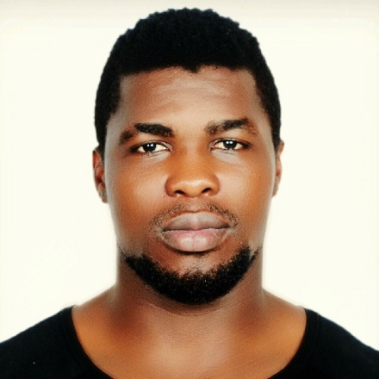
CURRICULUM VITAE
Name Personal Information:
Name: Raphael
Sex: male
Place of Birth: Mutengene
Date of birth: 15 March 1988
Country: Cameroon
Email: Raphael.369886@2freemail.com

I can describe myself as an ambitious diligent young man enthusiastic to integrate myself in a rapidly growing multicultural economy and utilize the opportunity to advance my academic and professional career in the domain of Quality,have good experience in fitness and sport industry.
Willing to relocate: Anywhere
Desired Job Types:
- Full-time
- Permanent
Academic Profile
Fitlifedxb Dubai---2017, Level 2 certificate
Sycoms College Abudhabi----2014, IATA diploma in travel and tourism
University of Buea---2007-2010, Bachelor in Geography
Longla Comprehensive High school Man kon….2006-2007, GCE Advanced level Certificate
Government Bilingual High School Bonaberi…1999-2004, GCE Ordinary Level Certificate
Unity Bilingual Primary School Bonaberi..1992-1999, First school Living certificate
WORK EXPERIENCE
Vitality Sport and fitness club, Douala……Feb 2016-April 2017, Gym and fitness instructor
Tyger gym, Abudhabi…………………….June 2014-Dec 2015, Gym instructor
Elite scurity llc, Abudhabi…..March 2014-Oct 2015, Security officer
Grand hanger eagles football club, Douala…..2011-2013, Football player.

OTHERS:
JJ fashion, Buea…..2007-2009, sales agent
Ralph fashion …….2009-2011, self own sales man

Language
English Language--Native
French language---Native
Arabic---Basic

Travel Experience:
Nigeria, Equitorial Guinea

Hobbies:
Sport, Swimming, Music, Dancing, Reading and Making New Acquaintance, cooking.

