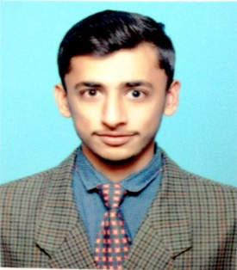
SHAHBAZ
Email: shahbaz.369892@2freemail.com

OBJECTIVE:

Graduate Material engineer with 8 month experience as Trainee engineer in a leading manufacturing company, Heavy Mechanical Complex(HMC) Pakistan. To pursue my dream to have a successful career as a Material engineer in an international market, i am in UAE for job search. I am confident that my communication & interpersonal skills, technical knowledge and ability to go beyond job description for bigger goals of the organization makes me strong candidate for any junior role in an engineering firm.

CAREER PROFILE/SKILLS:

- Above average in quality control testing techniques( both Destructive and Non-destructive testing)

- Well exposed to crystal growth techniques, thin film deposition, ion implantation and photo lithography

- Good knowledge of Heat treatment methods such as annealing, quenching, carburizing etc

- Well knowledge of preparing Metallographic samples

- Above average in casting techniques and forging such as sand casting, die casting, investment casting, impression die forging, open die forging etc

- Welding techniques

- Good verbal and written Communication skills

- Leadership skills

- Team working skills

PROFESSIONAL WORK EXPERIENCE:

Organization:

Tenure:

Heavy Mechanical Complex(HMC), Pakistan (Manufacturing Company like Siemens) August 2016 – March 2017

Designation:

Trainee Engineer

Responsibilities:

- Testing materials to assess how resistant they are to heat, corrosion or chemical attack

- Conduct tests on raw materials or finished products in order to ensure their quality

- Assist in determining appropriate methods for fabricating and joining materials.

- Worked in almost every department of HMC to get trained and exposed to throughout manufacturing processes.

Organization:

Tenure:

Oil & gas development company limited(OGDCL), Pakistan (Oil & gas Company like Saudi Aramco) 01 July 2015 – 29 July 2015
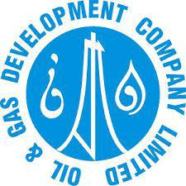

Designation:

Internee

Responsibilities:

- Follow safety protocols and ensure reliable and environmentally responsible operations.

- Recording pressure and temperature readings.

- Assist with maintenance and repair to ensure that machines and equipment’s are functioning according to specifications.

ACADEMIC EDUCATION:

 | DEGREE/CERTIFICATION |  |  | EXAMINING BODY​: |  |  | YEAR
 | Material Engineering |  |  | Ghulam ishaq khan institute of science & technology, |  | 2016
 |  |  |  | Giki, Pakistan.

CERTIFICATION/ ADDITIONAL SKILLS:

o

o

MS Office
Autocad

(All versions, esp. MS Word, MS Powerpoint and MS Excel)
(PTC Creo Parametric software)

TRAININGS & WORKSHOPS:

Occupational health and safety(OHS) workshop

Year - 2016

- Successfully meeting the requirements of Service Excellence Training by GIKI

PERSONAL INFORMATION:

Date of Birth

08 june 1994

REFERENCE:

Reference will be furnished on demand.

