Curriculum vitae
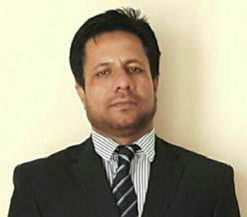

Mohammad
Mohammad.369931@2freemail.com

B.E. (Electrical & Electronics)

CURRENTLY WORKING IN:

Arenco Architectural & Engineering Consultant, as Sr. Electrical Engineer.

SEEKING OPORTUNITIES IN:

Sr. Electrical Engineer/ Lead Electrical Engineer / MEP Manager.

CAREER OBJECTIVE:

A challenging career in esteemed organizations with inherent skills and knowledges of over 19 dedicated years in the field of MEP services; encompassing all aspects of MEP Contracting like Design & Built, Subcontract finalization, coordinating, monitoring and execution till success fully handing over of project.

ACADEMICS.

Bachelor of Engineering. : Electrical & Electronics.
IIT, Bangalore.
Bangalore University, Karnataka, India.
Year of passing. : August 1998

Total Working Experience. : 19 Years (14 years in UAE + 5 years in India).

ADDITIONAL QUALIFICATIONS/SKILLS.

- M/s DEWA approved Engineer.
- M/s Dubai Municipality approved Engineer. Ref# DM/62689.
- M/s Dubai Civil Defense approved Engineer. Ref# DCDS000014414.
- Very well familiar with all local authorities such as Etisalat, Du, Tecom etc.
- Valid UAE Driving License – Light Vehicle.
EXPERIENCE IN UAE (TOTAL 14 YEARS.)

(1) Duration : December 2014 to till date.
Designation : Sr. Electrical Engineer.
Company : M/S Arenco Architectural & Engineering Consultant.
Dubai, UAE.

(2) Duration : November 2006 to December 2014.
Designation : MEP Manager (3 Years) / Sr. MEP Coordinator (5 Years)
Company : M/S ANC Co. LLC.

Dubai, UAE.

(3) Duration : April. 2004 to November 2006.
Designation : Electrical Engineer.
Company : M/S Al Amiri MEP Contracting LLC.
Sharjah, UAE.

JOB DESCRIPTION AS SR. ELECTRICAL ENGINEER:

Over 6 years of experiences in consultancy as Electrical Engineer.

Comprehensive knowledge on all kind of electrical services/systems such as Lighting, Power, Lighting Control/Dimmer System, Lightning/Surge Protection, Fire Alarm, Emergency lighting, , GRMS, CCTV, ACS, PABGM, IP/SMATV etc.

Comprehensive knowledge on all kind of electrical equipment such as LV panels, MDB/SMDB/DB, Cap-Bank, MCC, VFD, Motors, Generators, Pumps, FAHU/AHU/FCU, Chillers.
Comprehensive experience in electrical codes, regulatory standards and criteria for power systems. Well familiar with international standards (IEE, IECC, BS/EN, NFPA, ASHRAE, NEMA) as well as local authorities (DEWA, DM, TECOM, DCD, ZAFZA, DCAA, DU and Etisalat) rules and regulations.

Skilled in ELV systems such as CCTV, ACS, GRMS, PABGM, TEL, DATA, Network Management.
Skilled in formulation of electrical calculations, loads schedule, cable sizing, containments sizing etc.
Responsible for supervising and providing direction to a team of designers, engineers and support personnel.

Ability to monitor, supervises, coordinate and manage staffs.

Technically sound, capable of solving technical problem with hands on experience for all MEP services.
Responsible for coordination and implementation for installation, testing commissioning of MEP services.

Preparation of quotation estimation and cost analysis for all MEP services with thorough knowledge of various aspects of projects, including planning, execution and handing over of projects.

Monitoring various activities related to the project execution, assessment of man power, materials and work progress.
Preparation/review of shop drawing, material submittal, request for information/inspection etc.
JOB DESCRIPTION AS MEP COORDINATOR/ MEP MANAGER:

Over 10 years of experiences in contracting as Electrical Engineer/MEP Coordinator/MEP Manager.
Worked at managing level for MEP coordination of large projects in all kind of working atmospheres.
A liaison between different parties working on the project, coordinate all MEP trade workers with the project's superintendent, subcontractors and project team, as well as manage communication between the subcontractors, field staff, project team and clients, for better coordination and successful/timely completion of the project.

Ability to build rapport and effective relationship with people at all levels. Coordinating effectively with client, consultant, subcontractor, senior staff and team mates.

Offer technical input related to the cost and feasibility of various designs, at the beginning of work at the earliest phase of the project. This includes estimates of the cost of labor, materials and special fees, hiring personnel, including subcontractors, to work on the project's MEP elements.

Studying thoroughly the ongoing activities of the project such as material/shop drawing approval, material deliveries, long lead items, site progress and forecasting to management for effect of same.

Ability to plan and implement modifications and installation in projects.

Attending regular management meeting to discuss operations efficiency. A motive experienced dynamic engineer with a strong aptitude for achieving results.

Effective communication and technical skill to fulfill a role with project, contract, support & procurement. Excellent job involvement for each and every aspect of the project.
Technically sound for all the MEP services, hence can perform better coordination at site.

Projects executed in UAE, as consultant:

- PROCECT: MARRIOTT RESORT HOTELS, B+G+13F.@ Palm Jumeirah Dubai, UAE.
CLIENT: Mr. Abdullah Ahmed Al Moosa.

CONSULTANT: ARENCO Architectural & Engineering Consultant.

- PROCECT: HILTON RESORT HOTELS, B+G+13F.@ Palm Jumeirah Dubai, UAE.
CLIENT: Mr. Abdullah Ahmed Al Moosa.

CONSULTANT: ARENCO Architectural & Engineering Consultant.

- PROCECT: TAJ EXOTICA RESORT AND SPA. B+G+6F.@ Palm Jumeirah Dubai, UAE.

CLIENT: Mr. Abdullah Ahmed Al Moosa.

CONSULTANT: ARENCO Architectural & Engineering Consultant.
(ON GOING)
Projects executed in UAE, as Contractor:

- PROCECT: THE BAY GATE LLC, 2B+G+9P+42F.+2M @ Business Bay, Dubai, UAE.

CLIENT: BAY GATE LLC.
CONSULTANT: Whitby & Bird. Engg. (Rambol).

- PROCECT: BILHAB TOWER, 3B+G+24F.@ Business Bay, Dubai, UAE.

CLIENT: Mr. Abdullah Saeed Abdullah Bilhab Al Ameri. CONSULTANT: Arkiteknik International Consulting Engineers.

- PROCECT: FIFTY ONE TOWER, 3B+G+3P+17F@ Business Bay, Dubai, UAE.

CLIENT: DEYAAR
CONSULTANT: Arab Expert Const. Engg.

- PROCECT: EMAAR SQUARE, 2B+G/P+6F, 2B+G/P+8F 2 Nos.@ Burj Dubai, UAE.

CLIENT: EMAAR .
CONSULTANT: Ian Banham Consultant.

- PROCECT: Upper Crest Tower, G+5P+36F+M+R, @ Business Bay, Dubai, UAE.

CLIENT: DAMAC.
CONSULTANT: ZAS PSE.

- PROCECT: Kings School, G+1F @Umm Suqeim 3. Dubai. UAE. CLIENT: Kings Dubai.

CONSULTANT: Dubai Consultant.

- PROCECT: Kings College, G+2F @Nad Al Sheba, Dubai. UAE. CLIENT: Kings Dubai.

CONSULTANT: Dubai Consultant.

- PROCECT: Kings College, G+2F @Al Barsha, Dubai. UAE. CLIENT: Kings Dubai.

CONSULTANT: Dubai Consultant.

- PROCECT: AAM TOWER OR ARENCO TOWER, G+9P+46F @ Dubai Media City, Dubai UAE.

CLIENT: MR. ABDULLAH AHMED AL MOOSA.
CONSULTANT: CLIENT: CONSULTANT: Arenco Consulting Engg.

Note: My presence was only in T&C period.

- PROCECT: Oakwood Residency, IMPZ, Dubai UAE. 3B+G+18F.

CLIENT: DEYAAR
CONSULTANT: BDPL Gulf Arch & Conslt.

Note: My presence was only in T&C period.
- PROCECT: 14 VILLAS. (G+1) @ Jaflia First, Dubai, UAE. CLIENT: M/s. Mohammed & Obaid Al Mulla L.L.C. CONSULTANT: M/S Al Amiri MEP Contracting LLC.

- PROCECT: 24 VILLAS. (G+1)@ Mirdif, Dubai, UAE.

CLIENT: M/s. Mohammed & Obaid Al Mulla L.L.C.
CONSULTANT: M/S Al Amiri MEP Contracting LLC.

EXPERIENCE IN INDIA (TOTAL 5 YEARS.)

Duration : Sep. 1998 To App. 2004.
Designation : Project Engineer.
Company : M/S Neutro Power and Control LTD.
Mumbai, India.

Followings are some of the important projects executed in India.

- Sea Water Cooling Tower Package for HPCL (Mumbai) refinery.
- Diesel Hydro De-Sulpherization (DHDL) Unit. For HPCL (Mumbai) refinery.

- G+3 HPCL office administrative building.
- G+4 Storey Building. Chembur, Mumbai.
- G+7 Storey Building. Dadar, Mumbai.

SOFTWARE KNOWLEDGE.

Office Automation Tools : AutoCAD, MS-Office (Word, Excel & Power Point)
Operating System : Unix, Windows.
Software language : Assembly (8085), C & C++, VC++.

PICTORIAL PRESENTATION OF MY PROJECTS.

PROCECT: MRRIOTT RESORT HOTELS, | PROCECT: HILTON RESORT HOTELS,
B+G+13F.@ Palm Jumeirah Dubai, UAE. | B+G+13F.@ Palm Jumeirah Dubai, UAE.
CLIENT: Mr. Abdullah Ahmed Al Moosa. | CLIENT: Mr. Abdullah Ahmed Al Moosa.
CONSULTANT: ARENCO Architectural & | CONSULTANT: ARENCO Architectural &
Engineering Consultant. | Engineering Consultant.
(ON GOING)
PROCECT: TAJ EXOTICA RESORT AND SPA. | PROCECT: THE BAY GATE LLC,
B+G+6F.@ Palm Jumeirah Dubai, UAE. | 2B+G+9P+42F.+2M @ Business Bay, Dubai, UAE.
CLIENT: Mr. Abdullah Ahmed Al Moosa. | CLIENT: BAY GATE LLC.
CONSULTANT: ARENCO Architectural & | CONSULTANT: Whitby & Bird. Engg. (Rambol).
Engineering Consultant.
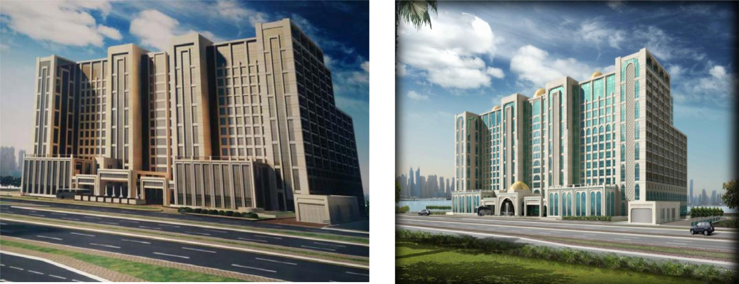
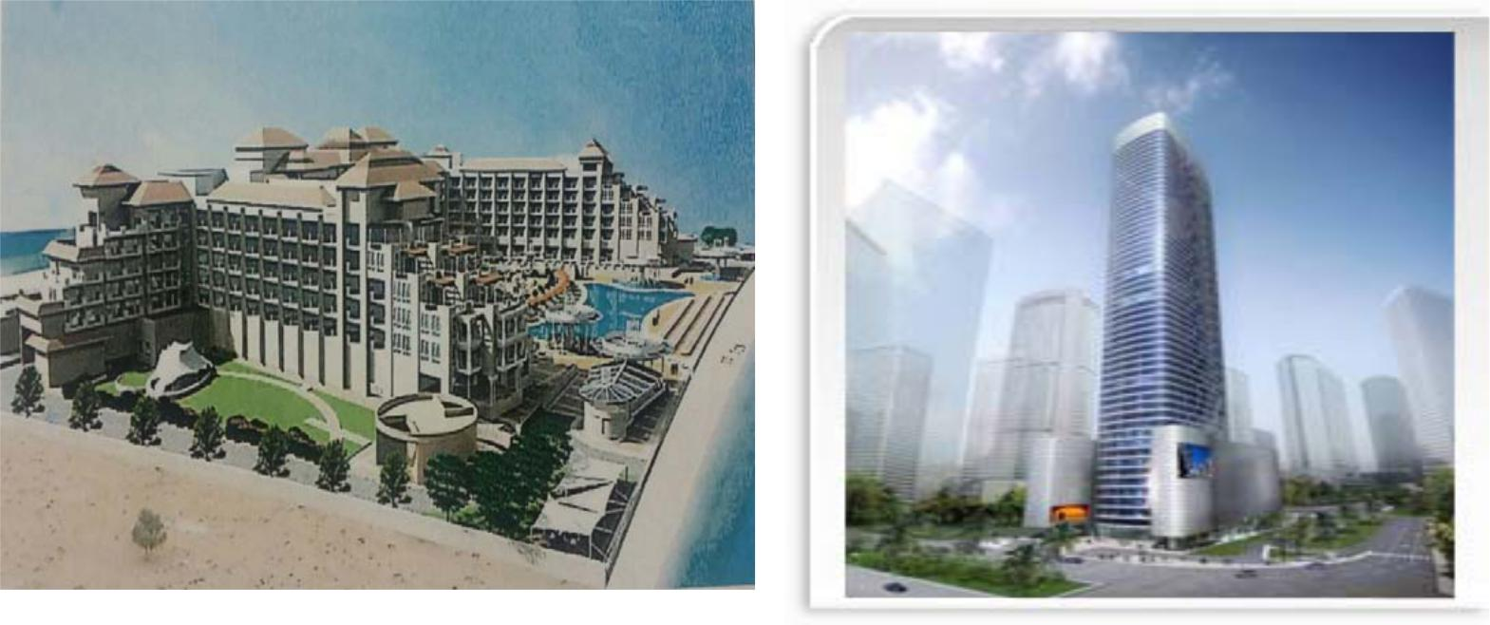
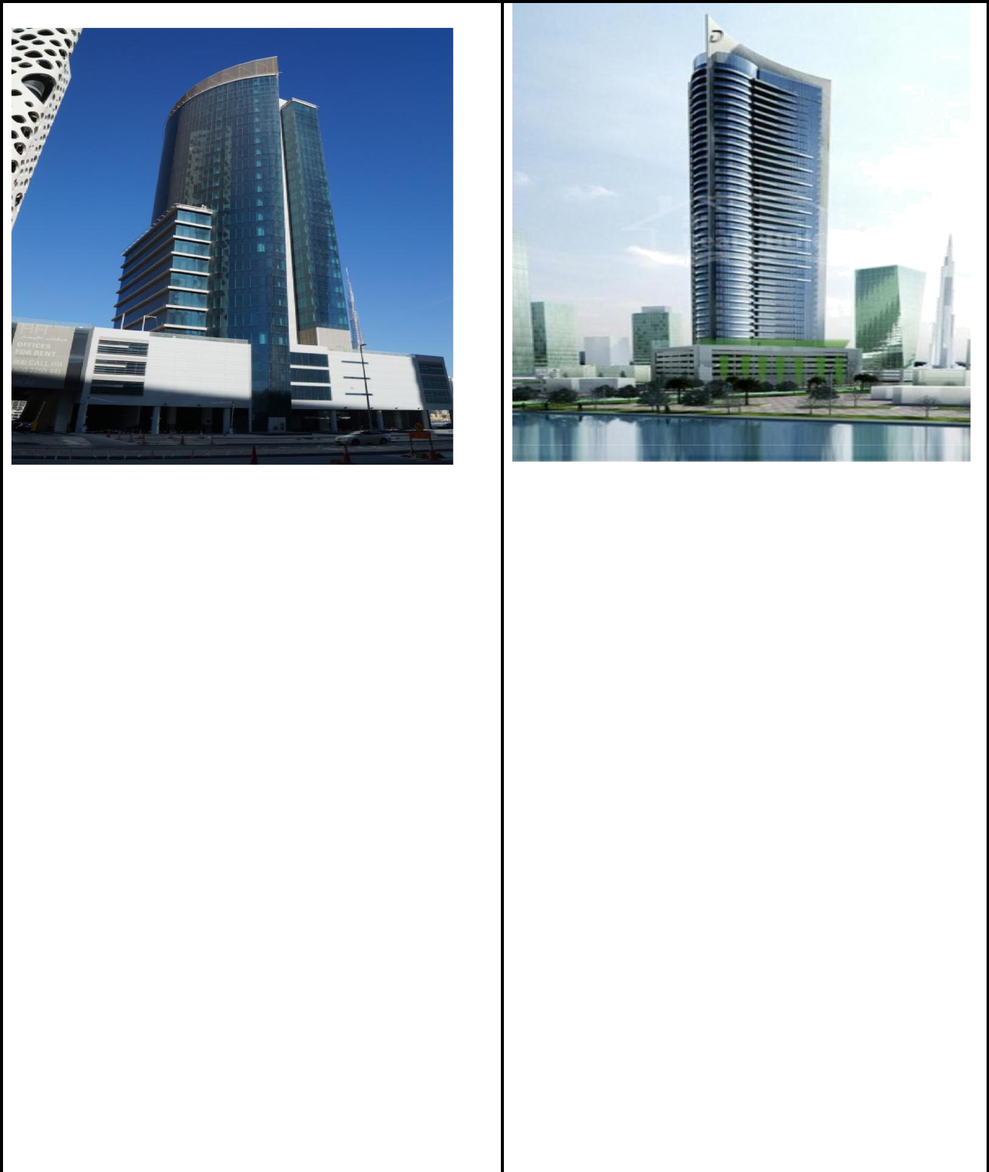

PROCECT: BILHAB TOWER, | PROCECT: Upper Crest Tower,
3B+G+24F.@ Business Bay, Dubai, UAE. | G+5P+36F+M+R, @ Business Bay, Dubai, UAE.
CLIENT: Mr. Abdullah Saeed Abdullah Bilhab Al | CLIENT: DAMAC.
Ameri. | CONSULTANT: ZAS PSE.
CONSULTANT: Arkiteknik International Consulting
Engineers.

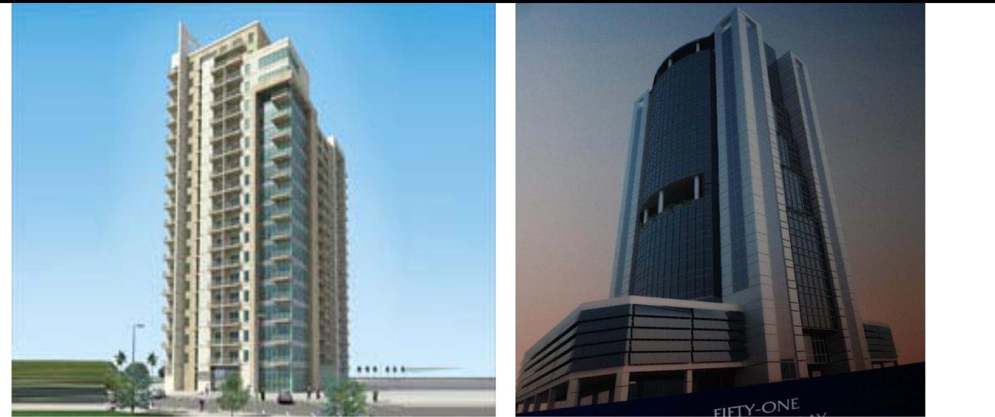

PROCECT: Oakwood Residency, IMPZ, Dubai | PROCECT: FIFTY ONE TOWER,
UAE. 3B+G+18F | 3B+G+3P+17F@ Business Bay, Dubai, UAE.
CLIENT: DEYAAR. | CLIENT: DEYAAR
CONSULTANT: BDPL Gulf Arch & Conslt. | CONSULTANT: Arab Expert Const. Engg.
Note: My presence was only in T&C period.

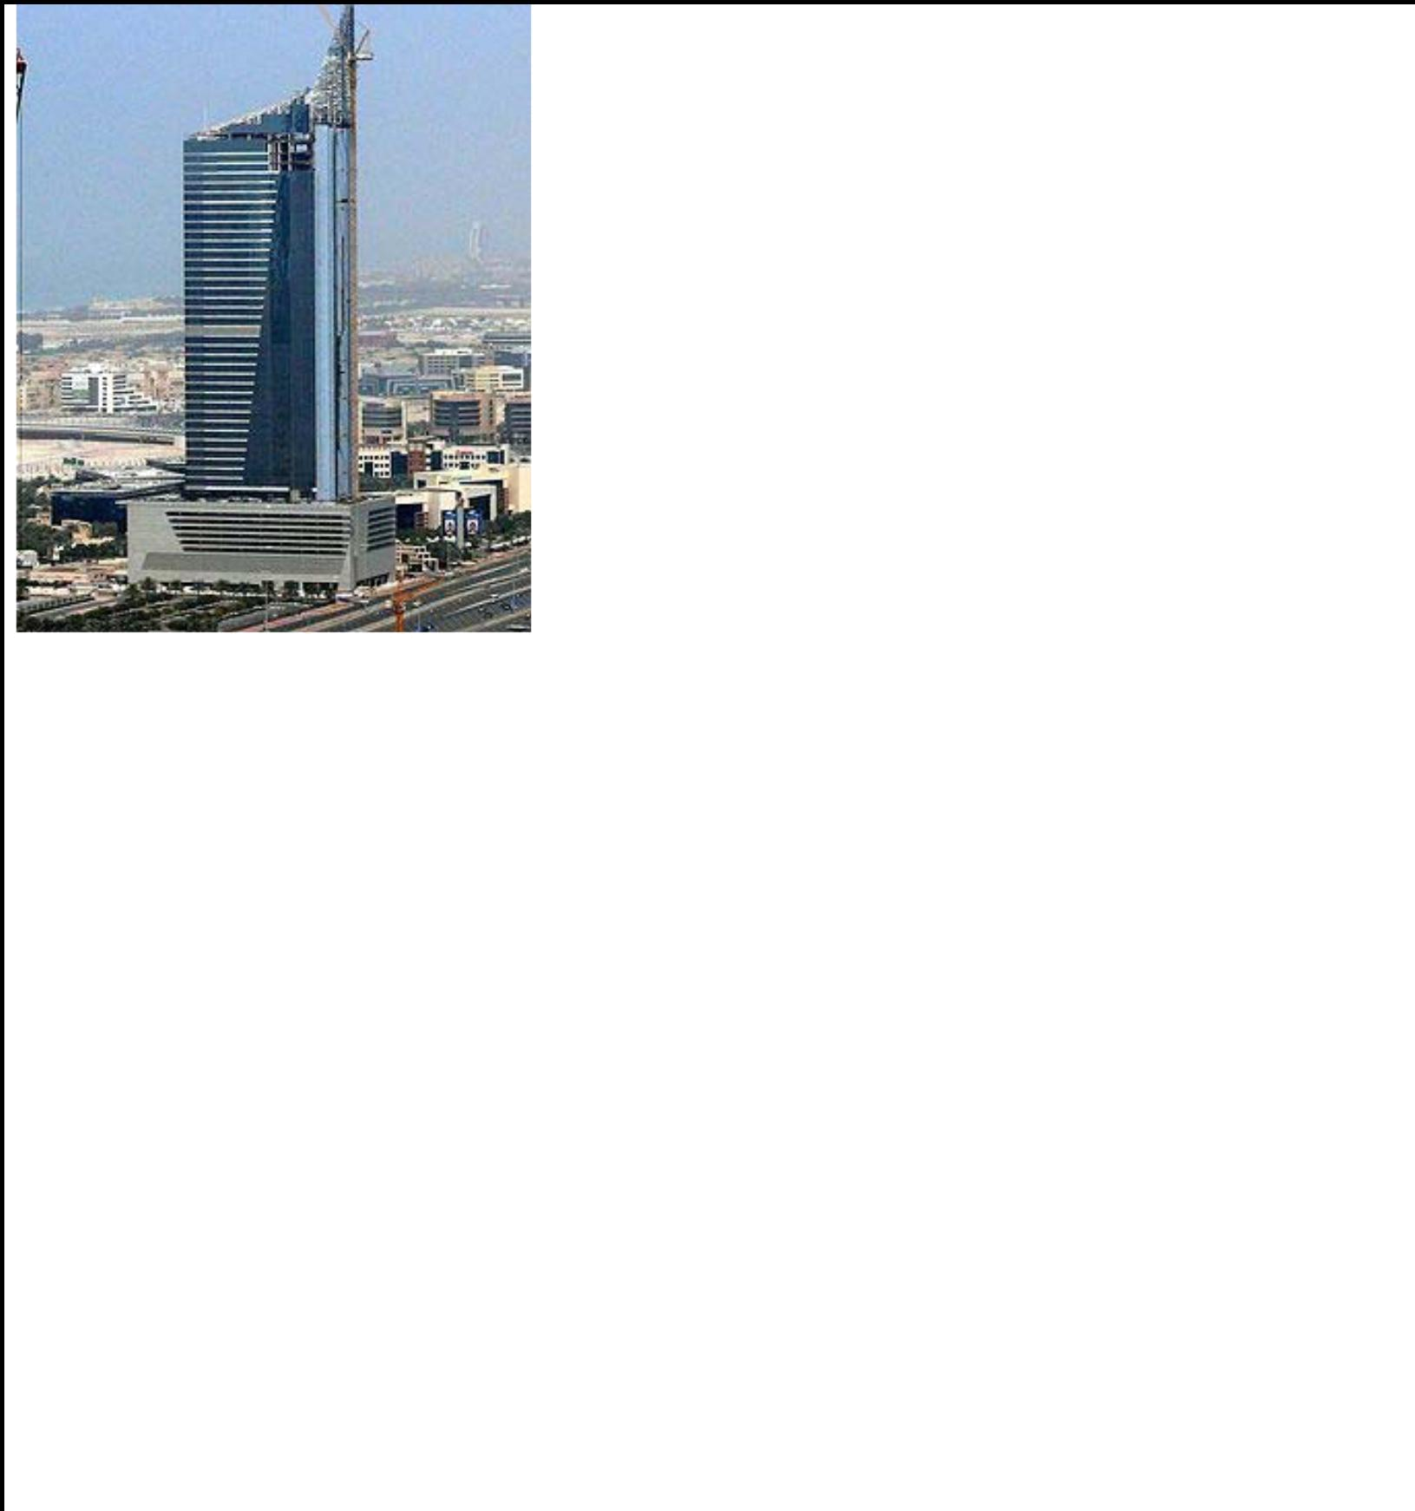

PROCECT: AAM TOWER OR ARENCO TOWER, G+9P+46F @ Dubai Media City, Dubai UAE.
CLIENT: MR. ABDULLAH AHMED AL MOOSA. CONSULTANT: Arenco Consulting Engg.

Note: My presence was only in T&C period.
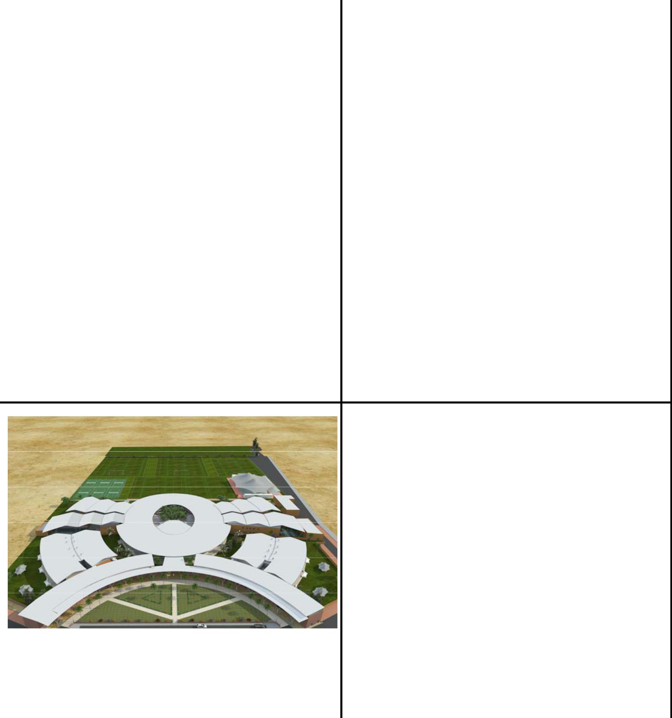

PROCECT: EMAAR SQUARE, 2B+G/P+6F,

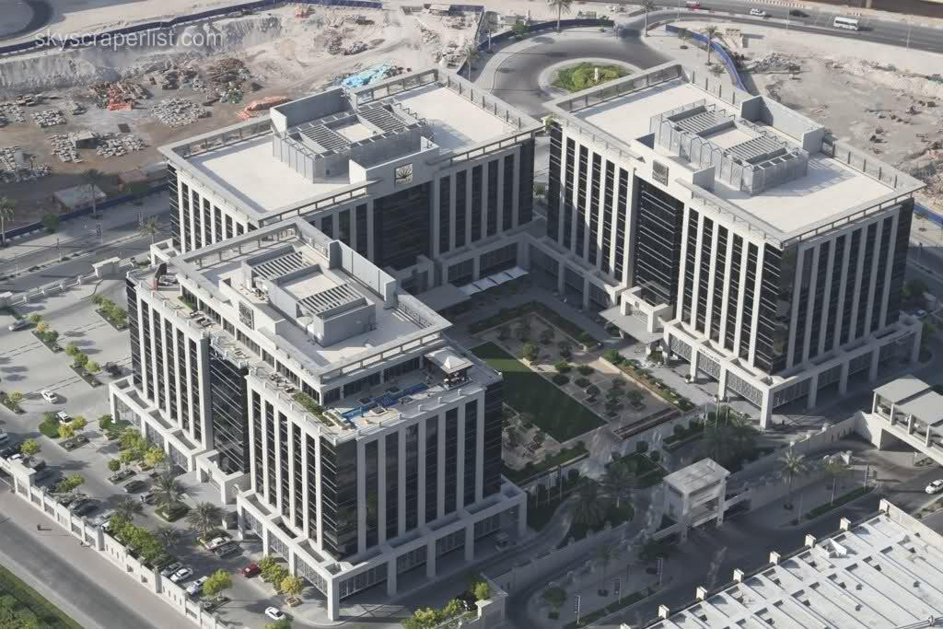
2B+G/P+8F 2 Nos.@ Burj Dubai, UAE.
CLIENT: EMAAR .
CONSULTANT: Ian Banham Consultant.

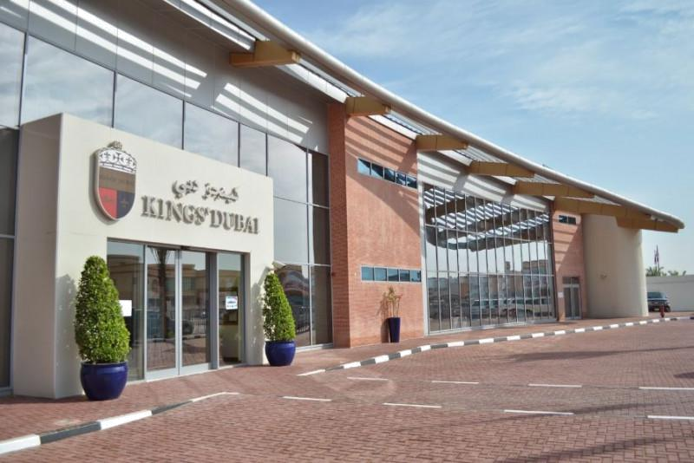

PROCECT: Kings College, G+2F @Nad Al Sheba, | PROCECT: Kings School, G+1F @Umm Suqeim
Dubai. UAE. | 3. Dubai. UAE.
CLIENT: Kings Dubai. | CLIENT: Kings Dubai.
CONSULTANT: Dubai Consultant. | CONSULTANT: Dubai Consultant.

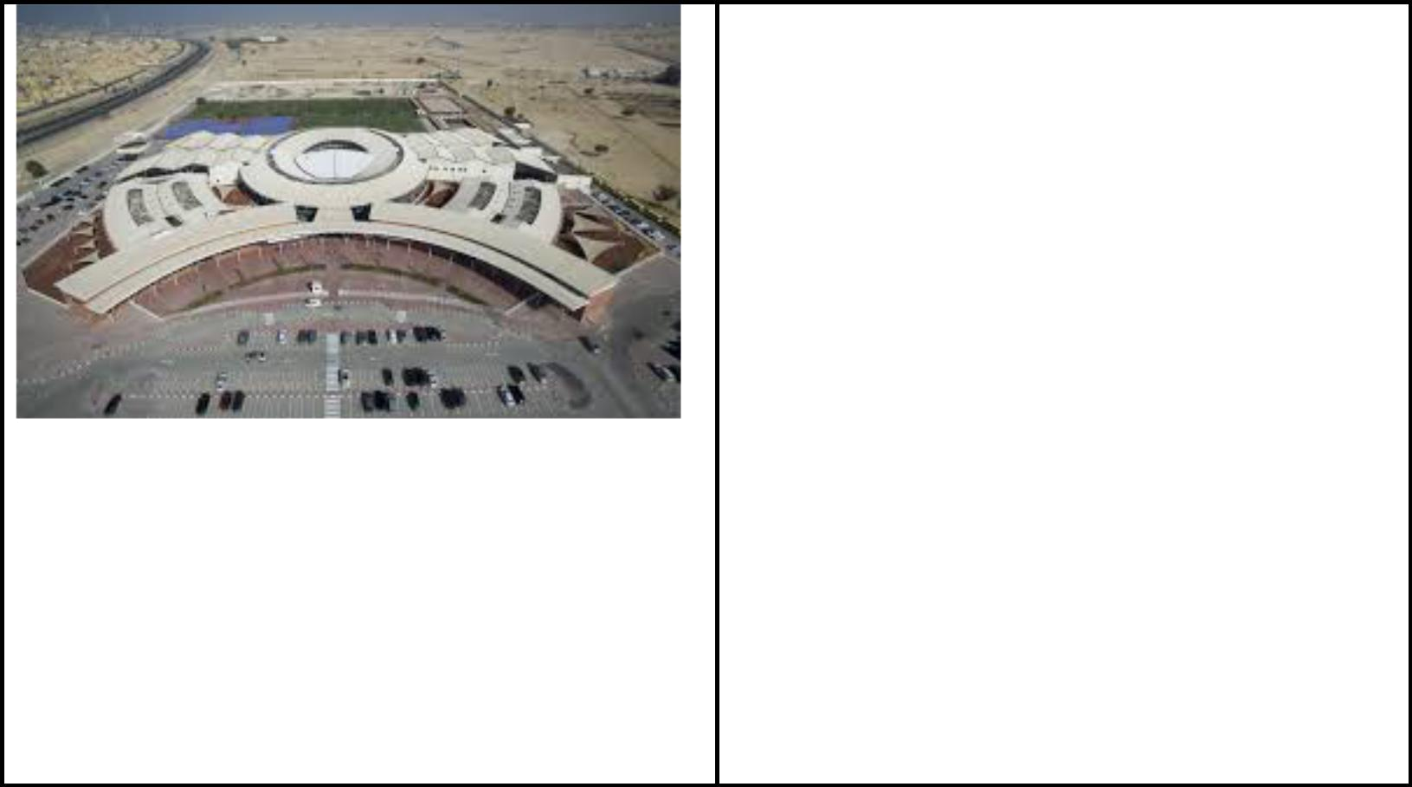

PROCECT: Kings College, G+2F @Al Barsha,

Dubai. UAE.
CLIENT: Kings Dubai.
CONSULTANT: Dubai Consultant.

May I take this opportunity to explore possibility of a career with your reputed organization with proven track record? I am sure to live up to your expectation. I attach a brief resume of my career (to date) for your reference, consideration and perusal.

