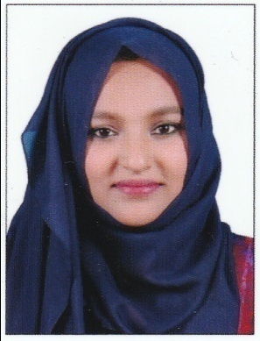
NAZIYA

Naziya369936@2freemail.com

PROFESSIONAL SUMMARY

Focused analytical civil engineer with two years of experience. Excellent communicator accustomed to working in teams and individually. Successful at cost estimation and drafting.

WORK HISTORY

Junior engineer, Dream Touch Designers  (06/14 – 08/16) | - Inspected project sites to monitor progress and adherence to design specifications, safety protocols and state sanitation standards.  - Estimated quantities and cost of materials, equipment and labor to determine project feasibility.  - Analyzed survey reports, maps, blueprints and other topographical and geologic data to effectively plan projects.  - Visited project sites during construction to monitor progress and consult with contractors and on-site engineers.  - Drafted detailed dimensional drawings and design layouts.  - Planned and coordinated work requiring modification of standard engineering techniques, procedures and criteria.  - Served as onsite project representative to clients and crewmembers.  - Edited project reports, specifications, plans, construction schedules, environmental impact studies, permits and designs.  - Drove business growth with positive client relations and staff development.  - Verifying and checking of invoices and claims from suppliers, vendors & subcontractors and ensure that project expenditures are captured and properly recorded.

EDUCATIONAL QUALIFICATION

B. Tech,  Vidya Academy of Science & Technology, Civil engineering  2010- 2014 | - 6.82 GPA  - Advanced AutoCad courses.  - Completed a project called structural designing analysis and estimation of a shopping complex. It was aimed to design the structural components of a shopping complex, analysis of the frames and finally estimation of whole structure.  - Presented a seminar paper about green walls and the various techniques for developing it.
Plus two,  G.H.S.S Edappally,  2008- 2010 | - 86 percentage of marks
S.S.L.C,  St.Antonys H.S.S,  Kochi 2008 | - 97 percentage of marks

SKILLS

- Autodesk AutoCAD
- Bentley STAAD Pro.
- C++
- Microsoft Office

- Construction site management
- Cost estimates
- Client relations
- Residential planning

ADDITIONAL INFORMATION

- Intern at Cochin port trust for 5 days.
- Intern at ULCCS for 5 days.
- Industrial visits to many sites and dams, including Kochi metro.
- Attended 2nd international conference EPSICON 2014.
- Attended 3 day workshop on power communication M- Power

ACHIEVEMENTS

- Central government of India Scholarship recipient.
- Paloli Mohammed committee Scholarship recipient.
- Kerala Wakf board scholarship recipient.

PERSONAL PROFILE

- Date Of Birth : 16th Oct 1992
- ationality : Indian
- Religion : Islam
- Marital Status : Married
- Known Languages : English, Hindi and Malayalam
- Strengths : Optimist, Confident, Fast Learner, Leadership, Responsible, Adaptable
- Interests : Reading, Adventure, Travel

DECLARATION

I hereby declare that the above statements are true and correct to the best of my knowledge and belief.

Place : Kochi Name: Naziya Hameed

