Curriculum vitae
Fatma

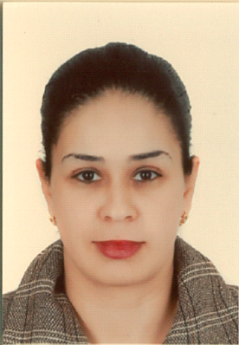

Profile:
A highly energetic and enthusiastic judo coach. I competed at a very young age but I chose to go into coaching rather than pursue my career in competitive judo.I like to train someone that does not fit in with team sports, a shy person or maybe someone that has been bullied! Judo gives that person confidence, some self-esteem. It gives them a feeling of achievement and using the grading system gives that child something that is measurable
Personal details:
- Date & place of Birth: January, 21st. 1982. Safax/Tunisia
- Nationality: Tunisian
- E-mail: fatma.369952@2freemail.com
Education and qualifications:

- 2002:Ellissa Secondary School (Tunis) =Third-year certificate in Economics 0and Management.
- 2010: Ministry of Youth and Sports= First grade coach certificate,
- 2013: Tunisian Judo = Certificate of recognition of second degree black belt

Sports track at the national level:

- 1995-1996 – Club SportifSfaxien

- 1997-1998: Club SportifSfaxien

- 1999: Tunisian national team for juniors and Intermediates

- 200-2004: Tunisian national team for Majors

Achievements on the International scale:

- Courses | - Awards and certificates
- Berlin International Open | - The 7th Place in Germany + A certificate of participation
- Bologna International Open | - The 7th Place in Bologna + A certificate of participation
- Hungary International Open | - The 5th Place in Hungary + A certificate of participation
- Tunisian International Open | - The 4th place in Tunis
- Championship Maghreb | - Bronze medal
- Arab Championship | - Golden Medal In Egypt
- 2001 Mediterranean Games in Tunisia | - 3rd place and a Bronze Medal

Experience in coaching
- A trainer in a Police`s Club for individual games in Bardo/Tunis.
- A trainer in a Women`s Club for individual games in Sukra/Ariana.

The results obtained in the field of training

- The Program | - Awards
- Winter Championship for Minors. | The first place cup, Juniors and Minors
- Spring Championship for Minors. | 2 golden and 3 bronze medals
- Final National Single Championship for Minors | 1 bronze medal
- The national championship for the promotion of sports centers | The 4th Place for the title of (the Best teacher)
Achievements of Players, who received my personal coaching:

During the Winter Championship for Young and Minors: 2014-2015
Names / Medal
- YosraNafati / Gold
- Yasmine Moumni/ Gold
- Aziz Guizani / Bronze
- OssamaMansri / Bronze

During :Spring Championship for Young and Minors: March 2015

- Aziz Al Guizani / Bronze
- Sohayl Al Guizani / Silver
- OssamaMansri / Bronze
- Yassine Al Naffati / Bronze
- Yasmine Moumni/ Bronze

During :Tunisian Championship for Minors: March 2015
- Khalil Kraidi / Gold
- Ibtihel Wada / Silver
- Mariem Al Tabii / Bronze
- AyaBarhoumi / Bronze
Other skills
- Computer analytic skills
- Communicate at all levels
- Patience
- Tolerance
- Able to listen and be objective with advice
- Provide constructive critic

Languages:

Arabic: native
French: advanced
English: advanced

