CURRICULUM VITAE

ABDUR

EXPERIENCE

YEAR 2012 - 2017

MAY 2016 – Current Job

Working as an Architect Supervisor at RAWDH ALKHUZAMA

Riyadh 11311

Kingdom of Saudi Arabia

PROJECTS:

Al Saab Palace

Marriage halls and conference area for 500 people capacity.

Location- AL Duwadimi Kingdom of Saudi Arabia.

Area- 40000 m2

Work stage- Completed

Project Year- 2015-2017

Baba House

Villa for Muhammad Al Saab Family.

Location- Al Quwaiiyah near Riyadh city, Kingdom of Saudi Arabia.

Area- 1222 m2

Work stage- Completed

Project Year- 2016-2017

Tower-2

Residential tower of 16 floor, each floor having 4 apartment of 4 BHK.

Location- King Fahd Road, Dammam, Kingdom of Saudi Arabia.

Area- 1800 m2

Work stage- Finishing level

Project Year- 2016

Hotel-3

5 Star Project Hotel with capacity of 60 rooms and 20 Suites.

Location- King Abdulaziz Road, Dammam, Kingdom of Saudi Arabia.

Area- 2610 m2

Work stage- Structure Finished

Project Year- 2016

Tower-3

Residential tower of 18 floor, each floor having 4 apartment of 4 BHK.

Location- Near Tower-2, King Fahd Road, Dammam, Kingdom of Saudi Arabia.

Area- 1920 m2

Work stage- Foundation Level

Project Year- 2017

July 2015 – April 2016

Working as an Architect at Design Arch (DASNAC) ECE House

28A Kasturba Gandhi Marg

New Delhi 110 001

India

Work on major Projects of Residential and commercial.

CMD House at hanuman road CP Central Delhi.

- Interior and facade treatment planning.

- Internal and external views.

- Furniture shop drawings

- Tower 3 planning and architectural works

- Interior and facade treatment planning.

- MEP

January 2015 - July 2015 (7 month)

Architecture Internship, Elegant Design Solution, New Delhi, India.

Work on major Projects of Residence.

- Villa of Abinash Nath @ Barpeta, Assam.

- Institute of Mr. Amar Yadav, Gtb Nagar career endeavor academy Pvt. Ltd.

- Mr. Kulvinder Singh villa @ indri. Padma villa. Prop.

- Planning of Padma villa @ phoosgarh, Distt. Karnal. (Haryana).

May 2014 - December 2014 (8 months)
Worked as a trainee RSP Design, Alaknanda, New Delhi.

Work on major Projects
- Housing for central green pride nit, Faridabad.

- Club design for Bhushan power & steel limited Delhi.

June 2013 - December 2013 (7 months)
Worked as a trainee Prabhat Kumar Asso. Dhaula Kuan, New Delhi.

Work on major Projects

- Auditorium for disables in Rohini, New Delhi

- Residence - nirvana Country, Gurgaon

May 2012 - November 2012 (7 months)
Worked as a trainee Vivek Khanna and Asso, Lajpat Nagar, New Delhi.

Work on major Projects

- Engineering block, Jamia Millia Islamia

- Indian bank, Jamia Millia Islamia

- Physiotherapy block, Jamia Millia Islamia

ACADEMICS

YEAR 2010 - 2015

Thesis

Integrated Institute and Vocational Training Centre, Basti, Utter Pradesh.

Urban Design

Jamia After metro.
Redesigning of Jamia Precinct - Extension market place.

Design Projects

Group Housing - A project emphasizing on sustainability through architecture a community living in a contemporary context.

ACHIEVEMENTS

YEAR 2010 - 2015

- Certificate of Participation in International Workshop on (Inclusive Planning and Architecture) Gender Research Center.

- Certificate of Participation In art exhibition held in international conference on Islamic arts & architecture.

- GGIF – Municipalika urban innovation challenge.

- MCD – Sports complex design east Delhi.

- Earth quake engineering workshop (Organized by IIT Kanpur).

- Green architecture works (Organized by IIT Bombay).

- Completion Certificate of foundation course on AutoCAD by Autodesk.

- Completion Certificate of Autodesk Revit course by Autodesk

ACTIVITIES

YEAR 2010 - 2015

2010 International conference for Islamic arts & architecture, Jamia Millia Islamia, new Delhi
2010 Manifold- art exhibition,

Jamia Millia Islamia, new Delhi.
2010 Urban mobility India conference on sustainable urban transport:
Accessible and inclusive cities.

2011 Ink students work exhibition, Jamia Millia Islamia, New Delhi (Won first prize in class display).

IWIPA- international workshop on inclusive planning and 2011 architecture

(organized by Etsab, Spain and Jamia Millia Islamia, new Delhi)

conference cum exhibition on sustainable mobility organized
2011 by:
urban mobility India (fellowship program)

2011 National seminar series-“architecture for masses-iv” on urban Regeneration.

Jamia Millia Islamia, New Delhi.

2011 international conference for Islamic arts & architecture, Jamia Millia Islamia, New Delhi.

2013 national seminar series on architecture for masses Jamia Millia Islamia, New Delhi.

workshop on earthquake resistant design practices for UG
2013 students of

architecture,
IIT Kanpur.
competition organized by Municipalika on “good urban
2013 governance for
safe, healthy,

Green, inclusive smart cities.”
2014 Green architecture workshop organized by:

IIT Bombay.

EDUCATION

Batch 2010 – 2015

Bachelor of Architecture from F/O Architecture & Ekistics, Jamia Millia Islamia, New Delhi INDIA.

Division- First (74 % in Aggregate).

Schooling- Jamia Senior Secondary School, New Delh

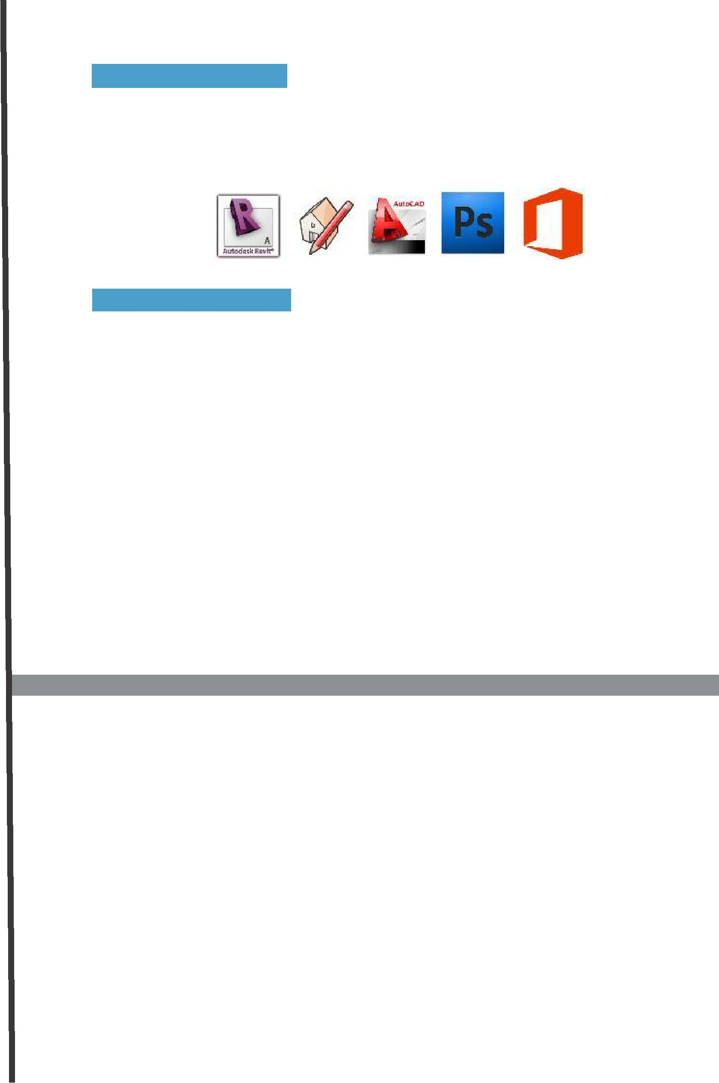
SOFTWARE SKILLS

- Revit Architecture 2014 o Sketch up Pro 8.0, V-ray

- Autodesk AutoCAD 2011

- Adobe Photoshop CS5, Adobe InDesign CS5, Adobe Illustrator CS5, o Microsoft Office Suite,

CAREER OBJECTIVE

To work in pragmatic way in an organization where I can show my talent and enhance my skills to meet company goals and objective with full integrity and zest where I can utilize all my knowledge and skills to the optimum level possible, which offers and helps me grow professionally while being resourceful, innovative and flexible, also work as a key player in a challenging and creative environment that tempts me to implement and visualize new ideas, to explore myself and enhance my skills for the betterment of the organization

ABDUR

Date of birth: January 2, 1991

Age: 25 yrs.

Sex: Male

Nationality: Indian
Language: English, Hindi & Urdu
Marital Status: Unmarried

Interests: Architecture, Sketching, Media and Travelling.

CONTACT

Email : abdur.369954@2freemail.com

Declaration: I hereby declare that the information given by me is authentic to the best of my knowledge.

Place: New Delhi ABDUR

