HITESH  Email: Hitesh.369964@2freemail.com  Personal Data  Date of Birth: 10th July, 1986  Nationality : Indian  Languages Known: English,  Hindi & Gujarati  Driving License: Emirates Driving License from Aug 2009. (Light vehicle Automatic Gear)  COMPETENCIES  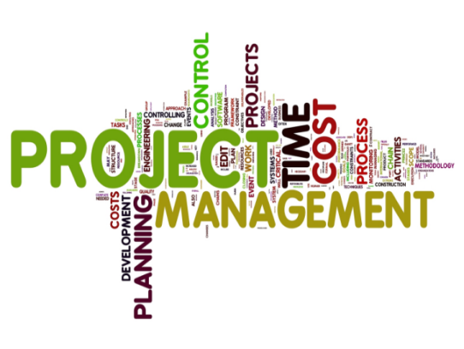  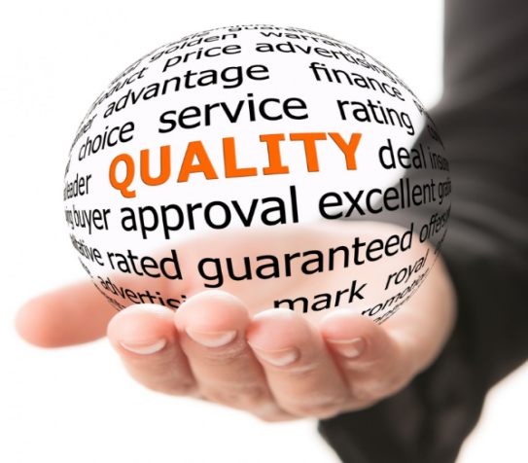  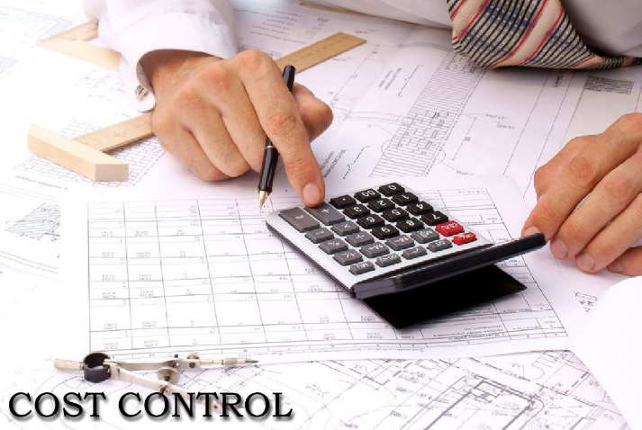  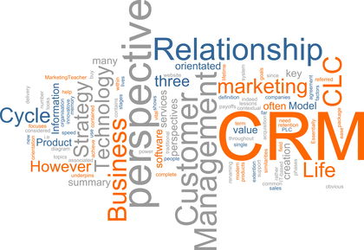  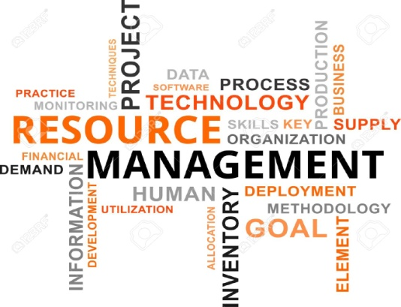  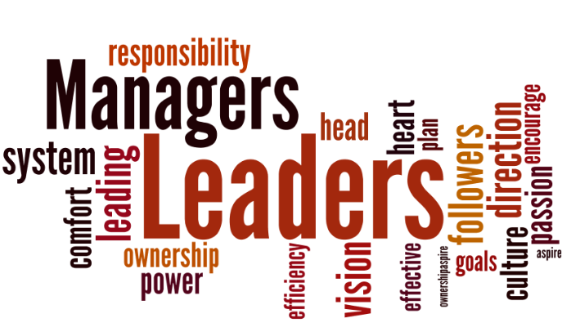 | JOB OBJECTIVE  To work in challenging and responsible position where I can apply and improve my knowledge and skill to contribute to a dynamic and growth oriented organization in the field of Senior Project Engineer. I uphold 12 Years experience in Project Management, site management, Fabrication Operations, Quality Assurance, Designing & Development, Resource Management, Cost Control, Client Relationship Management and Team Management. I am looking forward for an opportunity at senior level position in reputed organization.  EMPLOYMENT CHRONICLE  Apr’15 – Till Date  HPPT ( High Performance Products Trading-DMCC & EPC contractor), Dubai – UAE working as Senior Project Engineer.  Project: EPC Project ( PP/PE Packaging plant ) at KIZAD Abu Dhabi  Client: ADT ( Abu Dhabi Terminals )  Description: Total project includes supply, installation and performance test for PP/PE packaging machines in packing plant, which includes German machine supply, hoppers, tilting frames, compressor room & instrument/conveying piping work  Key Result Areas:  - Strengthening good relationships with clients, other project team members, contractors & PMC  - Assisting technically to check on interfaces with other sub-contractors & their supplies  - Supervising for the purpose of project progress & identifying improvements & efficiencies  - Consulting draft on behalf of the project team correspondence  - Keen-eye on ensuring risks to key milestones are captured & flagged accordingly  - Monitoring regular updates to the management board by creating presentations & project progress report as necessary; weekly meetings with client & PMC to discuss on interfaces  - Coordinating with internal project team members and assisting the main Project Manager  - Preparing project documentation like approved drawings, variations records, design change requests, NCRs, Inspection reports & others to keep on track  Project: EPC project (Catalyst logistics plant) at KIZAD Abu Dhabi  Client: Schmidt  Description: Total project includes supply and installation of conveying/instrument air piping, electrical wiring work for Siemens control panels like DCS panel, customer supplied instruments/machines like tilting frame, compressor, blower, filters, unloading below and Siemens instruments.  - Leading project with overall responsibility for delivery of the project from financial close to commercial operation within budget and schedule  - Significantly handling contract variation orders and claims with support from the Owner’s Construction Site Manager & the site team  - Key role in troubleshooting for various site problems with innovative ideas and solutions  - Accountable for all company supply and activities on site is on satisfactory level and give better image of company in front of client  - Maintaining commercial proposals & technical inputs for new projects and inquiries  Jul’14 – Mar’15  Tekzone Electromechanical Works ( LLC ), Ras – Al - Khor, Dubai – UAE as Sr. Project  Engineer  Key Result Areas:  - Formulated mechanical designs at the Pre & Post contract stages and timely preparation of the design review deliverables for ADT packing plant project at Khalifa Port Abu Dhabi  - Oversaw the activity related to site planning for checking and notifying party for the required material, services, outside support or equipment for next 7-10 days on site to verify and confirm the required material availability on site  - Liaison with other sub-contractors, PMC and client by attaining weekly review meetings to discuss on project schedule, schedule plans, clashes on activities & loop holes identification  - Maintained and prepared weekly and monthly progress reports and updating the schedule based on daily site activities  - Responsible for establishing requirements for sub-contracting of works like fabrication, installation and others as per site requirements  Aug’07 – Jun’14  Ferrofab FZE, Jebel Ali Free Zone, Dubai–UAE as Sr. Project Engineer at Production Workshop  Key Result Areas:  - Looked after various requirements & monitoring overall production operations for ensuring timely completion  - Effectively managed production operations for strategic utilization & deployment of available resources to achieve the organizational objectives.  - Followed up activity at sites, estimating the costs within budget, planning for cash flow requirements, etc.  - Undertook operations like studying drawings, plans or patterns of structures to be made or repaired as per requirements  - Steered efforts in eliminating redundant / obsolete processes involved in the design, development processes & working towards value-addition  - Liaison and coordinated with the customer and coordinating the other services for preparation of project; handling equipment, material inspection and report keeping  - Responsible for leading, mentoring & monitoring the performance of Engineers & other Technical peoples to ensure efficiency in process operations and meeting of project targets  - Build dynamic environment that fosters development opportunities and motivates high performance amongst team members  Highlights:  With Ferrofab FZE, Jebel Ali Free Zone, Dubai – UAE  - Successfully completed execution of projects starting with prepare initial project layout, technical support to other dept, monitoring of project and to ensure scheduled completion of project  - Meticulously planned scheduled, conducted and coordinated technical & management aspects of project  - Merit in handling projects for different clients and projects includes separator Vessels, glycol contactors, cement silos, surge vessels, K O drums etc.  - Played a stellar role in:  - Executing major project from PGI, to ensure tight delivery of Production Separator, Slug Catcher, Degasser and Dehydrator  - Developing and manufacturing for all kinds of Dish Heads, Cones and Transaction Sections, Pipe Rolling and Bending  - Devising an Excel and Auto-CAD Method for develop Petal segments used for construction of Petal Dish Heads (Hemispherical and Ellipsoidal Dish Heads)  - Scheduling and Monitoring the project  - Exposure in projects like Burner Booms, Storage tanks, Air Receivers, Filter tanks, Pig launchers, Media filters etc.  - Developed a Pipe Bending Machine for in-house use up to 24” dia X 1 ½” thickness  - Served as Production Supervisor for different kinds of pressure vessels, structures and pipeline work  - Maximized all kinds of production activities like cutting, bending, rolling, welding, NDT, inspection coordination, hydro testing, etc.  - Actively participated in developing all type of cones (concentric, eccentric & tori-cones), transition structure, and crown - petal dish heads, etc.  - Evaluated and maintained the mechanical data sheets and engineering drawings for vessels  Larsen & Toubro, Hazira Works, Surat, Gujarat, India. On Planning engineer  position: Since  April 2005 till July 2007  Key Result Areas:  - Functioned as Planner for Indian Defence Project  - Monitored the sub-contracting functions of different fixtures to outside venders  - Pivotal in:  - Project co-ordination with shop floor and other departments  - PCR (Plate Cutting Request) in co-ordination with Material Control Department  - Dimension Tolerance Sheet on AutoCAD for Production and QC Department  ACCOMPLISHMENTS ACROSS THE TENURE  - Served as internal auditor for Latest Version of ISO 9001:2008  - Acted as internal auditor for Latest Version of ISO 14001(HSE) & 18001(OHSAS)  ACADEMIC QUALIFICATION  2004: Diploma in Mechanical Engineering from T.E.B., Gujarat (Dr. S. & S. S. Gandhi Collage, Surat,  Gujarat  IT SKILLS  Conversed with:  - MS Office  - AutoCAD (2D & 3D)  - Internet Applications  In view of the above, I request you to be kind enough to give an opportunity to serve your esteemed organization in the capacity mentioned above for which act of kindness, I shall be very thankful and grateful to you.  DATE :  HITESH

