C.V Quality Control Engineer 12y
ihab.369996@2freemail.com

Experience in contracting (MEP)
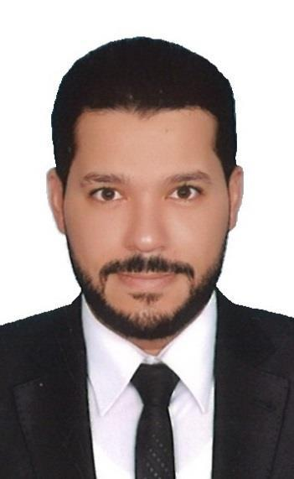
Personal Data:

Name: Ihab

Nationality: Egyptian

Marital Status: Married

University: Academic Monographs-Tanta University

Graduation Year and Degree: 2005: Good

Courses: Total Quality Management TQM program in 2005 - Sadat Academy

Employment History & Experience:

1. AXAL KSA (Arabia construction company limited) (MEP)

From July 2015 to January 2017

Job Role: Senior Engineer quality control

  - Contractor: Saudi Binladin Group

- ANEL KSA Company . Contracting (MEP) From September 2012 to July 2015

Job Role: Senior Engineer quality control & Technical support for materials

  - Contractor: Saudi Binladin Group

  - The project: Al Haramain High Speed Railway Makah Station

  - The cost: Four hundred million saudi riyals

My experience

-Heating, Ventilating and Air-conditioning Systems (HVAC)

• Air handling units (AHU) • Fan-coil units (FCU)

• Water chillers • Related air ducts and pipes

• BMS systems

-Fire Fighting System (FF)

•Sprinkler •Fire hose cabinets

•Fire valves and accessories •Integration with fire alarm systems

•Fire hydrants •Water mist systems

•Related piping •Clean agents & FM200 fire extinguishing systems

-Plumbing (PL)

•Potable water (cold & hot) •General drainage

•Waste water •Storm wate

3. Saudi Binladen Group

From September 2011 to September 2012

Job Role: Quality control engineer

  - Contractor: Saudi Binladin Group

  - The project: King Abdul-Aziz International Airport . Jeddah

  - The cost: Two hundred million saudi riyals

- Morsalah international Saudi Arabia- Riyadh

From April 2010 to April 2011

Job Role: Quality control engineer

•Contractor: Ministry of petroleum

•The project: King Abdullah University of Science and Technology

•The cost: One hundred million Saudi riyals

- Al-Gihaz holding Ksa. Saudi Arabia – Riyadh From February 2008 to February 2010

Job Role: Quality control engineer

•Contractor: Ministry of petroleum

•The project: King Abdullah University of Science and Technology

•The cost: One hundred million Saudi riyals

- Al-Sherif Food & Beverage Factory. Egypt

From August 2005 to September 2007

Job Role: Quality control engineer

I was in the quality control department. My responsibilities were to apply in conformity with standards to get a high quality production with no defects. And I was supervising on the periodical machines maintenance.

Trainings:

1- Ezz El-Dikhyla Steel Factory (Quality Control Engineer)

2- Toshiba Al-Arabi Factory (Quality Control Engineer)

3- Pepsi Factory Tanta Branch (Quality Control Engineer)

4- Cloth Weaving Factory Elmahala Al-Qupra (Quality Control Engineer)

5- Alexandria Factory For Oil & Soap Kafr El-Zayat (Quality Control Engineer)

This data is correct and under my own responsibility

