CURRICULUM VITAE
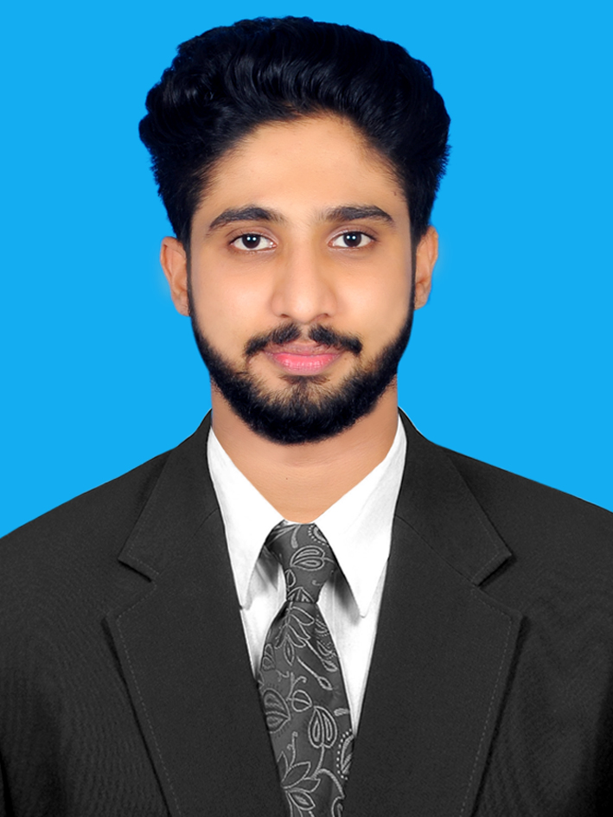
MOHAMMED

E-MAIL: mohammed.370022@2freemail.com

CAREER OBJECTIVE

To obtain an MBA (Master Business Administration) career that makes me utilize the knowledge and skills that I have acquired during my education and to work for the growth of an organization.
Applying for :- Human Resources, Administration, Accounting, and Marketing
EDUCATIONAL QUALIFICATIONS

- MBA (Master Business Administration) from Sahyadri college Engineering and Management Mangalore D.K with first class in 2016
- BBM (Bachelor of Business Management) from Nalanda Collage Arts and science Perla, Kasaragod with first class in 2014
- Class XII from Higher Secondary Education Board with 76% in year 2011.
- Class X from High School Education with 68% in the year 2009.
EXPERIENCE

- Star Dessicated Cocont Industry Kundpura :- Two year worked in at administration of the company at the year of 2014 to 2016
- Star Desiccated Coconut Industry Kundapura :-Two month Internship Training and project work, the topic about “Computer Based Training and Development Programme” at under graduate level under kannur university
- KVR CARS Maruthi Suzuki Company: - Internship Training and Project Work, about “Employees Performance appraisal” at Post graduate level under VTU (Viswasaraya Technology University) Belgavi.
COMPUTER PROFICIENCY

- Business Management software:- TALLY,SPSS, Microsoft Excel, Microsoft Word, Microsoft PowerPoint
- Operating System known: Windows XP, Windows7, Windows 8, Linux.

EXTRAS

- Won Grade A in Kerala State Youth Festival representing Kasaragod Dist.
- Played cricket in college level as all-rounder.

PERSONAL INFORMATION

Date of Birth : 18/05/1993
Gender : Male
Nationality : Indiany
Marital Status : Single
Languages known : English, Hindi, Malayalam & Tamil.y

DECLARATION

Ihereby declare that all the above mentioned information is true to the best of my knowledge and I bear the responsibility for the correctness of the above said particulars.

Mohammed

*************

