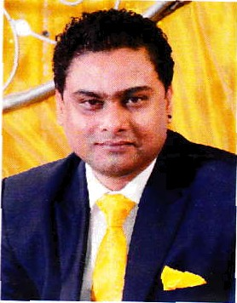
Curriculum Vitae

Rohan
email: rohan.370038@2freemail.com

Objective Summary:
Obtain a challenging role in a growth oriented organization where I can contribute towards organizational success and become an integral part of the team.

Target Job Preview:

Job Category: Administration & Coordination / Customer Service / Cargo and Logistic Support Employment: Employee Full time
Desired Salary: Negotiable

June 2010 till date
Working as a Custom Clearance Executive with Seashell Shipping Services LLC. Responsibilities
- Handle team of 10 people.
- Handle Import and export operations, documentation, coordination, entire process from start till delivery of shipment,
- Monitoring cargo movement through tracking system and taking action accordingly to clear the shipment.
- Passing Exit declaration and Bill of Entry for Sea, Land and Air (online) in Mirsal 2.
- Online company registration, new import code and renewal.
- Online custom card application new and renewal.
- Custom inspection online.
- Custom Claim (refund of deposit) online, solving if any issue occurs for claim.
- Custom related all works at Dubai Custom Department.
- Dubai Municipality registration.
•Processing of FIRS (food importing and re-exporting system).
- Dubai Municipality item registration (Bar code).
- Check DIP case if any and close the DM cases.
- Arranging for the transport of the shipment.

- July 2006 to May 2010
Worked as an Information Research Auditor with Just Dial Pvt LTD (US Process).

Responsibilities

- Handle team of 15 people.
- To Audit/ Quality check work done by the respective Executive.
- Generate weekly report of the team performance and update Manger regarding the same.

- Oct2005 to June 2006
Worked as a Team Coach / Tele Marketing Executive with Infovision.

Responsibilities

Handle team of 10 people for credit card sales for ABN Amro Credit card.
- To approach the new customer for sale of ABN Amro Credit card.

- Nov 2001 to Sept 2005
Worked as a coordinator with HDFC Standard Life Insurance

Responsibilities

  - Coordinating with respective Underwriter and the Re-insurance company for Re insurance of a clients and provide them necessary information and documents via email.

ACADEMIC PROFILE

Completed TY BSC in 2001 from Mumbai University.
  - Completed HSC in 1998 from Mumbai University.
  - Completed SSC in 1996 from Mumbai University.

I.T Skills
- Proficient in MS Office.

Personal Details: Nationality: Indian Birth Date: 1“Nov 1979 Marital Status: Married
Languages: English, Marathi, Hindi and Gujarati.
Hobbies: Watching Movies, Listening to Music, Travelling.

