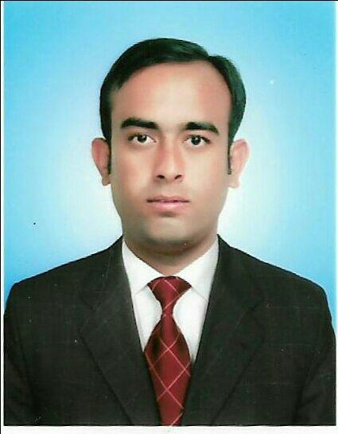
Islam

CAREER OBJECTIVE

To succeed in an environment of growth and excellence and earn a job which provides me job satisfaction and self development and help me achieve personal as well as organizational goals.

SKILLS

customer service

computer literacy

communication skills

strong team work skills

WORK EXPERIENCE

Aug-2011 - Aug-2015 Pacific hypermarket and dept store

assistant supervisor Advising & serving customers.Processing payments.Assisting

customers in order to help them find what they need.Ensuring stock levels are well maintained.Promoting store cards or special offers.Providing customers with information on pricing and product availability.Arranging window displays.Handling customer complaints or handing customers on to management.Staff scheduling.

EDUCATION DETAILS

Degree/Course |  | Institute/ | University/ | Percentage/ |  | Year of Passing
 |  | College | Board | CGPA
 |  | govt highier
matric |  | secondary | bhawalpur | 55 % |  | 2009
 |  | lalsohanra

PERSONAL DETAIL

Address chal no 1 bc

bahawalpur, punjab, lalsohanra

Date of Birth 5 March 1991

Gender Male

Nationality Pakistani

Marital Status Single

Languages Known urdu, Punjabi, English, Malaysian

REFERENCES

Mr Eric Tan

Branch manager

Pacific hypermarket and dept store

60124273883

Ms Noraini

sales executive

Pacific hypermarket and dept store

DECLARATION

I hereby declare that all the details furnished here are true to the best of my knowledge and belief.

Islam

