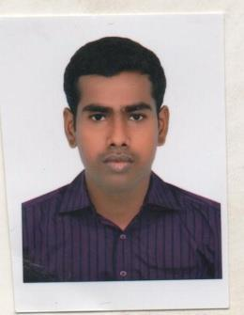
Udhayakumar
Email: udhayakumar.370077@2freemail.com

Objective

Seeking to evolve as a successful professional and leverage my technical and professional expertise to grow in your esteemed organisation.

Professional Experience

- November 2016 – Present

Boston Consulting Group, Dubai, UAE Office Assistant

- May 2015 – October 2016 Al-Futtaim Electronics, Dubai, UAE Office Assistant

- July 2014 – March 2015

Sutherland Global Service, Chennai, India Customer Care Executive

- July 2013 – June 2014

CSC – Computer Software College, Ramanathapuram, India Office Assistant

Education

- 2013 - Bachelor of Computer Application in BCA

Caussanel Arts and Science College, Alagappa University, Karaikudi Percentage of 70%

- 2010 - Higher Secondary at Govt. Higher Sec School Percentage of 52%

- 2008 - SSLC at Govt. Higher School Percentage of 80%

Technical Skills

- Good knowledge of Internet

- Computer Proficiency: C, C++ & JAVA

- Package: MS Office - Word, Excel, PowerPoint, Outlook

- Languages: C- Language, HTML

Skills and Strengths

- Good communication skills

- Reliable and responsible

- Management & organization skills

- Strongly committed to assigned task

Extra Curricular Activities

- Good knowledge of computer & programming

- Attended seminar on interviewing skills and active communication skills

Personal Profile
Name | : | Udhayakumar
Date of Birth | : | 19/12/1991
Additional Qualification | : | DWA (Diploma in Web Animation)
Gender | : | Male
Marital Status | : | Single
Nationality | : | Indian
Email Address | : | udhayakumar.370077@2freemail.com
Language Skills | : | English, Tamil & Hindi
Hobbies | : | Reading, Playing Cricket, Volleyball, Football

Declaration

I hereby declare that the above mentioned information is true to the best of my knowledge.

Date Signature

Dubai Udhayakumar

