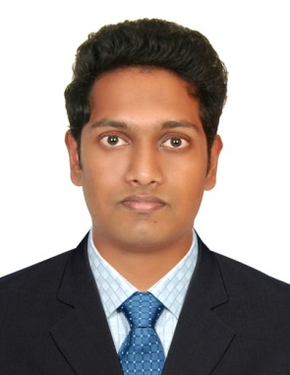
ABEL
Mechanical Engineer
Email: abel.370086@2freemail.com

Career Objective
Seeking a responsible and challenging leadership position in a reputed organization, where I could utilize and develop my operation management and engineering skills to benefit mutual growth and success.
Key skills and Competence
- Knowledge of business development and sales principles.
- Outstanding abilities in leadership and team-building.
- Skills in employment recruitment and training.
- Facility for strategic big -picture thinking.
- Adept at decision making and problem solving.
- Sound skills in cost control and reduction strategies.
- Strong knowledge of relevant safety and quality control standards.
- Excellent communicator who is always articulate and well presented.

Experience
Interned at ARECA L.L.C, Business Bay, Dubai.
Project Engineer- at Techno Consultancy Services, India. (01-Jun-2015 till 31-May-2016)
Responsible for ensuring that all engineering activity is managed through the lifecycle of the project from detailed requirement generation, design, development, integration right through to customer validation.
Duties
- Developing engineering systems, plant and personnel.
- Carrying out a range of engineering maintenance and development duties.
- Reporting progress on jobs and shutdowns to senior management.
- Managing engineering risks and identifying opportunities during the project cycle.
- Ensuring a tight control over costs.
- Maintaining engineering workshop tools, materials and other consumables.
- Creating project specifications and outlining the scope required to meet goals.

Academic Projects
- MAIN PROJECT
Analysis of pump Impeller Made of Composite Materials in ANSYS
Analysed the properties of a pump impeller made of various composite materials such as ABS plastic, AlSiBr, Banana and Kenaf fibres. Designed a pump impeller in CREO and simulated the working of an impeller under various fluid pressures and complex surface forces.

- MINI PROJECT
Mechanical Washing Machine
Designed and fabricated a Miniature Mechanical Washing Machine based on the crank and rocker Mechanism. In the process, could apply theoretical knowledge picked up during Graduate Studies.

- ACADEMIC TRAINING
Attended hands on and rigorous training at K.S.R.T.C Regional Workshop, Aluva, India.
Worked as a trainee in several departments of the workshop and had a lot of interactive and illuminating administrative exposure during the tenure.
Academic Qualification
- Master’s Degree in Engineering Management (current)
Rochester Institute of Technology (New York), Silicon Oasis campus, Dubai
- Bachelor’s Degree in Mechanical Engineering from Calicut University - Passed with First Class
Vidya Academy of Science and Technology, India (Completed in 2015)
- Senior Higher secondary from CBSE board - Passed with Distinction
Devamatha CMI Public School, India (Completed in 2011)
- Schooling from CBSE board - Passed with Distinction
Our Own High School, Dubai (Completed in 2009)

- Software Skills
Microsoft Office
MINITAB
AUTO CAD/CAM
ANSYS WORKBENCH 14.0
CREO
INVENTOR

Personal Details
Date of birth: 15 February 1994
Marital Status: Single
Languages known: English, Hindi, Malayalam
Valid UAE Driving License holder

Declaration
I, Abel, hereby declare that all the above-mentioned information and particulars that I have provided are true to my knowledge and belief.

ABEL

