CURRICULUM VITAE

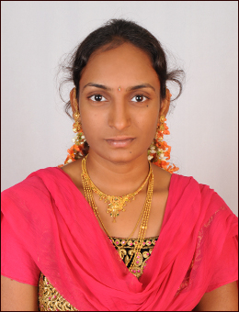
PERSONAL DETAILS
Name: PAVANI
DOB: 14 June 1993
Marital status: Married
Nationality: Indian
Current location: Sharjah (U A E)
Availability: Immediate
Email: pavani.370112@2freemail.com

CAREER OBJECTIVES

Seeking a challenging career position where my people management skills can be effectively utilized by a company offering long-term opportunities for professional growth in recognition of dedication, drive, and superior performance. Self-motivated with strong analytical and inter-personal skill, looking for an opportunity to build up a good career

WORK EXPERIENCE

Having 2 year of experience as a computer operator in Narayana junior college, Kukatpally, Hyderabad-072

EDUCATION

M.SC
Bapatla engineering college Andhra Pradesh
Specification: Computer science
Percentage: 75

BSC computers
Sri Harshini degree College (Ongole)
Acharya nagarjuna University
Specification: M.E.C
Percentage: 68

Pre-University
State Board of inter mediate Andhra Pradesh
Specification: MPC
Percentage: 74.44

SSLC
B.V.Subbaiah high school, (Prakasam dt)
Andhra Pradesh State Board
Percentage: 82

SKILLS
• Possess good educational background with post-graduation in M.SC.
• Possess good people management & mentoring skills.
• Team Player, having effectively interacted with superiors, peers and colleagues.
• Good communication and presentation skills.
• Possess good typing speed and technical skills.
• Assist in business development and manage client relationship.
• Knowledge about MS office, word and excel.
• Ability to handle and work with a team.
• Ability to work under pressure.
• Self-confident.
• Quick learner.
• Time management.

LANGUAGES
• English: fluent read write speak
• Hindi: Basic read write
• Telugu: fluent read write speak

DECLARATION:
I hereby declare that all the information furnished by me is true to the best of my knowledge.
Awaiting an early response
Yours faithfully
PAVANI

