

**Ubaid**

***Accounting & Finance Professional***

[Ubaid.370127@2freemail.com](mailto:Ubaid.370127@2freemail.com)



Why ***Ubaid?***

* Dynamic & level-head professional with extensive knowledge and experience of financial management, cash flow management, stock management & corporate finance; adept at preparing financial reports and statements
* Expert in financial applications with command on ERP & GW Basic to keep the cutting edge of technology for management of organizational task; adept at general ledger management, account reconciliation, audit & taxation
* Strategic thinker possessing sound decision-making and negotiation skills with proven record in enhancing service levels, payroll management, budgeting, administration, improving workflow processes and managing internal & external client relationships. Possesses strong problem-solving skills and operational expertise in FMCG sector
* Incredible communicator with well-developed interpersonal skills to handle internal coordination of engagement & external client service by preventing escalation of issues and diffusing most situations between employees & clients

|  |  |  |
| --- | --- | --- |
| **CORE STRENGTHS & ENABLING SKILLS** | | |
| * Financial Management * Cash Flow Management * Budgeting & Variance Analysis * Audit & Taxation | * General Ledger Management * Account Reconciliation * Batch Processing * Risk Assessment & Mitigation | * ERP & GW Basic * Fast Moving Consumer Goods * P&L Management * Communication & Presentation Skills |

**PROFESSIONAL EXPERIENCE**

**Almarai Company, Riyadh, KSA**

Working as ***“Assistant Manager Accounts”,*** May 2013 - Present

**Responsibilities/Accomplishments:**

* Successfully reviewing general ledger entries in SAP to ensure the reliability and accuracy of the figures; rendering data extraction tasks from SAP for development of financial statements. Actively participating in monthly closing of books of accounts, income statement, balance sheet preparation with schedules; supervising store activities including monthly closing, issuances, receipts, , local purchase orders authorization & follow ups of POS
* Preparing annual budget, rolling forecasts period and updating upcoming budget schedules, adhering to budgeted figures and variance reporting; overseeing implementation of company policies and procedures. Overseeing management review meetings & internal control; highlighting issues which surpass budget and target projections
* Providing support in management decisions and participating in initiating improvement activities. Managing various administrative tasks, maintaining headcount and gathering information for flash report; preparing petty cash reconciliation statement for approval and handling monthly payroll reporting, salary, absences, overtime calculations, medical reimbursements, traffic fines and other cost deductions. Updating fixed asset register for transfers, disposals, and depreciation charges, performing capex analysis, fixed asset verification & scheduling balance sheet accounts

**Tufail Chemical Industries, Karachi, Pakistan**

Worked as ***“Deputy Manager Accounts”,*** February 2012 – April 2013

**Responsibilities/Accomplishments:**

* Successfully prepared and interpreted financial statements of company on monthly quarterly and annually basis, rendered quantitative reconciliation of raw material and finished goods. Provided support in landing cost sheets and finalized imports for company as well as oversaw monthly stock count of raw material
* Computed sales tax receivables and payables advance income tax on imports, utilities and cash withdrawals; effectively implemented ERP software and assisted in income tax audit of organization. Effectively coordinated with external auditor for statutory audit; reported to department head, directors and CFOs on periodic basis

**Raiwind Chemical Industries (Pvt.) Limited, Karachi, Pakistan**

Worked as ***“Senior Accounts Officer”,*** January 2011 – January 2012

**Responsibilities/Accomplishments:**

* Provided support to department head in preparation of financial statements; effectively maintained bank reconciliation statements and rendered e-filling of sales tax and withholding tax
* Successfully maintained dealer accounts and reporting of trader debtors; conducted monthly stock count on raw material and finished goods. Periodically reported to department head

***Additional Experience:***

* Worked as *Audit Trainee* at Haroon Zakaria & Company Chartered Accountants from September 2009 to December 2010

**PROFESSIONAL TRAININGS**

* Training on Personal and HR Liaison by Almarai Group, Riyadh, KSA’(2014)
* Training on SAP by Almarai Group, Riyadh, KSA, (2014)
* Training on Material Management Module of SAP by Almarai Group, Riyadh, KSA, (2014)
* Training of Basic Leadership Course by Almarai Group, Riyadh, KSA, (2016)
* Training on Planning, Organizing and Time Management Development by Al Jhood Training Center, UAE, (2014)

House No: 1100, Block 14, Federal B Area, Karachi, Pakistan

8,Street-3,Younaspura Baghbanpura, Lahore, Pakistan

UAE-Address

**PROFESSIONAL QUALIFICATION**

* **Association of Chartered Certified Accountants (ACCA) United Kingdom** (2015)

ACCA

* **University of Karachi, Pakistan** (2004-2006)

B. Com

**LINKEDIN RECOMMENDATIONS**

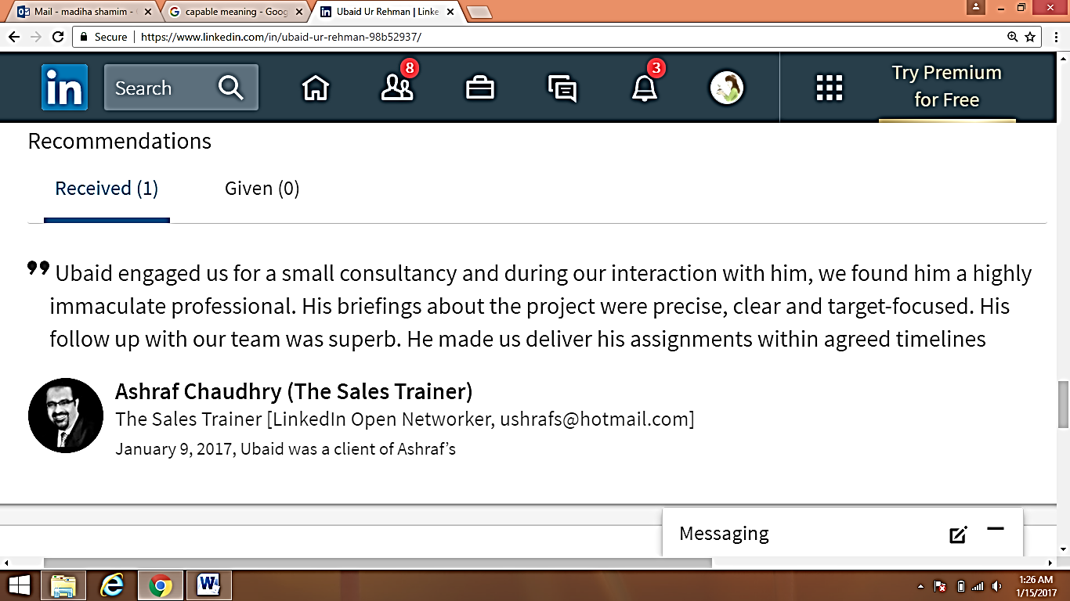

Address