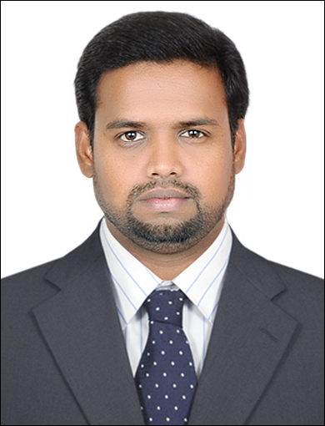
Post Applied For Supervisor

NAME : Mohamed
EMAIL ID : mohamed.370159@2freemail.com

CAREER OBJECTIVE:-

To expose my intelligence and creativity, to give the highest growth to the industry, to myself and ultimately to the society.

PERSONAL STATEMENT:-

I have above 9 years experience as a Fire alarm team leader in fire safety and security Related field in Juma al majid (al Arabia safety & security).Since 2008 January to till date in Dubai & Abudhabi UAE. (EDWARD SYSTEM TECHNOLOGY,QUICK START PANEL,VIGILANT PANEL,IO PANEL & ALL type of FM 200 PANELS) and have some experience in fire pumps also.

EDUCATIONAL QUALIFICATION:-

- NATIONAL COUNCIL FOR VACATIONAL TRAINING in Tamilnadu.
- ITI A/C & REFRIGRETION MECHANIC (2 years course) with an aggregate of 70% marks in the year of 2007.
- UTC fire & security programming course in Dubai.
- DIPLOMA AIRCONDITIONING & REFRIGERATION ENGINEERING SERVICE course.
- ITES ENGENEERING & VOCATIONAL course Mumbai.

COMPUTER SKILLS:-

- MS-OFFICE

Responsibilities:-

Installation of new fire alarm panels and civil defense floor control system and programming of newly added smoke detectors and testing of fire pumps.

PROJECT DETAILS:-

- Dubai Mall, Dubai internet city, Dubai knowledge village, Dubai media city, Lee Meridian hotel, Hilton hotels Dubai & Abudhabi, Ibis Suite hotels, Holidayn Express hotel, cooling plants, capital mall, Yas marina circuit in Abudhabi, Abudhabi international airport, Al ain airport, Sheraton hotel, petroleum institute Abudhabi, sheik syed mosque, Dubai world central.

PERSONAL PROFILE:-

Date of Birth : 24/03/1988
Gender : Male
Marital Status : married
Languages known : Tamil, Hindi, English
Nationality : Indian
Religion : Islam
Hobbies : Web browsing and Sports.
Notice Period : Immediately.

PASSPORT DETAILS:-

Validity : 27-01-2025

Issued place : Dubai

PERSONAL APPRAISAL:-

- Sincere, Honest and dedicated.

- Good communication and interpersonal skills.

- Disciplined and sociable.

- Hard working, self-motivated and result oriented.

- Strategic thinker.

- Ability to work under pressure.

I hereby declare that all the information provided above is true and correct to the best of my knowledge and belief.

Yours faithfully,

Mohamed

