Vishal.370218@2freemail.com

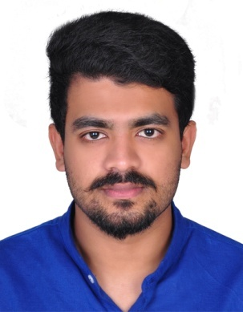

VISHAL
B.E, Mechanical Engineering

CAREER OBJECTIVE
To work in a firm with a professional work driven environment where I can utilize and apply my knowledge and technical skills which would enable me as a fresh graduate to grow while fulfilling organizational goals.

ACADEMIC CREDENTIALS
Qualification | Board/University | Year
BE (Mechanical Engineering) | Visvesvaraya Technological University | 2016
+2(Science) | Higher Secondary Examination Board of Kerala | 2011
S.S.L.C | CBSE | 2009

PROJECTS REPORT IN BE

- Submitted project on Design and Development of energy efficient domestic Water Heater using smart materials.
 |  | Graduation Project |  |  |  |  |  | ENERGY efficient water heater using smart materials
 |  | Description |  |  |  |  |  | The main objective of the project is to develop an
 |  |  |  |  |  |  |  | energy efficient domestic water heater using smart
 |  |  |  |  |  |  |  | materials instead of the conventional heating coil
 |  |  |  |  |  |  |  | which is less efficient.
 |  | Graduation Seminar |  |  |  |  |  |  |  |  | Thorium reactor
 |  | Description |  |  |  |  |  | A nuclear reactor using thorium instead of uranium as the
 |  |  |  |  |  |  |  | fuel. It is much advantageous as it produces no harmful
 |  |  |  |  |  |  |  | byproduct and also INDIA alone has more than 25% of the
 |  |  |  |  |  |  |  | world's thorium.
 |  |  |  |  |  |  |  |  |  | 1

ADDITIONAL QUALIFICATIONS

Softwares :Solid Edge, MS Office, CNC Programming
Operating Systems :MS WINDOWS XP,7,8,10

TECHNICAL /HSE QUALIFICATIONS

- NEBOSH National General Certificate in Occupational Health & Safety.

- Course certificate in First aid training from National Academy for Professional Training.

- Course certificate in Fire and Safety Engineering from National Academy for Professional Training.

- Training completed on Risk Assessment from EIHS, Kerala.
- Course certificate in Autocad 2D & 3D.

INTERPERSONAL SKILL

- Ability to rapidly build relationship and set up trust.
- Confident and Determined.
- Ability to cope up with different situations.
- Ability to perform under high pressure and against targets/deadlines.
- Ability to motivate and inspire confidence in the team.
- Hardworking and dedicated to the companies objectives.

PERSONAL DETAILS

- Date of Birth :- 04th March 1993
- Passport issue date :- 15-01-14
- Passport expiration date :- 14-01-24
- Language Known :- English, Hindi & Malayalam
- Marital Status : -Single.

Vishal

