Resume

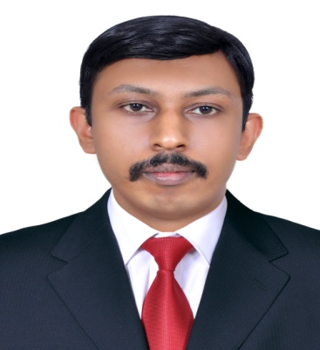
Aji
Email: aji.370262@2freemail.com

Working as a Physical therapist of Dr. S.M.C.S.I Medical College and Rural Health Training Centre, Trivandrum, Kerala, India from (29 October 2012 – current)

JOB DESCRIPTION
- Rehabilitation after joint replacement, sports injuries, traumatic and other pathological orthopedic surgeries.
- Rehabilitation after stroke, traumatic brain injuries, spinal cord injuries and other neurological and neuro surgical conditions.
- Rehabilitation after cardio thoracic and micro vascular surgical conditions etc.
- Worked in ICU and other various departments
- Performed diagnostic and prognostic exams to evaluate muscle, nerve, joint and functional abilities.
- Planned and administered treatments, modalities and therapeutic exercise programs.
- Ability to customize and adapt conventional physiotherapy techniques to meet the special needs of individual patients.

KEY SKILLS
- Orthopedic and sports physiotherapy
- Manual joint Mobilization
- Myofacial Release, Stretching technique
- Stroke, Parkinsonism, nerve injury and other neurological rehabilitation
- Cardiothoracic and surgical rehabilitation
- Electrotherapy
- pre and post-operative rehabilitation
- Fitness program, chest physiotherapy, mat exercises
- Ergonomic Evaluations & Postural Corrections and Taping techniques.
- ICU Management
EDUCATIONAL QUALIFICATIONS
- MASTER OF PHYSIOTHERAPY IN MUSCULOSKELETAL & SPORTS
May 2010-May 2012
Rajiv Gandhi University of Health Sciences, Bangalore.
- BACHELOR IN PHYSIOTHERAPY (BPT).
Aug2005-May2010
Rajiv Gandhi University of Health Sciences, Bangalore.

REGISTRATION and DHA ELIGIBILITY

Registered under: The Indian Association of Physiotherapists- 36425

DHA eligibility exam passed, Ref number: DHA/LS/1252016/594404

PERSONAL STRENGTHS:

- Determination and dedication towards Work.
- Adaptive to new atmosphere.
- Willing to take responsibilities and challenges.
- Excellent communication, leadership, presentation skills and strategic planning capabilities
- Able to work independently and as part of a team
- Language proficiency: English, Hindi, Kannada, Tamil, Malayalam.

INTERNSHIP AND CLINICAL TRAININGS:
- Worked as an Internee in various Hospitals with excellent exposure to various cases in several wards (Orthopedics, Neurology, Medicine, ICU etc.)
- Internship from National Institute of Mental Health and Neuro sciences (NIMHANS), Bangalore.
- Internship training from St.Martha’s hospital and its stroke rehabilitation unit- Bangalore.
- Training from Hosmat Hospital – Bangalore.
- Internship training from Sagar Hospitals-Bangalore.
- Clinical training from Ravi Kirloskar Memorial hospital& Research Centre -Bangalore.

SEMINARS AND WORKSHOPS (Professional Development)

- Workshop on Spinal Pain Management- An Evidence based Approach
Resource person - Mr. Richard Bartley (UK)
- Maitland Technique for Lumbar and Cervical Spine(Workshop)
Resource person - Mr. T. Sathiya Selvam MPT
- The Unique role of the Women’s Health Physiotherapist in Antenatal Care”
Resource person - Dr. Shagufta Parveen (PT) (Women’s Health)
- Attended Workshop on Motor Relearning program
Resource person - Mr. R. Vasnthan (PT)
- Attended Workshop on Proprioceptive Neuromuscular Facilitation (PNF) Technique. Resource person - Mr. R. Vasnthan (PT).
- Attended Medical symposium on “Continuous Professional Development on Multiple Sclerosis”, conducted by Multiple Sclerosis Society of India.

THESIS WORK
- Submitted a Thesis work during my Post Graduation period on - A comparative study to analyze the effect of PNF exercise versus cervical stabilization exercise in mechanical neck pain subjects.

PERSONAL INFORMATION

Date of Birth : 18-05-1984
Nationality : Indian.
Religion : Christian.
Marital status : Single.
Visa status : on Visit
Language proficiency: English, Hindi, Kannada, Tamil, Malayalam.
Hobbies : Gardening, outdoor games

DECLARATION

I hereby declare that the above-mentioned information is correct up to my knowledge and I bear the responsibility for the correctness of the above mentioned particulars.

Date: 10/06/2017 AJI

