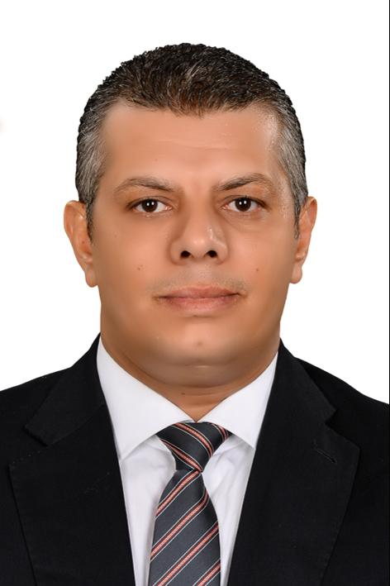
- CV

- Credit controller manager . Collection manager . Customer service representative

Location: Dubai, United Arab Emirates
Education: Bachelor's degree, commerce
Experience: 17 Years

PERSONAL INFORMATION

Mahmoud Mohamed Wasel

Birth Date: 2 October 1976 (Age: 40)
Gender: Male
Nationality: Egypt
Additional Nationalities: Egypt
Visa Status: Residency Visa (Transferable)
Marital Status: Married
Number of Dependents: 2
Driving License Issued From: United Arab Emirates; Egypt; Oman
________________________________________________________________________________________________

EXPERIENCE (17 YEARS)

August 2014 - Present
Credit controller manager . Collection manager . Customer service representative

Caterpillar Financial Services (Dubai) Limited - DIFC
Location: United Arab Emirates
Company Industry: Financial Services
Job Role: Finance and Investment
Credit controller . Collection manager. customer service representative and account receivable 9 to the General Manager.

⬥ Updating the management & assisting them in accepting credit deals, by evaluating the credit customer according to the
company policy.
⬥ Ascertaining payments are keyed on to the system correctly and promptly and ensuring that all records are kept orderly and easy to access.
⬥ Processing weekly reviews with the Account managers 6 with the BDM to clarify the accounts facing any problems.
⬥ Developing age analysis and participate on dispensation of the provisional reports.
⬥ Check and ensure that all cheques and bank remittances are banked daily and Allocate received payment.
⬥ Monitor accounts constantly to identify any potential bad debt, send deadline letters for the bad payer’s accounts.
⬥ Clear orders suspended due to Credit Limit being exceeded or Maximum Order value exceeded and issue copy of invoices and credit notes & mortgage release letters for ended contracts.
⬥ Developing cash flow report monthly, & weekly past dues reports for overdue invoices, and send it to our clients on Weekly bases and send statements periodically (Fax/ Email /Courier) and ensure that the client has received it on time.
⬥ Assuring reduction of accounts receivable. In the BS business this includes both Unbilled Project and all Billed Receivables.
⬥ Restructuring for dead debts & old pending outstanding to support management for collecting outstanding.
⬥ Establishing and maintaining effective working customer relationships.
⬥ Ascertaining effective customer relationship to optimize progress billings. Leading the liaison between external customer and
internal project managers to proactively manage the balance between accurate, timely billing and maximization of receipts.
⬥ Leading resolution of disputes with assistance of Field Leaders and Finance Support. Ensure team and individual goals on
dispute reduction/resolution are achieved.
⬥ Manage and administer customer accounts including customer account reconciliations and some direction of application of unapplied credits/cash.
⬥ Identify and escalate defined uncollectible accounts.
⬥ Work on E-Receivables and update invoice comments, follow-up date, promise to pay date.
⬥ Act as control point for business AR specific policies and processes.
⬥ Act as a team member of the Customer Specialist Team.
⬥ Visiting clients to solve problems overseas.
⬥ Make arrangements for legal cases with legal dep. or external lawyers and arrange for provision for dead depts.

Achievements:
⬥ Successfully reduced old outstanding and the time for customer credit evaluation for only 2 days.
⬥ Old legal cases solved & outstanding collected.
⬥ Functioned as control point for business AR specific policies and processes.
⬥ By end of 2016 all middle east figures reduced from 23% to 10.7% by 31st December 2016.
_____________________________________________________________________________________________________
June 2011 - July 2014
Senior credit controller, collection manager & account receivable
AWRostomany(Arabian automobile Nissan & infinity )
Location: Dubai, United Arab Emirates
Company Industry: Automotive
Job Role: Accounting and Auditing
⬥ Reporting to the General Management
⬥ Updating the management & assisting them in accepting credit deals, by evaluating the credit customer according to the
company policy.
⬥ Ascertaining payments are keyed on to the system correctly and promptly and ensuring that all records are kept orderly and
easy to access.
⬥ Processing weekly reviews with the Account managers together with the BDM to clarify the accounts facing any problems.
⬥ Developing age analysis and participate on dispensation of the provisional reports.
⬥ Check and ensure that all cheques and bank remittances are banked daily and Allocate received payment.
⬥ Monitor accounts constantly to identify any potential bad debt, send deadline letters for the bad payer’s accounts.
⬥ Clear orders suspended due to Credit Limit being exceeded or Maximum Order value exceeded and issue copy of invoices
and credit notes.
⬥ Developing cash flow report monthly, lists for overdue invoices, and send it to our clients on monthly bases and send
statements periodically (Fax/ Email /Courier) and ensure that the client has received it on time.
⬥ Assuring reduction of accounts receivable. In the BS business this includes both Unbilled Project and all Billed Receivables.
⬥ Establishing and maintaining effective working customer relationships.
⬥ Ascertaining effective customer relationship to optimize progress billings. Leading the liaison between external customer and
internal project managers to proactively manage the balance between accurate, timely billing and maximization of receipts.
⬥ Leading resolution of disputes with assistance of Field Leaders and Finance Support. Ensure team and individual goals on
dispute reduction/resolution are achieved.
⬥ Manage and administer customer accounts including customer account reconciliations and some direction of application of
unapplied credits/cash payments.
⬥ Identify and escalate defined uncollectible accounts.
⬥ Work on E-Receivables and update invoice comments, follow-up date, promise to pay date.
⬥ Act as control point for business AR specific policies and processes.
⬥ Act as a team member of the Customer Specialist Team.
⬥ Visiting clients to solve problems.
⬥ Make arrangements for legal cases with legal dep. and arrange for provision for dead depts.
Achievements:
⬥ Successfully reduced old outstanding and the time for customer credit evaluation for only 2 days.
⬥ Old legal cases solved & outstanding collected.
⬥ Functioned as control point for business AR specific policies and processes.
⬥ Made arrangements for legal cases with legal debt
____________________________________________________________________________________________________
June 2006 - June 2011
credit controller.collection supervisor
Juma Al Majid EST
Location: Dubai, United Arab Emirates , DUBAI
Company Industry: Contracts/Purchasing
Job Role: Accounting and Auditing
⬥ Reported to general manager.
⬥ Updated the payments on the system correctly and promptly and all the records were kept orderly and easy to access.
⬥ Processed weekly reviews with the Account managers together with the BDM to clarify the accounts facing any problems.
⬥ Prepared age analysis and participate on dispensation of the provisional reports.
⬥ Checked and ensured that all cheques and bank remittances were banked daily and allocated received payment.
⬥ Monitored accounts constantly to identify any potential bad debt.
⬥ Sent deadline letters for the bad payer’s accounts.
⬥ Cleared orders suspended due to Credit Limit being exceeded or Maximum Order value exceeded.
⬥ Issued copy of invoices and credit notes.
⬥ Prepared lists for overdue invoices, and sent it to our clients on monthly bases and sent statements periodically (Fax/ Email
/Courier) and ensured that the client has received it on time.
⬥ Actively led the reduction of accounts receivable. In the BS business this includes both Unbilled Project and all Billed Receivables.
⬥ Established and maintained effective working customer relationships.
⬥ Worked the customer relationship to optimize progress billings. Led the liaison between external customer and internal
project managers to proactively manage the balance between accurate, timely billing and maximization of receipts.
⬥ Led resolution of disputes with assistance of Field Leaders and Finance Support. Ensured team and individual goals on
dispute reduction/ resolution are achieved.
⬥ Managed and administered customer accounts including customer account reconciliations and some direction of application
of unapplied credits/cash.
⬥ Identified and escalated defined uncollectible accounts.
⬥ Work on E-Receivables and update invoice comments, follow-up date, promise to pay date.
⬥ Acted as control point for business AR specific policies and processes and as a team member of the Customer Specialist
Team.
_____________________________________________________________________________________________________
January 2005 - June 2006
credit controller
Kuwait Finance House (car & heavy equipment’s finance) Auto plus.
Location: Muscat & Salalah, Oman
Company Industry: Automotive

Job Role: Administration
- Make financial analysis for customer from his financial position
- Be sure that deal value installment suitable for customer income.
- Arrange with the customer to submit full documents.
- Following collection for all debts.
_____________________________________________________________________________________________________
October 2001 - January 2005
senior credit controller
Al Seeb Tech Est. (SARCO)
Location: Muscat, Oman
Company Industry: Finance/Economics
Job Role: Accounting and Auditing
- Directly report to the finance manager.
- Prepare age analysis and participate on dispensation of the provisional reports.
- Handle overall Supervision & Management of the Branches(5 Branches).
- Preparing reports on monthly and annual basis.
- Make arrangements for all credit facilities forms for all clients.
- Visiting for clients to solve problems.
- Make arrangements for legal cases with legal dept.

Extra years of experience not listed above: 1 Years, 7 Months

EDUCATION

Bachelor's degree , Commerce .

Bachelor of commerce
Location: Tanta Egypt
May 1998
Grade: GOOD
Bachelor of commerce from 1994 to 1998

SKILLS

Senior credit controller, collection manager & account receivable
(Expert)

MS OFFICE .Oracle. Salesforce . Docexpress
(Expert)

Oracle ،. outlook ، greenbelt ، power point.
(Expert)

LANGUAGES

Arabic
Level: (fluent Writing. Reading & speaking)

English
Level: (fluent Writing. Reading & speaking) Experience: More than 17 years

TRAINING AND CERTIFICATIONS
Using the last option in my Job
Training Institute: Oracle . Green belt certificated. Salesforce

