JESTONI 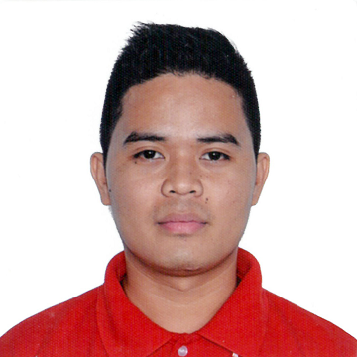
Email: jestoni.370271@2freemail.com

OBJECTIVE:

To serve the institution the best that i can through sharing my knowledge and abilities to your company for the betterment not only of my self but most especially the institution.

PERSONAL INFORMATION:

NAME : Jestoni
VISA : Tourist Visa
AGE : 27yrs old
BIRTH DATE : January 22, 1990
STATUS : Single
WEIGHT : 120lbs / 60kls
HEIGHT : 5’6

SKILLS :

*Speak in English, *Microsoft Excel,Word and Powerpoint
*Handle People *Display Merchandise or Promotional Display
*Computer Typing

EDUCATIONAL BACKGROUND :

PRIMARY : Buasao Elementary School
YEARS : 1996 - 2002
ADDRESS : Buasao Sto Domingo Nueva Ecija Philippines

SECONDARY : Sto Domingo National Trade School
YEARS : 2002 - 2006
ADDRESS : Baloc Sto Domingo Nueva Ecija Philippines

TERTIARY : Nueva Ecija University of Science and Technology
COURSE : Associate Information Technology
YEARS : 2006 - 2008
ADDRESS : Cabanatuan City Nueva Ecija Philippines

JOB EXPERIENCE :

SCHOOL : Nueva Ecija University of Science and Technology
ADDRESS : Cabanatuan City Nueva Ecija Philippines
JOB : (OJT) On The Job Training
WORK : Encoder of New Enrollees
YEAR : 2008

COMPANY : Rolly’s Catering
JOB : Waiters
YEAR : 2007

JOB : Printing Shop
: Typing , Encoder
YEAR : 2008

COMPANY : Chow king
JOB : Service Crew
YEAR : 2008

COMPANY : Ace Hardware Philippines Inc.
ADDRESS : SM Corporate Office Building B, Bay Boulevard SM Central Business Park, Bay City, Pasay, Metro Manila Philippines.
BRANCH : Megamall
ADDRESS : SM Megamall Bldg. B Julia Vargas Ave Cor. Edsa Mandaluyong City, Metro Manila Philippines.
DATE HIRED : October 17, 2008
DESIGNATION : Sales Utility Clerk
YEAR PROMOTED : 2013
DESIGNATION : Sales Assistant
YEARS : 2013 – 2017
TOTAL YEARS : 8years and 5months

I hereby certify that above information is true and correct to the best of my knowledge

____________________
Jestoni

