 |  | BABY SHEELA |  |  |  |  |  | Skills
 |  |  |  |  |  |  |  | Specialization: INVENTORY MANAGEMENT/SALES CO-ORDINATOR
 |  |  |  |  |  |  |  | Experience In: INVENTORY/SALES CO-ORDINATOR/PURCHASE
 |  |  |  |  |  |  |  | Skills: ERP software ORION, CG.VAK, Ms Office.
 |  |  |  |  |  |  |  | Profile: I am a computer graduate, over 13years experience in Inventory
 |  |  |  |  |  |  |  | Management & sales co-ordination of a leading Trading company in UAE based
 |  |  |  |  |  |  |  | European brand quality, Electro-mechanical equipments with more challenging
 |  |  |  |  |  |  |  | and result oriented functions with an innovative working environment.
 | Email: sheela.370278@2freemail.com |  |  |  |  |  |  | Credentials: Strong interpersonal skills, team player with excellent attention to
 |  |  |  |  |  |  |  | detail commitment to the highest standards of quality.
 |  |  |  |  |  |  |  | Objectives
 |  |  |  |  |  |  |  | Seeking an innovative, inspiring career to work for a reputed company, it would be
 |  | PERSONAL INFORMATION
 |  |  |  |  |  |  |  | my privilege and honor to be a part of an eminent organization where my skills
 |  |  |  |  |  |  |  | may be used for its growth and success, by achieving goals and personal
 |  | Nationality |  | Indian
 |  |  |  |  |  |  |  | development through my dedication.
 |  | Date of birth |  | 03/02/1975
 |  | Marital |  | Married
 |  | Status |  |  |  |  |  | Career Highlights
 |  | Visa Status |  | Employment |  |  |  | ➢ Mohammed Tayyeb Khoory & sons, Dubai – Presently working as an Inventory
 |  | Present
 |  |  |  | Dubai |  |  |  | controller cum sales co-ordinator - July 2004 – till date.
 |  | Location
 |  | Languages |  | English,
 |  |  |  | Hindi, Tamil, |  |  |  | Summary of Works Exposure
 |  | Known
 |  |  |  | Malayalam, |  |  |  | INVENTORY/SALES COORDINATOR – MOHAMMED TAYYEB KHOORY & SONS
 |  |  |  |  |  |  |  | JOB PROFILE
 |  | How can I contribute |  |  |  |  |  | Responsible for managing all inventory control related activities for the company’s
 |  | Through my hard work, |  |  |  | ❖
 |  |  |  |  |  |  |  | material and stocked product.
 |  | positive attitude |  |  |  | ❖ |  | Execute inventory control measures to ensure the company minimizes stock
 |  | sincerity, dedication & |  |  |  |  |  | holding and maximizes stock system and paperwork accuracy.
 |  | commitment. |  |  |  | ❖ |  | The role carries responsibility for working with purchasing, goods inwards and
 |  |  |  |  |  |  |  | dispatches to ensure necessary functions are carried out correctly.
 |  | Strengths |  |  |  | ❖ |  | Ensure incoming product is receipted and managed appropriately according to
 |  |  |  |  |  |  |  | company procedure.
 |  |  |  |  |  | ❖ |  | Ensure materials are ready and available for production, installation, resale,
➢ |  | Flexibility & Commitment to work❖ |  |  |  |  |  | servicing as and when required.
 |  |  |  |  |  |  |  | Preparing sales Delivery orders & Invoices, Material Received Reports- Import &
➢ |  | Creative & Goal Oriented |  |  |  |  |  | local purchase.
➢ |  | Leadership & Negotiation skills
 |  |  |  |  |  | ❖ |  | Updating stock ledger –weekly/monthly basis
➢ |  | Ethics believer &Team player |  |  |  | ❖ |  | Maintaining files & dispatch register
➢ |  | Hardworking & Self-motivated |  |  |  | ❖ |  | Co-ordination and assisting all sales Engineers for material deliveries & arranging
➢ |  | Problem Solving Skill |  |  |  |  |  | payments for a smooth operation with customers.
➢ |  | Adaptability to the situation |  |  |  | ❖ |  | Attending enquiries from various branches for stock reservation and assisting their
 |  |  |  |  |  |  |  | sales requirements.
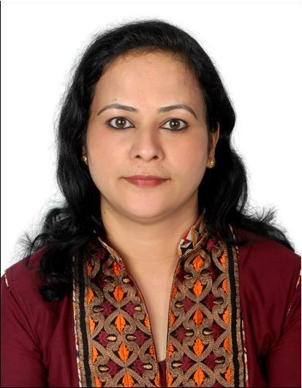

- Receiving and relaying telephone messages from clients, branches & co-workers

- Reliable with all co-workers to create friendly atmosphere and to get a full achievement of my entire department as well as my organization.

- Maintain separate record for fast moving materials and intimate to the sales dept. for the stock updation.
- Receive LPO from branch together with all supporting documents such as approved submittal copy, cost evaluation sheet, any other supporting documents to execute the job.

- Assistance to prepare OPO/ Local purchase order.
- Assistance to do credit approval
- To handle the Petty cash and arrange for the small and urgent purchases

Educational – Details

- Diploma in Computer Technology from NPA Century Polytechnic, Nilgiris, Tamil Nadu.

Reference:

- Shall be provided on request.

DECLARATION

I hereby declare that the above written particulars are true to the best of my knowledge and belief. If I am offered an opportunity to work, I will discharge the duties entrusted to me to the best of my capacity, talents & ability and to the entire satisfaction of my superiors.

Date:

Place: Dubai

Baby Sheela

