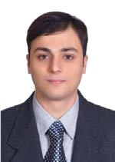
Maykel

Mechanical Engineer

E-mail address: maykel.370282@2freemail.com

PROFILE

Eight years experienced Mechanical Engineer in the MEP Construction Field. Working experience In HVAC , Plumbing and Firefighting in Gulf Region.

Education

Bachelor of Mechanical Engineering,
Faculty Of Engineering Suez Canal University,
Port-said, Egypt. (2009)

Work Experience

MEP COORDINATOR (January 2015 - Present)

ALSHAFAR UNITED LLC (MEP)
Duties and Responsibilities:

- Coordination with consultant, client, Main Contractor & sub contractors, Arranging & forecasting of manpower, materials, tools & machineries as per project requirement, strictly follow up & chase the site staff to complete the project as per target program & in budget cost.

- Assisting for preparing shop drawings and material approval request submittals.

- Responsible for smooth running of projects, track & control on Labor, Material and Equipment, utilization of site resources effectively, ensuring safety & quality as per the company standards, Assigning & monitoring task to the site staff, report the progress of work to the PM. Keeping track of As built documents for smooth handover of project. Ensure correct reporting of project status to the top management. Preparations of quotations, variations and running bills of concerned projects.

- Monitor MEP site execution works to ensure:

    - Contractors are following all relevant and latest drawings,

    - Material/installation on site is as contractual specifications,

    - Installations meet all building and authority regulations

- Monitor and review final handover procedures, final inspections, deficiency lists, and defect liability periods along with warranties/guarantees.

- Co-ordination of all MEP services:

  - HVAC systems : Exhaust fans - FCU'S - AHU's - FAHU'S - VAV's - Chillers - Chilled Water Pump (primary secondary) - Chilled water Pressurization Unit - Chemical Dosing system - Air balancing - Chilled water balancing
  - FIREFIGHTING systems : Sprinkler and Fire hose reel system - Fire Hydrant System– Electric and Diesel Fire Pumps sets - Kitchen Hood Wet Chemical Fire Suppression system - Clean Agent FM200 system - Foam system - Deluge Water Spray System

  - PLUMBING and Drainage systems : Transfer Pumps - Booster pumps - sump pumps - Irrigation pumps - Storm water systems - Drainage System - Solar System - Filtration System - Hot Water System - Water Tanks

  - ELECTRICAL systems : Power - Lighting - Fire Alarm System - LV Panels - Capacitor bank - DBs - MCC panels &VFDs - UPS - Generator sets - Earthing and Lightning protection system - CCTV - Public address Voice Alarm - Central Battery System - BMS - Lighting Control System - CO2 detection -Access Control - Barrier System.

Project Engineer

Plumbing, Fire Fighting

(July 2014 - January 2015)

ALSHAFAR UNITED LLC (MEP)
Tasks and Duties:

- Responsible for setting-up detailed implementation / execution plan of Plumbing (water supply and drainage) and Fire Fighting network installation, including defining project’s needs such as materials, follow up with the suppliers and sub contractors.

- Follow up, coordination, administration and total management of site
- Managing project timelines and schedules.
- Attend the project management meetings.

Plumbing and Fire Fighting Engineer

(May 2013 - June 2014) : Arabian Construction Company

From (January 2012 - April 2013) : New power for trading and constructions

Tasks and Duties:

  - Prepare submittals /shop drawings / as built drawings and material take off.

  - Keep a proper documentation for all site activities, submittals, correspondences, drawings.

  - Coordination of testing and commissioning activities.

  - Prepare operation and maintenance files.

  - Coordinated the fire protection system design with other disciplines to improve the building design and eliminate any errors during construction.

- Performed final inspections for compliance with building permit requirements.

Mechanical Maintenance Engineer

(May 2011 - October 2011)

Kuwait Gypsum Manufacturing and trading Co. (K.C.S.C)

Responsibilities: In charge of mechanical maintenance for plaster board and powder plant (Preventive/ Predictive/ Breakdown and Shut down maintenance)

Tasks and Duties:

- Co-ordinate maintenance activities with operations.

- Attend breakdowns to release within minimum time.

- Spares management, inventory control and Making spare parts request.

- Document all repair and maintenance work performed on equipments.

Mechanical Piping Engineer

(October 2009 - March 2011)

ESISCO Egyptian Sponge Iron and Steel Company

BESHAY STEEL

Tasks and Duties:

Site engineer (Mechanical Construction Department) in the DRI Plant (Miedrix):

- Fabrication and Erection of pipe lines for (shaft furnace, Reformer ,Reformer gas duct bridge, water treatment unit and pipe rack area )

- Supervising a group of pipe fitters, grinders and welders working in Hydraulic, Oxygen, Gas, Water pipe lines.(using mechanical drawings and P&ID)

- Prepare the weekly progress report and daily manpower reports.

Technical office

- Making isometrics for workshop

- Drawing piping and mechanical parts for fabrication

- Making material request according to drawings and Miedrix standers.

Training and Courses

- Certified from the General Administration of Fire of Kuwait as grade 1.

- Summer training in El Amreia Petroleum Company for one month (2008)

- Summer training in Webco Petroleum Company for three months (2006)

Skills

- Ability to prioritize work and manage projects under budget and time constraints.

- Expertise in using Computer Aided Design (CAD) software like Revit and Autocad.

- Co-ordination of all MEP services.

- The ability to design buildings plumbing system (water supply and drainage), fire-fighting system and fire alarm for both New Construction and Modifications to existing Buildings.

- Familiar with International Design code like ASHRAE, IPC, and UPC.

- Knowledge of National Fire Protection Association (NFPA) Standards.

- Experienced in construction activities of metallic pipes, PVC and HDPE pipes.

Computer skills:

- Revit MEP

- Primavera P6

- Microsoft Office suit

- Auto-Cad 2D,3D /Autodesk Inventor

- Plate'n'Sheet /pipedata pro

- Adobe Photoshop

Languages:

- English : Excellent

- French : Good

- Italian : Fair

- Arabic: Mother tongue.

Personal data

Date of birth: 18th October 1981.
Place of birth: Alexandria.

Nationality: Egyptian.

Marital status: Married.

Driving License: Valid UAE driving license

Projects Handled:

Marina Bloom
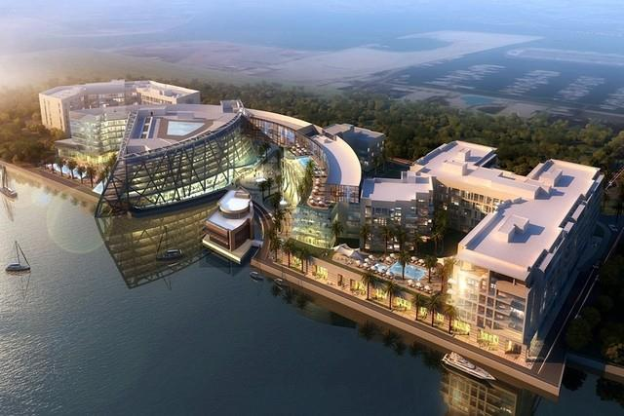

The project features hundreds of luxurious residential apartments, ranging from one to four bedrooms. The development also includes a 5-star hotel component consisting of over 200 rooms which will be managed by a world-renowned hotel chain. There will be executive serviced apartments and waterfront retail areas, providing residents and guests with a complete hospitality experience.

Key facts

- Description: Five-star hotel, serviced apartment building, and two residential blocks

- Client: Bloom Properties

- Consultants: Khatib & Alami

- Location: Abu Dhabi Marina

Bluewaters Island.
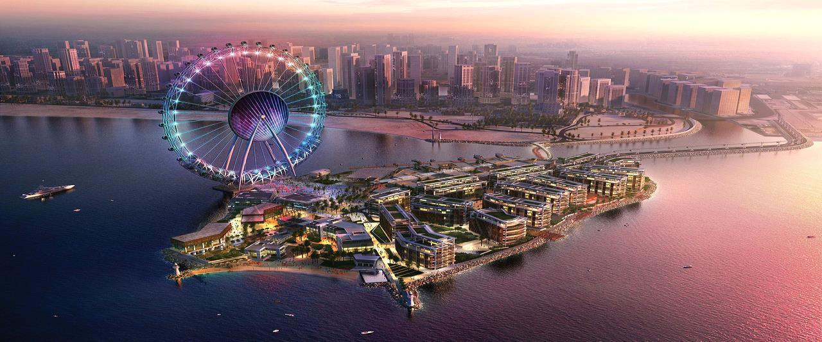

This project will comprise 10 high-grade residential properties, which will sit alongside the world's tallest Ferris wheel and

a range of commercial and retail developments

Key facts

- Description:Residential buildings

- Client:Meraas Development

- Consultants:Mirage

- Location:Bluewaters Island

- Value:AED 718,232,786

City Walk development.
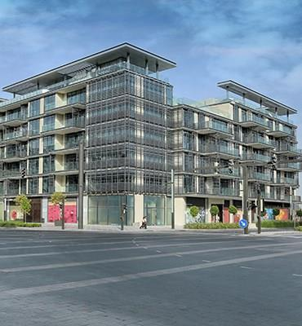

The project is in a prime location in Jumeirah with close proximity to Sheikh Zayed Road. The scope includes construction of multiple low and medium rise residential buildings.

Key facts

- Description: Low rise and medium rise pre-cast buildings

- Client: Meraas Development

- Consultants: Holford

- Location: Jumeirah, Dubai

CICPA COMPOUND FACILITY AT QUSAHWIRA FIELD
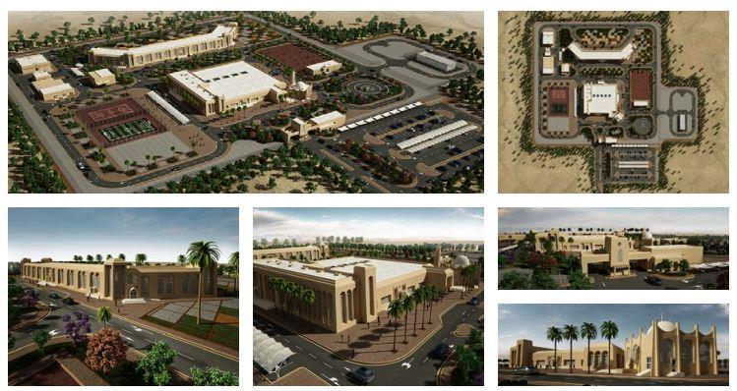

This self-sufficient complex features a multitude of facilities, including administration and staff accommodation buildings, mosque, community areas, ST plant and a helipad, along with infrastructure and landscaping works.

Key facts

- Description: self-sufficient complex

- Client: ADCO / Al Hosn Gas

- Consultants: ECG

- Location: Qusahwira Oilfields, Abu Dhabi, UAE

