Gregorios
MIDDLE MANAGEMENT PROFESSIONAL
Travel Operations/ Business Development/ Client Relationship Management

gregorios.370287@2freemail.com
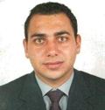
Key Skills |  | Profile Summary
Contract Management  Reservation  Travel Operations  Business Development  Outbound & Inbound Sourcing  Customer Relationship Management  Budgeting  Sales & Marketing  Documentation |  | - Result-oriented Professional with over 13 years of experience in Travel Operations, Outbound & Inbound Sourcing & Negotiation, Budgeting, Business Development and Customer Relationship Management  - Expertise in visiting new destinations to gather information on issues & amenities of interest to consumers  - Skilled in ensuring travel agents are familiar with selling features and advantages over competitors  - Played a key role in managing special attention of repeats & VIP guests with proficiency in English, French & Arabic languages  - Hands-on-experience of providing high value-added services to customers by providing them effective travel packages, thereby enhancing their satisfaction levels  - Pivotal in resolving passenger queries through latest available data in order to avoid any confusion in future  - An enterprising leader with skills in leading personnel towards accomplishment of common goals
Soft Skills |  | Education
Team player  Communicator  Innovator  Thinker  Collaborative  Intuitive |  | 1997: MBA in Banking and Finance from University Saint Joseph, Lebanon  1996: BA - Business Administration from University Saint Joseph, Lebanon
Career Timeline
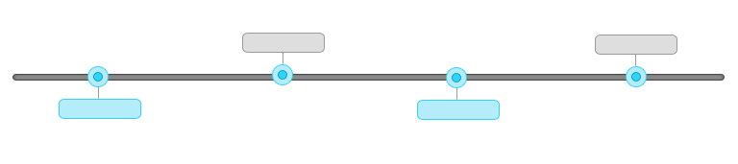
MBA in Banking and Finance
BA - Business Administration
Sna Allianz, Lebanon as Financial & Insurance Consultant
2004-till date

1998-2004

Professional Tourism, Dubai as Operations Manager
1996

1997

Work Experience
Since Jun’04 with Professional Tourism, Dubai
Growth Path:
Jun’04 to Jun’06: Reservation & Contracting Manager
Jun’06 to Jun’09: Business Development Manager
Jun’09 to till Date: Operations Manager

Role:
As Operations Manager:
- Monitoring Pre-Launch Of An OTA B2C Under Apartmentwithus.Com Specialized Only In Hotel Apartments
- Contracting:
  - Channels Management Such Rate Gain, Rate Tiger
  - Hotel Apartments On B2C Contracts & Hotel & Hotel Apartments on B2B Contracts
  - B2B Wholesalers
- Managing Marketing Plans And Campaigns
- Collaborating With Key Corporate Clients Of Research, Marketing And Selling Skills
- Supervising Entire Operational Set-Up Of The Company
- Sourcing Products & Destinations To Meet Customer Demands
- Managing A Sales Team Of Highly Motivated People
- Mentoring & Motivating The Sales Team To Hit Their Targets And Ensure Company Profitability

As Business Development Manager
- Contracting Suppliers For Outbound Packages
- Regulating Designing, Marketing And Promoting Holiday Packages Research, Marketing And Selling Skills
- Formulating Sales & Marketing Plans & Campaigns Developing New Services & Products
- Administered In Contracting B2B Wholesalers
- Organized client-companies events & managed groups in Dubai
- Involved In Visiting Agents Abroad
- Played A Key Role In Starting Using Email Marketing Adding 2 New Destinations Every Year

As Reservation & Contracting Manager
- Monitored A Reservation Team As Manager
- Served Customers Professionally To Achieve Excellent Levels Of Satisfaction & Generate Revenue
- Formulated In Negotiating & Contracting Hotels, Self-Catering Or Serviced Apartments
- Managed The Best Available Rates & Availability In New Hotels & Re-Contracting Existing Agreements
- Confirmed That The Reservation & Operation Teams & Finance Were Provided With Accurate Data To Complete Booking Processes And Produce Accurate Customer Invoices
- Evaluated Market Requirements Related To The Needs Of Tactical Products (I.E. New Destinations, Weak Periods Etc.) To Support The Defined Business Strategy In Collaboration With The Business Product Team
- Actively Engage With Contracted Partners
- Negotiating And Contracting Extra Services Like Transfers, Limousine & Excursions
- Managed Sales Meeting With Corporate Clients In Dubai

Previous Work Experience
Jun’98 to Jun’04 With SNA Allianz, Lebanon as Financial & Insurance Consultant
It Skills
Operating Systems: Windows 10; MS Office; Social Media: Facebook, Twitter, Linkedin, Pinterest; Email Marketing: Icontact, Mailchimp
Personal Details
Date of Birth: 1st March, 1975
Marital Status: Married
Nationality: Lebanese
Driving License: Valid U.A.E. driving license
Languages Known: English, French, & Arabic
Location Preference: Dubai

