ANGELO
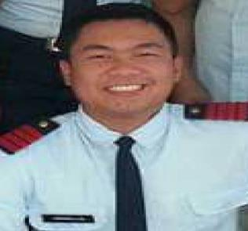

Email: angelo.370288@2freemail.com

Summary:

- Profile:

Male, 23 years old, Single

- Nationality: Filipino

- Visa Status:

Transferrable Visa (Can join immediately)

Work Experience:

June 2016 – April 2017
Instinct Marine
Al Jadaf, Dubai, U.A.E.
Assistant Laminator

This company is a manufacturer of premium sport fishing boats, and the first to introduce a boat specifically designed for the waters, weather, and wave characteristics of the Gulf region.

August 2014 - January 2016
McDonald's Victoria

Tarlac, Philippines
Service Crew

This company is active in sales when it comes to fastfood, McDonald's is the second most popular fastfood in the Philippines.

Education:

SitesPower Training Center (Filipino Institute)
Dubai, U.A.E.
Short Courses – Basic Photography and Basic Videography (February 2017 to March 2017)

University of Perpetual Help System
Pangasinan, Philippines
College Graduate - Bachelor of Science in Criminology (June 2012 to March 2016)

Osias College
Tarlac, Philippines
Vocational Course – Associate in Computer Technology (June 2010 to March 2012)

Languages:

- Tagalog, Ilocano - Fluent

- English – Working knowledge

Additional Qualifications

- Hardworking

- Trustworthy and dedicated

- Persistent and willing to learn

Certificate of Participation

- Effective Hotel Security Management, Pangasinan, Philippines – October 2015

- Physical Security and Risk Analysis/Security Survey, Pangasinan, Philippines – October 2015

- Security Investigation, Pangasinan, Philippines – October 2015

- VIP Executive Protection (Body Guarding), Pangasinan, Philippines – January 2016

- Forensic Ballistics, Pangasinan, Philippines – January 2016

- Polygraphy, Pangasinan, Philippines – January 2016

