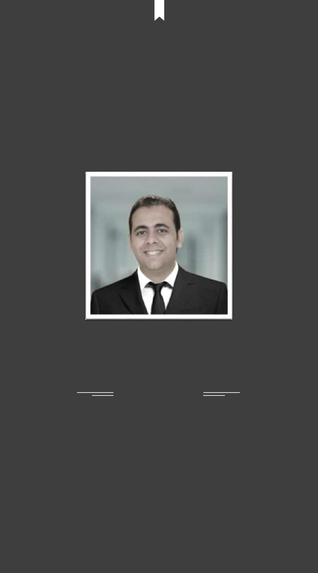

Welcome to My Resume

Rami

IT MANAGER

Get in Touch

- Rami.370293@2freemail.com

Rami

IT MANAGER

Nationality: Egyptian Email: Rami.370293@2freemail.com DOB: 7/9/1989

My Profile

Hello I am Rami. I have worked in many areas of information technology for more than 5 years in several areas, including hotels and companies. Currently now working at Sofitel Worldwide Hotel - (ACCORHOTELS ), as Digital Services Solutions Manager ( IT Manager ) .

DIGITAL SERVICES SOLUTIONS MANAGER - NOVEMBER 2016 - PRESENT ASSISTANT IT MANAGER (IN CHARGE) - APRIL 2015

Sofitel Dubai Jumeirah Beach Residence

- 438 rooms – Business Hotel

- 5 Stars Hotel

Experience

ASSISTANT IT MANAGER (IN CHARGE) - FEB 2013 -APRIL 2015 Sofitel Egypt Taba Heights

- 442 rooms – Resort Hotel

- 5 stars Hotel

- 2nd Rank in Trip Advisor

IT COORDINATOR (IN CHARGE) - DEC 2010 -FEB 2013 Sofitel Alexandria Cecil

- 4 stars Hotel

- Business Hotel

- Ranked no 7 in Trip Advisor

IT MANAGER - 2007 - 2010

Kamar Trade Solutions

- Software Solutions.

- Hardware Solutions.

- Network Solutions.

PHOTOGRAPHER & DESIGNER - 2005 - 2007

ELBASHA Digital Studio

- Photographing.

- Design pictures and animated videos.

E d u c a t i o n

Language

FACULTY OF ARTS - SOCIOLOGY - 2013

Alexandria University - Egypt

Bachelor Degree

COLLEGE SAINT MARC - 2007

French High School.

NEW HORIZONS COMPUTER LEARNING CENTERS - 2013 Computer Science Training Centers

ARABIC

Native Language

FRENCH

Fluent

ENGLISH

Fluent

Certificates

- 70-680 : MCTS: WINDOWS® 7, CONFIGURATION

Microsoft • License: 70-680

- 70-640 : MCTS: WINDOWS SERVER® 2008 ACTIVE DIRECTORY, CONFIGURATION

Microsoft • License: 70-640

- 70-642 : MCTS: WINDOWS SERVER® 2008 NETWORK INFRASTRUCTURE, CONFIGURATION

Microsoft • License: 70-642

- 70-643 : MCTS: WINDOWS SERVER® 2008 APPLICATIONS INFRASTRUCTURE , CONFIGURATION

Microsoft • License: 70-643

- 70-647 : MCTS: WINDOWS SERVER® 2008 ENTERPRISE ADMINISTRATOR

Microsoft • License: 70-647

- LINUX FUNDAMENTALS

New Horizons Computer Learning Centers

- LINUX SYSTEM ADVANCE

New Horizons Computer Learning Centers

- CISCO CERTIFIED NETWORK ASSOCIATE (CCNA)

New Horizons Computer Learning Centers

- LINUX REDHAT NETWORKS

New Horizons Computer Learning Centers

- FRENCH CERTIFICATE

College saint mark

- SOFITEL ATTITUDE FOR MANAGERS BY ACCOR ACADEMY

Sofitel Luxury Hotels and Resorts

- KEEPING THE BASICS RIGHT BY ACCOR ACADEMY

Sofitel Luxury Hotels and Resorts

- AUTODESK 3D STUDIO MAX FUNDAMENTALS,ADVANCE , CHARACTER DESIGN

Learn2B Training center

- ADOBE FLASH

ICC Training center

- VCE CERTIFIED CONVERGED INFRASTRUCTURE

EMC Online Certificate

- SQL ADMIN

New Horizons Computer Learning Centers

- FIT FOR BUSINESS

Sofitel Luxury Hotels and Resorts

- ADOBE PHOTOSHOP

New Horizons Computer Learning Centers

- 5115 : INSTALLING AND CONFIGURING THE WINDOWS VISTA OPERATING SYSTEM

New Horizons Computer Learning Centers

- 5116A : CONFIGURING WINDOWS VISTA MOBILE COMPUTING AND APPLICATIONS

New Horizons Computer Learning Centers

- 6292 : INSTALLING AND CONFIGURING WINDOWS 7

New Horizons Computer Learning Centers

C e r t i f i c a t e s

- 6421A-: CONFIGURING AND TROUBLESHOOTING A WINDOWS SERVER 2008 INFRASTRUCTURE

New Horizons Computer Learning Centers

- 6425A CONFIGURING AND TROUBLESHOOTING A WINDOWS SERVER 2008 ACTIVE DIRECTORY

DOMAIN SERVICES

New Horizons Computer Learning Centers

- ACTIVE DIRECTORY

New Horizons Computer Learning Centers

- 6418: DEPLOYING WINDOWS SERVER 2008

New Horizons Computer Learning Centers

- 6428A : CONFIGURING AND TROUBLESHOOTING WINDOWS SERVER 2008 TERMINAL SERVICE

New Horizons Computer Learning Centers

- 6427 : CONFIGURING AND TROUBLESHOOTING INTERNAL INFORMATION SERVICES IN WINDOWS

SERVER 2008

New Horizons Computer Learning Centers

- 6435 : DESIGNING A WINDOWS SERVER 2008 NETWORK NFRASTRUCTURE

New Horizons Computer Learning Centers

- 6436A : DESIGNING A WINDOWS SERVER 2008 ACTIVE DIRECTORY INFRASTRUCTURE AND SERVICES

New Horizons Computer Learning Centers

- 6437 : DESIGNING WINDOWS SERVER 2008 APPLICATIONS INFRASTRUCTURE

New Horizons Computer Learning Centers

- AUTODESK 3D STUDIO MAX FUNDAMENTALS,ADVANCE , CHARACTER DESIGN

New Horizons Computer Learning Centers

- ACCREDITATION OF AMBASSADOR PROGRAM

SOFITEL WORLDWIDE HOTELS

- INTEL TRAINING PROGRAM

INTEL ONLINE TRAINING

- HP TRAINING PROGRAM

HP ONLINE TRAINING

HOTEL SKILLS:

- Opera PMS

- INFOR SUN

- MICROS POS 3700/9700/SYMPHONY

- Financial Material Control

- Fidelio Front Office

- Fidelio Back Office

- PBAX AVAYA/ALCATEL

- IPTV

- HOTSOS

- OASYS

- ACT HR PAYROL

- REDBERRY PASSPORT SCANNER

- FIREWALLS

- NETWORKING

- RUKUS Networks

- ARUBA Networks

- Backup Systems

- Office 365

Thanks for Reading

Get in Touch

Rami.370293@2freemail.com

