RESUME

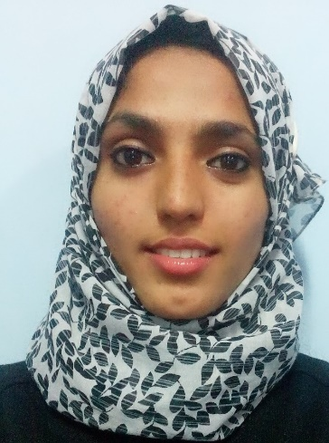
HUDA

Email Id: huda.3703111@2freemail.com

Personal Details:
Date of Birth : 08 May 1991
Nationality : Indian
Gender : Female
Marital Status : Single

Objective:
- To teach in a highly reputed and eminent educational institution that imparts a quality education, to effectively contribute to the overall development of the students and benefit the institution.
- I look for an ambience that is both challenging and encouraging at the same time which would help me put all my potential into a qualitative output to help the institution as well as myself grow.

Work Experience:
1. Working as an English Lecturer at Aliya International Academy, Kasaragod, Kerala, India.
2. Worked as an English teacher at Hira Girls’ High School, Babbukatte Mangalore, Karnataka, India- 2015
3. Internship for a month at Women’s Islamic P.U College. Mangalore, Karnataka, India- 2014

Educational Qualification:
M.A English -First Class with Distinction
2012-2014 : St Agnes College for Post-Graduation and Research, Mercara Hill Road, Mangalore, Karnataka, India.
Areas Covered in Literature:
- British Literature
- American Literature
- Indian Writing in English
- Indian Literature in Translation
- European Classics in Translation
- Literary and Critical Theory
- Post-Colonial Literature and Thought
- Cultural Studies
Areas Covered Under Language Studies:
- Modern and Functional Grammar
- English Language Teaching
- English for Effective Communication
- English for Specific Purpose
hudam5335@gmail.com

B.A- Computer Applications, Psychology, Optional English
Overall Percentage 73.36%
2009-2012 : School of Social Work, Roshni Nilaya, Valencia, Mangalore, Karnataka, India.

PUC- Arts- History, Economics, Sociology, Political Science
Overall Percentage 81.66%
2007-2009 : Women’s Islamic P.U College, Mangalore, Karnataka, India.

SSLC- Overall Percentage 66.56%
2006 : St. Sebastian High School, Thokkottu, Mangalore, Karnataka, India.

Other Accomplishments:
1. Participated in “Discover Yourself” workshop organized by Aliya Group of Educational Institutions, Kasaragod, Kerala, India. 2015
2. Took part in the National Level E-Lit Fest, The Bard of Stratford- on- Avon at S.D.M, Ujire, Karnataka, India. 2014
3. Attended a UGC Sponsored National Workshop on English for Specific Purposes at St. Agnes College, Mangalore, Karnataka, India. 2013
4. Participated in the ‘One day Theatre Workshop- Stage craft’ organized by St. Agnes College in association with Hopkins Literary Association, St. Aloysius College, Mangalore, Karnataka, India. 2012
5. Received Meritorious Excellence Reward for securing second highest in English literature in B.A. 2013
6. Received Meritorious Award for the Academic Excellence in the Pre University College Examinations by “The Bearys’ Welfare Association, Bangalore, Karnataka, India. 2010
7. Received Academic Excellence Award given by “Yenepoya Moideen Kunhi Memorial Educational and Charitable Trust, Mangalore, Karnataka, India. 2009
hudam5335@gmail.com

8. Won ‘Third Place’ in the ‘District Level Essay Competition’ held at “Sarojini Madhusoodana Kushe Institutions, Mangalore, Karnataka, India. 2008
9. Won ‘Second Place’ in the ‘District Level Essay Competition’ held at “Meridian College, Mangalore, Karnataka, India. 2008
10. Won several prizes during school and college time in singing, drama, speech, poetry writing and essay writing competitions.

Language Proficiency:
Spoken Languages – English, Hindi, Kannada, Beary Bhashe
To Read and Write – English, Arabic, Hindi, Kannada, Beary Bhashe

Hobbies:
Reading books.
Writing poems on nature and life.
Prose writing on general aspects.
Helping people with English and translating vernacular texts into English for relatives and friends.
Participating in ‘Poetry Competitions’ and other ‘Creative Writing’ events.
Gardening.

