sampath.370317@2freemail.com
Sampath
Senior Level Assignments- Plant Maintenance
Location Preference: UAE & Bangalore

Executive Profile  Gained over 11 years of experience in Maintenance & Facility Management objectives. Expertise in leading maintenance processes to optimize project (equipment availability, energy efficiency & productivity), implementing effective preventive & predictive maintenance system / condition monitoring. Out-of-box thinker with proven track record of establishing processes & SOPs, streamlining workflow and creating work environment to enhance productivity.  Skilled in working on CNC machines such as Fanuc, Haas, Heidenhain, Siemens, Charmilles, Sodick, Actspark, Chmer & Mazatrol and Molding machines such as ARBURG (Selogica & Multronica), Battenfeld, Demag & Toshiba. Excellence in controlling projects with respect to cost, resource deployment, time overruns and quality compliance to ensure satisfactory execution of the same. A forward thinking person with communication, analytical & organizational skills  Education & Credentials  - B.Tech. (Electricals Engineering) from Neptune Institute of Management & Technology, Delhi in 2015  - ITI in Electrical from Department of Employment and Training, Karnataka in 2004  Training:  - 1 year apprenticeship training (2004-2005) Mangalore Refinery and Petrochemical Ltd. | Key Impact Areas  Maintenance Management  Safety Management  Total Project Management  Preventive & Predictive Maintenance  Troubleshooting  EMS Auditing  Business Continuity Planning  Spare Management  Team Building  Key Skills  Communicator  Motivator  Innovator  Analytical  Problem Solver
Career Timeline
MSSL Tooling, Sharjah, UAE
Xdrive Factory Automation, Bangalore
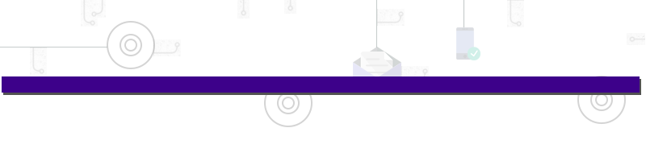
Mar’10 till date
Flowserve Controls India Pvt. Ltd.
Nov’07-Feb’10
Aug’06- Nov’07

Knowledge Purview

- Completed the two months of AutoCAD (CADIAN-Electrical CADD) Course in CADD Centre, Bangalore

Professional Experience
Mar’10 till date
MSSL Tooling, Sharjah, UAE as Assistant Manager
Key Result Areas:
- Leading the productive maintenance (machine software related, electrical, electronics, hydraulics and mechanical breakdown) of all the tool room & injection molding machines
- Undertaking regular inspections; eliminating unsafe operations to prevent accidents
- Planning & implementing equipment preventive, routine & breakdown maintenance jobs and ensuring maximum uptime of the equipment to avoid breakdowns for tool room, injection molding machines & utility machines
- Supervising & improving maintenance processes and personnel performance to achieve enhanced levels of efficiency
- Improving processes and reducing task completion time to attain better availability of the equipment, thereby increasing productivity
- Conducting performance evaluations and staffing need assessments; creating & sustaining a dynamic environment that fosters development opportunities & motivates high performance amongst team members
- Developing budgets & annual plans to managing facilities as per organizational needs & parameters
- Managing condition monitoring and geometrical test of molding & tool room CNC machines
- Implementing root-cause analysis for breakdown maintenance
- Executing activities spare management & procurement, TPM, safety & 5s’ in plant, power saving projects, EMS & TS activities documentation and machine history card maintaining
Special Equipment:
- Energy Logger, Thermal Insulation Camera, Insulation Tester
- Spindle Mandrel, Rod Micro Meter
- Laser Welding Machine
Highlights:
- Gained knowledge about MTTR, MTBF, Kaizen and improvements
- Acted as Safety Officer-Internal, EMS Auditor – Internal (Certified), TPM Coordinator and 5S Zone Leader
- Resolved major breakdown in critical machinery due to electronic phase by replacing with spare; fixed the same within in 3 hours
- Implemented several energy saving projects by converting machinery into turbo
- Imparted trainings to the juniors related to maintenance & safety management as per the defined training schedules
- Worked on several maintenance tools such as CMMS & EMPRO

Nov’07-Feb’10
Flowserve Controls India Pvt. Ltd. (An American MNC), Bangalore as Machine Shop Maintenance Executive
Key Result Areas:
- Worked on breakdown maintenance of CNC, PLC operated & conventional and welding machines
- Managed diesel generator & air compressor operation and general maintenance of LT transformer

Aug’06- Nov’07
Xdrive Factory Automation, Bangalore as Electrical Technician

IT Skills
- MS Office
- CADIAN
- CMMS (Computerized Maintenance Management System)
- EMPRO
- FLUKE Energy analyzer & thermal analysis
- DSS (Decision Support System)
Personal Details
Date of Birth: 21st May 1983
Languages Known: English, Hindi, Kannada and Tulu
Nationality: Indian
Marital Status: Married
No. of Dependents: 5
Visa Details: Employment Visa

