Contact:

Email:
Niranjan.370323@2freemail.com
Interest

- Current Affairs
- Medicine
- Reading
- Music
- Internet
- Driving
- Work shops

Skills and Achievements

- Proficient in English, Sindhi, Hindi & Urdu speaking, and Arabi related to medical.
- Strong interpersonal and communication skills.
- MS office and Advanced PC User.
References:

Will be furnished upon request

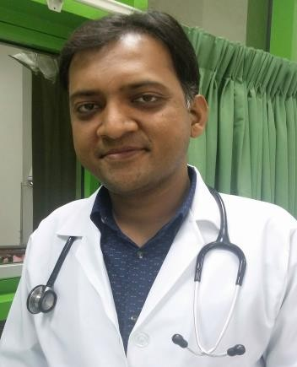
Dr. NIRANJAN

STATUS: HAAD PASSED
(License Transferable)

Objective

Attaining experience and professional excellence by working at a reputable organization that help me to apply my interpersonal skills and medical knowledge and experience.

Personal Information: Date of Birth 2nd April 1983 Nationality PAKISTANI
C.N.I.C 45102-1449817-3

Academic Qualification

MBBS: 2001 to 2006 (Liaquat University of Medical & Health Sciences Jamshoro, Sindh, Pakistan
- HSC-II: 2000 (Al Mehran Higher Secondary School Ghotki)
- SSC-II: 1998 ((N) D.A.V. High School Ghotki)

Work Experience

- General Medical Practitioner (May 2016 up till now)
- @ Al Aahed Medical Centre, Al Ain.

- Job Description:

- Treat O.P.D. Patients.
- Providing necessary inpatient services like Injections, Drips, Nebulization etc.
- Advising necessary labs and other diagnostic tests.

- R.M.O. (General Medical Practitioner) January 2014 to December 2015
- @ Sakhi Baba General Hospital & Maternity Home, Pano Aqil

- Job Description:

- Provide General Medical treatment to Patients in Hospital
- Treat O.P.D. Patients
- Assist Clinical Rounds with Consultants

R.M.O. (General Medical Practitioner) July 2011 to December 2013

@ Bismillah Medical Complex, Qadirpur Road Ghotki

- Job Description:

- Provide General Medical treatment to Patients in Hospital
- Treat O.P.D. Patients
- Assist Clinical Rounds with Consultants

R.M.O. (General Medical Practitioner) March 2010 to April 2011
- @ Goolbanoo & Dr. Burjor Anklesaria Nursing Home, Karachi

Job Description:

      - Provide General Medical treatment to Patients in Hospital
- Also, Treat Emergency Room Patients
      - Assist Clinical Rounds with Consultants

Internship (May 2007 to May 2008)

- 6 months in Surgery (General Surgery)
- @ CHANDKA MEDICAL COLLEGE HOSPITAL LARKANA
- 6 months in Pediatrics Medicine
- @ CHANDKA MEDICAL COLLEGE HOSPITAL LARKANA

Job Description

  - Learnt & Practiced Diagnosis and Management of Common and Uncommon Diseases of all Systems of the Body.
  - Dealt with Surgical Emergencies like Appendicitis, Cholelithiasis, Nephrolithiasis, Pneumothorax, Intestinal obstruction, Perforation, Road Traffic Accidents (RTA), etc.
  - Measurement of Anthropometric Parameters and Keeping Records

- Professional Activities

- During Training at Bismillah Medical Complex Ghotki, have given many presentations like Chronic Liver Diseases, Cardiac Failure & MI, Infectious Diseases, Thyroid Disorders & many Other Endocrine Disorders, and etc.
- At House job (2008) gave many presentations like Pneumonia, Gastroenteritis, Chronic Obstructive Pulmonary Diseases, Diabetes Mellitus, and Hepatitis in Medicine rotation.

