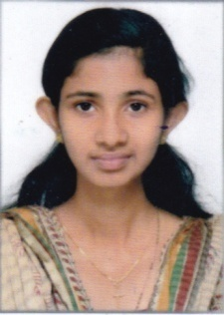

ANUSHA

Email: anusha.370324@2freemail.com

CARRIER OBJECTIVES
To work as a team member to learn with people with whom I work and assist the people I wish to work in a professional organization where I can use my skills, strength and knowledge by adding value to the organization and by getting new challenges and opportunities for my career growth
EDUCATION
Academic Qualification
SSLC March 2009 Infant Jesus GHS
Aranattukara, Thrissur
Plus Two March 2011 Sacred Hearts HSS, Thrissur
Professional Qualification
2013-2016 Srinivas College of Pharmacy, , Mangalore
ACADEMIC PROFILES
Educational Qualification | Institution | University | Year of Passing | Percentage
B Pharm | Srinivas College of Pharmacy | Rajiv Gandhi University of Health Sciences, Karnataka | 2016 | 1st year-78.00%  2nd year-70.00%  3rd year-70.00%  4th year- 73.00%
Plus Two | Sacred Heart HSS, Thrissur | Govt. Kerala | 2011 | 84%
S S L C | Infant Jesus GHS, Aranattukara, Thrissur | Kerala State Board | 2009 | 95%
Registration: Kerala Pharmacy Council, Thiruvananthapuram
Registration No: 57747
Issue Date: 05/12/2016

PERSONAL DATA
Marital Status : Married
Date of Birth : 11th April 1994
Gender : Female
Religion : Christian RC
Nationality : Indian
Profession : B Pharm
WORK EXPERIENCE
- Presently working as Pharmacist in West fort Hi Tech Hospital, Thrissur
SKILLS & STRENGTH
- Good Communication Skills
- Good Organizational Skills
- Good Writing Skills
- Knowledge of Medical Terminology
- Willingness to learn New Things and ability un understand them quickly
- Ability to work as a part of Team or Individually
- Optimistic
TECHNICAL & STRENGTH
Application of Software : MS Office
PASSPORT DETAILS
Issue Date : 04/08/2016
Expiry Date : 03/08/2026
Place of Issue : Cochin
Visa type : visiting visa

LANGUAGES PROFICIENCY
Language | Read | Write | Speak
English
Hindi
Malayalam
Kannada

DECLARATION
I, hereby declare that the above mentioned facts are true & correct to best of my knowledge and belief.

Place:
Date
ANUSHA

