CURRICULUM VITAE

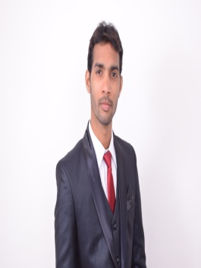
Dr. IRSHAD

E-MAIL: irshad.370328@2freemail.com
KARNATAKA MEDICAL COUNCIL

PROFESSIONAL QUALIFICATION:-

QUALIFICATION | BOARD | YEAR OF PASSING | UNIVERSITY
M.B.B.S | VIMS, BELLARY KARNATAKA | 2014 | Rajiv Gandhi University of Health Science, Bangalore.

WORKING EXPERIENCE:

- Presently working as a Junior Resident in Dept. of medicine (ICCU) at KBNIMS, Gulbarga Karnataka from 12/07/2017 to till date
- Worked as a Resident dooctor in ICU at Bahmani hospital Gulbarga Karnataka from 10/11/2014 to 25/06/2016
- 1 year of internship in VIMS, BELLARY KARNATAKA.

JOB RESPONSIBILITY AND PROCEDURE EXPERIENCE

      - Responsible for check up of the patients and giving prescriptions.
      - Confident in managing patient with Actue cardiac emergencies including MI, tachyarrhythmias and bradyarrythmias , congestive cardiac failure, pulmonary embolism.
      - Neurologic emergencies like stroke , status epilepticus
      - Respiratory emergencies like pneumothorax , status asthmaticus , COPD exacerbation
      - Assisted endotracheal intubation , arterial line insertion , ICD insertion
      - Investigational work up , acute medical intensive care duties , gastric lavage , administering IV medication, nasogastic tube insertion, urethral catheterization, assisted pleural tap , assisted lumbar puncture.
      - Pre op assessment , incision and drainage, post op care, acute trauma care
      - Assisting the senior doctors in major surgeries like appendicitis , hernia repair, hydrocoele , excision of mass , debridement .
      - Performing minor procedure like skin suturing , cyst excision, wound dressing
      - Checking the reports and accordingly diagnosing the disease and giving prescription.
      - Responsible for regular check up and improvement of the patients.
      - Conducting laboratory tests and radiological investigations to distinguish which part of the body needs to be attended to and make decisions to make any surgeries for patient’s betterment.
      - Prescribe medicines to patients to lessen the pain they are feeling and giving them quick treatments before the surgery.
      - To keep a check on patient’s medical records for any further testing and diagnosis required.
      - Providing special care for serious patients assigned and conducting physical examinations and evaluating treatments on a regular basis

KEY SKILLS

- Highly articulate, demonstrating excellent relationship building, communication, analytical and interpersonal skills
- Confident & Helping nature.
- Disciplined
- Ability to handle the stressed situation
- Excellent theoretical knowledge
- Excellent communication skills
- Good knowledge of clinical practices and protocols
- Ability to handle different types of patients in critical situations
- Flexible and adaptable
- Extremely motivated towards career
PERSONAL DETAILS :-

Name : Dr. IRSHAD
Date of Birth : 06-06-1990
Place of Birth : Gulbarga
Religion : Muslim
Sex : Male
Marital Status : Married
Nationality : Indian
Languages known : English, Hindi, Kannada & Urdu

PASSPORT DETAILS :-

Date of Issue : 30/03/2016
Date of Expire : 29/03/2026

DECLARATION:-

I hereby declare that the above mentioned information is correct to the best of my knowledge and I bear the responsibility for itsauthenticity.

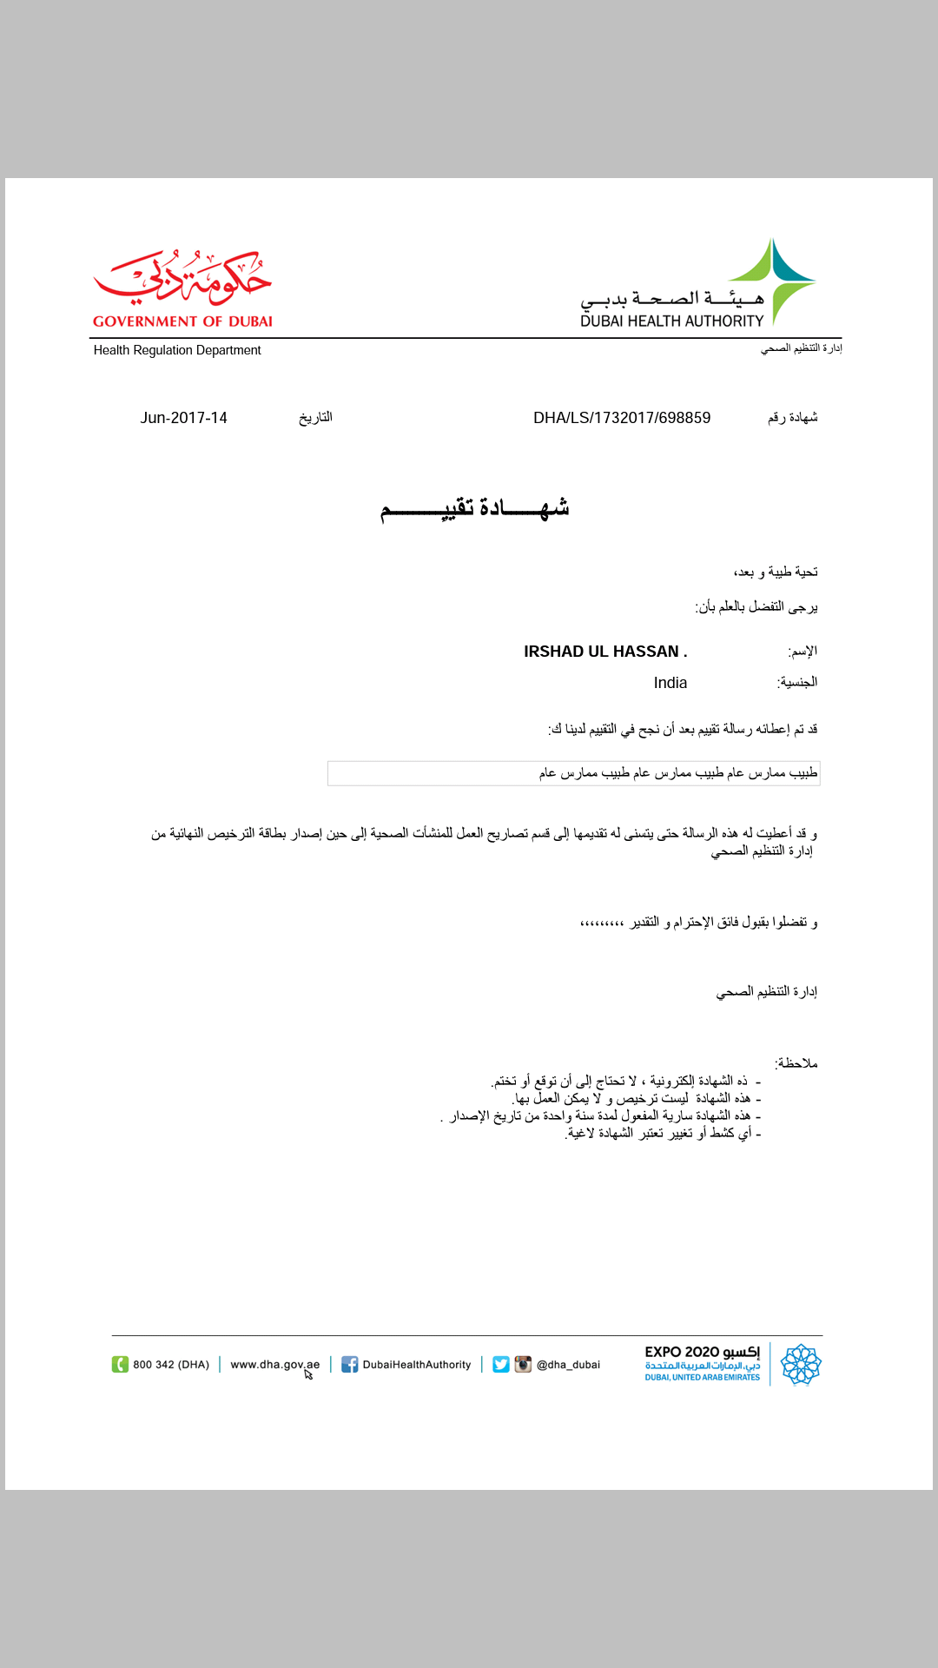
Place : Gulbarga (Dr. IRSHAD)

