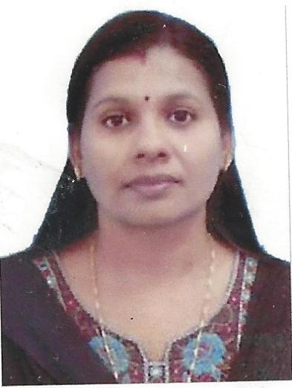
DEEPA
Deepa.370334@2freemail.com

CAREER OBJECTIVE:
I am a Diploma holder in Medical lab technology and a degree holder in Zoology too, I am a diligent, dedicated and performance oriented person with proven skills and abilities in lab technology.I seek a suitable placement in a similar position in any hospitals or laboratories with an outstanding performance. I will utilize my skills and ability to work for the growth of the organization, simultaneously ensuring my own career growth.
ACADEMIC BACKGROUND:
- Did Post Graduation in Counselling and psychotherapy from Tamilnadu Open University in the year 2017.
- Did Diploma in Medical Laboratory Technology from Directorate of Medical
Education, in the year 1998 with first class.
- Did Bachelor's Degree in Zoology from University of Calicut, in the year 1996 with first class.
- Passed Pre Degree from University Of Calicut with in the year 1993 with first class .
- Passed SSLC from Board of Secondary Examinations in the year 1991 with Distinction.

WORKING EXPERIENCE:

- Worked as Lab Technician at Government Medical College, Palakkad, Kerala, India (2014-2017)
- As Lab Technician at MDC Lab, Mananthvady, Wayanad, Kerala (2009-2014).
- As Lab Technician at Primary Health Center, Mannur, Palakkad, Kerala, India (2008-2009)
- As Lab Technician at Primary Health Center, Ozhalapathy, Palakkad, Kerala,-India(2006-2007)
- As Lab Technician at Government Hospital, Kozhinjampara,Palakkad, Kerala -India(2005-2006) As MLT Instructor at Government Vocational Higher Secondary School, Payyoli, Kozhikode, Kerala-India(2004-2005)
- As Lab Technician at School of Health Sciences, Calicut University, Kerala-India(2003-2004)
- As Lab Technician at Government Ayurveda Hospital, Palakkad,Kerala-India(2000-2001)
- ALab Technician at E.S.I Hospital, Palakkad, Kerala-India(1999-2000)
- As Lab Technician at Government Medical College, Thrissur, Kerala-India(1998-1999)
(Majority of the appointments were through employment exchange,which s gives employment only for one year.)

Technical skills
- Passed DHA Exam for Lab Technicians on 13/03/2017
- Trained Under Revised National Tuberculosis Control Programme
- Trained under Kerala Aids Control Society.
- Well versed in Biochemical, Haematological Microbiological and Pathological Techniques.
- Trained in the operation and maintenance of fully automated analyser and semi automated Biochemistry analyser and Eliza reader.
- Experienced in Histopathological works.
- Know Sterilization techniques and plebotomy.

PROFESSIONAL STRENGTHS:
Good Communication Skills,Good Organization Skills,
Ability to work as part of a team., Able to work under pressure and meet deadline.
Dedicated and strong desire towards learning.

PROFICIENCY IN LANGUAGES:

Can Speak | English | Malayalam | Tamil
Can Read | English | Malayalam | Hindi
Can Write | English | Malayalam | Hindi

HOBBIES AND INTERESTS:
- Listening to Music and Singing
- Reading
- Gardening.

PERSONAL INFORMATION:

Name | Deepa
Husband's name | Dr. Anuj Vasudevan
Nationality | Indian
Sex | Female
Mother Tongue | Malayalam
Blood group | B+ve

DECLARATION:

I hereby declare that the above mentioned information is true and correct to the best of my knowledge.
Place: Palakkad, Kerala
Date: DEEPA

