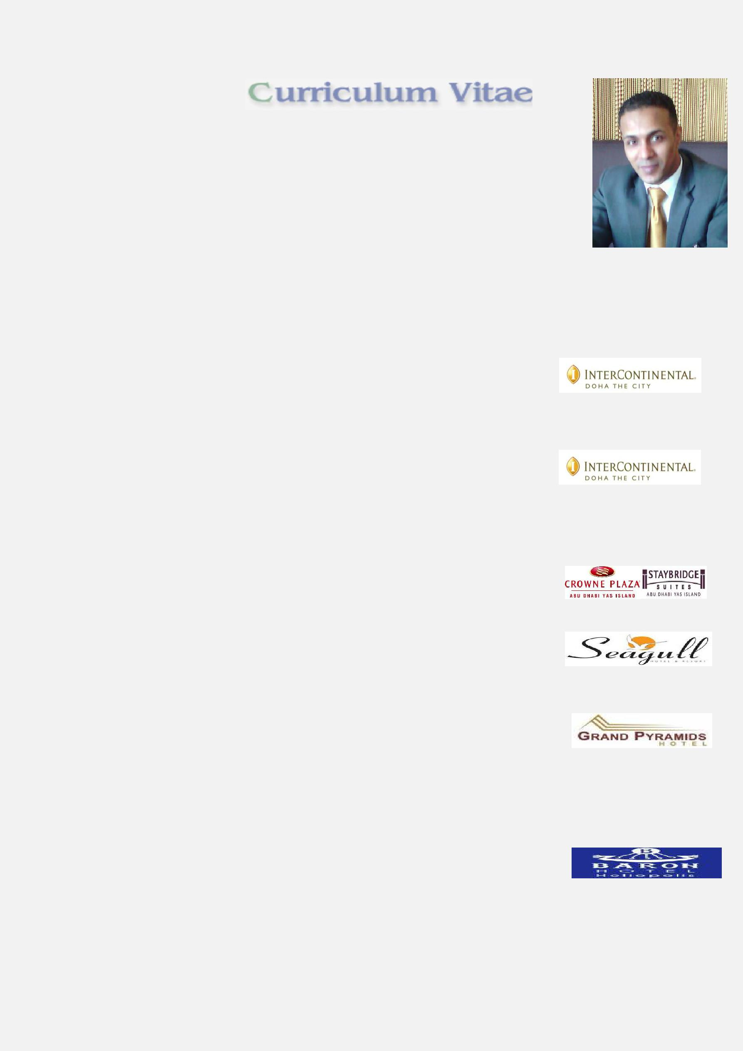

Wael
Wael.370337@2freemail.com

Personal Information
Nationality : Egypt

Birth date : 05/07/1986
Gender : Male
Marital Status : Single
Military Status : Finished

Work Experience

Current Job
Job title : Front Office Supervisor
Employer : InterContinental Doha The City
Employer Country : Qatar (Doha)
From : February2013: To Now

Previous Job
Job title : Instant Service Centre Supervisor
Employer : InterContinental Doha The City
Employer Country: Qatar (Doha)

From : December 2011To February 2012

Job title : Guest Service Agent

Employer : Crowne Palza &Stay bridge Suites Yas Island Abu Dhabi
Employer Country: United Arab Emirates
From : September 2010 To December 2011

Job title : Front office Agent
Employer : Seagull Resort &Club (5 * hotel) (710 room)
Employer Country: Egypt (Hurghada)
From : September 2009 To Aug2010

Job title
Employer
Employer Country
From

: Telephone Operator

: Grand pyramids Hotel (5 * hotel) (300 room)
: Egypt (Cairo)
: September 2006 To January 2007

Job title : Business Centre Agent
Employer : Baron Hotel in Cairo
Employer Country: Egypt (Cairo)

From : January 2006 To September 2006
Job title : Telephone Operator
Employer : Baron Hotel in Cairo

Employer Country: Egypt (Cairo)

From : September 2005 To January 2006

Education

First University Degree : B.Sc. Tourism & Hotels
University : Cairo Institute

Major : Tourist Guidance

Grade : Good
Graduation year : 2005

Languages
Arabic

English

Technical Summary

- To be aware of all activities inside and outside the hotel and its layout To extend a personal service to the guests and assist them in all their requirements To handle the guest's mail, take telephone messages and ensure that all faxes mails, and messages are distributed promptly To ensure that there exists an up-to-date selection of booklets, guides, maps and

brochures for tourists and business travellers To place emphasis on in-house restaurants and its facilities

Courses
- Egypt Tourism Workforce Development project (ETWDP) From (American Hotel &Lodging Educational Institute)

- ALDP (Accelerated Leadership Development Program) From InterContinental Hotels Group
- Traveller Safety EMEA
- IHG Management of Leisure Safety EMEA
- Security Awareness for Manager on Duty EMEA

Computer Skills
(Ward- Excel-PowerPoint)

Front office system : Fidelio 7.14 & suite 8 & Opera

(QMES) Quality Management and Engineering System,
(Skytel) Sky Telephone Information System,
(NEVOTEK) Telephone Report System,
(VICAS) samsoteck ID Systems

Availability & Job Requested
Availability : I am able to start work after One month from announcement

As : Full Time
Rank : Senior
Job field : Hotel ,Tourism, Customer Services

