CURRICULUM VITAE

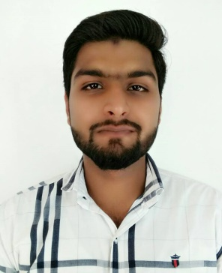
ABSAR
Email.- absar.370350@2freemail.com

PROFESSIONAL SUMMARY
High energy Civil Engineer who skillfully manages the demands of the building construction, execute the projects, oversee all the activities, controls the Labour by following all the security terms, make plans of buildings, supervise all site activities as well as quality check, survey of quantity, estimation and inspection process.

PROFESSIONAL QUALIFICATION
- Diploma engineering (civil) from Subharti University , Meerut.
- (I.T.I) Diploma course in civil from Madani Technical Institute duration 2 years.
- AutoCAD from Cadd Centre Muzaffarnagar duration 3 month.
- Application software MS office, MS word. Power point and Excel.
- one year diploma in computer applications (DCA).

EDUCATIONAL QUALIFICATION
10th passed from CBSE .
EXPERIENCE DETAIL

- Worked on Construction site of Grand Library project at darul uloom Deoband as a Site Supervisor from 2nd july 2014 to 29th October 2015.

- Worked in a commercial college building (I.T.I) as site supervisor from 10th November 2015 to 15 April 2017.

PROFESSIONAL SKILLS
Commercial and residential planning , quantity analysis, various measurements,
2D Drafting, site layout, Estimation & costing, etc.

PERSONAL DETAIL
NATIONALITY - INDIAN
DATE OF BIRTH - 27 DEC. 1994
LANGUAGE - ENGLISH, HINDI, URDU
GENDER - MALE
RELIGION - ISLAM
MARITAL STATUS - UNMARRIED

DATE: ABSAR

